|  | **MINISTRY OF EDUCA MINISTRY OF EDUCATION AND TRAINING** |
| --- | --- |

| FPT UNIVERSITY |
| --- |
| SWD392 Project Document |
| Koi Ordering System |

| **<Group-2>** | |
| --- | --- |
| **Group Members** | Lê Hoàng Phúc - SE173083  Huỳnh Nguyễn Ngọc Nguyên - SE171880  Phan Trần Minh Trí - SE172500  Trần Minh Nhật - SE172319  Bùi Bảo Khang - SE170512  Nguyễn Huy Hoàng - SE162194 |
| **Supervisor** | Nguyễn Ngọc Lâm |
| **Ext Supervisor** |  |
| **Capstone Project code** |  |

# - HoChiMinh, November 2024 -

# 

**Table of Contents****2**

Acknowledgement **6**

I. Project Introduction **7**

1. Overview 7

1.1 Project Information 7

1.2 Project Team 7

2. Product Background 7

3. Existing Systems 8

3.1 Kodama Koi Farm 8

3.2 Dainichi Koi Farm 8

3.3 Koi.com 9

3.4 Sakai Fish Farm (SFF Koi) 9

3.5 Marudo Koi Farm 9

4. Business Opportunity 10

5. Software Product Vision 10

6. Project Scope & Limitations 10

II. Project Management Plan 1**2**

1. Overview 12

1.1 Scope & Estimation 12

1.2 Project Objectives 12

1.3 Project Risks 13

2.1 Project Process 13

2.2 Quality Management 13

2.3 Training Plan 14

3. Project Deliverables 14

Internal Deliverables: 14

External Deliverables: 14

4. Responsibility Assignments 14

5. Configuration Management 14

5.1 Document Management 14

5.2 Source Code Management 15

5.3 Tools & Infrastructure 15

III. Software Requirement Specification 15

1. Product Overview 15

2. User Requirements 16

2.1 System Actors 16

2.2 Use Cases 16

3. Functional Requirements 60

3.1 System Functional Overview 60

3.1.1 Screen Flow 60

3.1.2 Screen Descriptions 61

3.1.3 Screen Authorization 62

3.1.4 Entity Relationship Diagram(ERD) 63

3.1.5 Entities Description 64

3.1.6 Activity Diagram 68

1. BookTour&CheckIn 68
2. BuyKoiFish,Delivery&FinalPayment 70
3. CancelOrder&RefundPolicy 71

4. Non-Functional Requirements 72

4.1 External Interfaces 72

4.2 Quality Attributes 72

5. Requirement Appendix 72

5.1 Business Rules 72

5.2 Common Requirements 75

IV. Software Design Description 76

1. System Design 76

1.1 System Architecture 76

2. Database Design 77

3. Detailed Design 78

3.1 <Login> 78

3.2 < Register>78

3.3 < Get All User> 79

3.4 < Delete user> 79

3.5 <Create User> 80

3.6 <Update user> 80

3.7 <View koi’s detail> 81

3.8 <Display koi in homepage> 81

3.9< Get one trip detail> 82

3.10<Display trip in homepage> 82

3.11<View all feedback> 83

3.12<Create Feedback> 83

3.13<Delete Feedback> 84

3.14 <Update Feedback> 85

3.15<Get Feedback by Id> 85

3.16 <Get all farm> 86

3.17 <Add farm> 86

3.18<Delete farm> 87

3.19<Update farm> 87

3.20<Create Order Koi Fish> 88

3.21<Update Order Koi Fish> 88

3.22<Delete Order Koi Fish> 89

3.23<Get All Order Koi Fish> 89

3.24<Get Order Koi Fish By Id> 90

3.25 <Get All Order Trip> 90

3.26<Get Order Trip By Id> 91

3.27 <Create Order Trip> 91

3.28 <Delete Order Trip> 92

3.29< Update Order Trip > 92

3.30<Get All Order Histories> 93

3.31< Get Order History by Id> 93

3.32<Create Order History > 94

3.33<Update Order History> 94

3.34<Delete Order History> 95

3.35<Delete Insurance Policies > 95

3.36<Create Insurance Policies > 96

3.37<Update Insurance Policies> 96

3.38<View All Insurance Policies> 96

3.39<View Insurance Policies By Id> 97

3.40<Create CheckIns> 97

3.41<Update CheckIns> 98

3.42 <Delete CheckIns> 98

3.43<View All Check Ins> 99

3.44<View Check In By Id> 99

3.45 <Delete Refund Request> 100

3.46 <Update Refund Request> 100

3.47 <Create Refund Request> 101

3.48<View Refund Request by id> 101

3.49<View All Refund Request > 102

3.50<View Payment> 102

3.51<Create Payment> 103

3.52.<Delete Payment> 103

3.53<UpdatePayment> 104

3.54<GetPaymentById> 104

3.55<View Schedule Farm> 105

3.56<Create Schedule Farm> 105

3.57<Update Schedule Farm> 106

3.58<Delete Schedule Farm> 106

3.59<GetScheduleFarmById> 107

3.60<View Trip Schedule> 107

3.61<Create Trip Schedule> 108

3.62<Update Trip Schedule> 108

3.63<Delete Trip Schedule> 109

3.64<GetTripScheduleById>109

3.65<UpdateTrip> 110

3.66<AddTrip> 110

3.67<GetByIdOrderKoiFishDetail> 111

3.68<DeleteTrip> 111

3.69<Forgot password> 111

4.State diagram 112

4.1<OrderTrip> 112

4.2<OrderKoiFish> 113

4.3<Payment> 114

4.4<CheckIn> 114

4.5<Order History> 115

# Acknowledgement

**Definition and Acronyms**

| **Acronym** | **Definition** |
| --- | --- |
| BR | Business Rule |
| ERD | Entity Relationship Diagram |
| UC | Use Case |
| FE | Feature |
| LI | Limitation |
| API | Application Program Interface |
| PCI DSS | The Payment Card Industry Data Security Standard |

# I. Project Introduction

## 1. Overview

### 1.1 Project Information

* Project Name: Koi Ordering System
* Project Code: KOSJP-2024
* Group Name: Koi Ordering System In Japan

### 1.2 Project Team

| **Full Name** | **Role** | **Email** |
| --- | --- | --- |
| **Lê Hoàng Phúc** | Leader | **phuclhse173083@fpt.edu.vn** |
| **Huỳnh Nguyễn Ngọc Nguyên** | Member | **nguyenhnnse171880@fpt.edu.vn** |
| **Phan Trần Minh Trí** | Member | **triptmse172500@fpt.edu.vn** |
| **Trần Minh Nhật** | Member | **nhattmse172319@fpt.edu.vn** |
| **Bùi Bảo Khang** | Member | **khangbbse170512@fpt.edu.vn** |
| **Nguyễn Huy Hoàng** | Member | **hoangnhse162194@fpt.edu.vn** |

## 2. Product Background

Today, the demand for Japanese Koi has increased significantly, attracting both hobbyists and large-scale collectors who value the quality and unique characteristics of Japanese Koi. However, purchasing Koi directly from farms remains challenging, especially for foreign buyers, due to language barriers that limit access to reliable farm information and logistical complexities in fish selection, payment and delivery.

My team identified these issues through feedback from foreign customers who had difficulty connecting with reputable Japanese farms, along with difficulties in arranging farm visits, ordering specific Koi and managing payment and delivery. Additionally, handling order cancellations and refunds is often complicated by manual processes.

As a result, we developed the Koi Ordering System, an integrated platform that simplifies the purchasing process for both customers and breeders. The system provides comprehensive farm information, allows customers to place orders via tours or direct inquiries, and streamlines payment, order cancellation, and delivery management. By addressing these inefficiencies, the Koi Ordering System enhances the purchasing experience, connecting global customers with the best Japanese Koi breeders.

**Reference:** <https://chatgpt.com/share/6726e070-390c-8001-873b-e03b250c7c2f>

## 3. Existing Systems

### 3.1 Kodama Koi Farm

* **URL:**<https://www.kodamakoifarm.com>
* **Description:** Kodama Koi Farm is one of the most renowned Koi farms in Japan, known for offering a fantastic selection of high-quality Koi fish. They cater to customers all around the globe, making it easy for anyone to browse and purchase Koi online or even visit the farm for a personal tour. Their website is packed with useful information about Koi care and breeding practices, which is a great resource for both beginners and seasoned enthusiasts.
* **Actors:** Guests, Customers, Sales Staff, Managers.
* **Functions:** Koi browsing, booking appointments, managing payments, customer support, and farm tours.
* **Main flow:** Customers can easily search for Koi, make bookings, process payments, and log into their accounts for a more personalised experience.
* **Pros:** Offers a wide variety of Koi with global shipping options, plus a wealth of information to help buyers make informed choices.
* **Cons:** The lack of a detailed order history feature can be a downside for those who prefer to keep track of past purchases.

### 3.2 Dainichi Koi Farm

* **URL**:<https://www.dainichikoi.com>
* **Description**: Dainichi Koi Farm has a stellar reputation for breeding some of the finest Koi in Japan. Their website allows customers to conveniently purchase Koi and learn more about the breeding processes involved. They also provide expert consultations and ship internationally, ensuring that buyers can receive the best care for their new fish.
* **Actors**: Guests, Customers, Sales Staff, Managers.
* **Functions**: Koi listing, booking, payment processing, scheduling consultations, and providing customer support.
* **Main flow**: The user-friendly interface allows for straightforward bookings, payments, and consultations with experts.
* **Pros**: Customers appreciate the premium quality of the Koi and the ease of navigating the site for a smooth purchasing experience.
* **Cons:** Similar to Kodama, Dainichi's system might not retain detailed customer order histories without account creation.

### 3.3 Koi.com

* **URL**:<https://www.koi.com>
* **Description**: Koi.com serves as a comprehensive platform that connects enthusiasts with various Koi farms in Japan. It offers an array of services, including Koi sales, expert advice, and care tips, making it a go-to resource for anyone interested in Koi. The site’s user-friendly design makes it easy to find what you’re looking for, whether it's a specific type of Koi or general information on care.
* **Actors**: Guests, Customers, Sales Staff, Managers.
* **Functions**: Browsing Koi, searching, customer support, consultations, and managing payments.
* **Main flow**: Visitors can easily search for Koi, reach out for consultations, and handle payments all in one place.
* **Pros**: The platform is praised for its extensive information and the variety of Koi available, making it accessible for everyone.
* **Cons:** The site may not provide comprehensive customer order tracking without users creating accounts.

### 3.4 Sakai Fish Farm (SFF Koi)

* **URL**:<https://sff-koi.com/en/>
* **Description**: Sakai Fish Farm, also known as SFF Koi, is celebrated for producing award-winning Koi fish. Their website offers a seamless shopping experience for customers looking to purchase high-quality Koi directly from the farm. They also provide international shipping and consultations to ensure that buyers have all the support they need.
* **Actors:** Guests, Customers, Sales Staff, Managers.
* **Functions**: Koi browsing, booking, payment processing, consultations, and customer support.
* **Main flow**: The process for booking and purchasing Koi is straightforward, with options for personalised consultations available.
* **Pros:** Their reputation for excellence and the availability of expert advice make them a trusted choice for Koi enthusiasts.
* **Cons:** Like other systems, there may be challenges in tracking customer purchases if they do not register on the site.

### 3.5 Marudo Koi Farm

* **URL**:<https://www.kodamakoifarm.com/>
* **Description**: Marudo Koi Farm is a highly reputable Koi breeder in Japan, known for producing top-tier Koi fish. Their website allows customers to browse a wide variety of Koi fish, make purchases, and schedule farm tours. They also provide detailed information about their breeding processes and international shipping options.
* **Actors**: Guests, Customers, Sales Staff, Managers.
* **Functions**: Koi browsing, booking, payment processing, farm tours, and customer support.
* **Main flow**: The site provides a straightforward experience for browsing, booking, and purchasing Koi, with farm tours available upon request.
* **Pros**: Marudo Koi Farm offers a broad selection of Koi fish with international shipping, making it a trusted source for buyers worldwide.
* **Cons**: The website may not have advanced features for tracking order history unless an account is created.

**Reference:** <https://chatgpt.com/share/672e002a-1988-8000-8fb5-fe773f890812>

## 4. Business Opportunity

The Koi Ordering System is an online platform that simplifies access for international customers to Japanese Koi farms, allowing them to book tours, order Koi fish, and manage payments and shipments all in one place. It addresses language barriers, ordering complexities, and lack of transparency, enhancing the buying experience between customers and Japanese Koi breeders. With rising demand for high-quality Koi, the Koi Ordering System seizes a market opportunity by providing convenience, transparency, and efficient cross-border transactions.

## 5. Software Product Vision

Koi Ordering System is designed as a comprehensive online platform to streamline the Japanese Koi purchasing process for customers worldwide. From discovering available Koi and booking farm tours to placing orders and managing payments, the platform connects international buyers with Japanese Koi farms, providing an intuitive and simplified experience, eliminating language barriers, manual processes and logistical challenges.

As a one-stop solution, the **Koi Ordering System** enhances transparency, convenience and efficiency for both buyers and breeders. Customers can easily access detailed farm information, place orders or tours as desired and enjoy a more personalised and seamless purchasing experience. For Koi farms, the platform supports better customer management, smoother communication and fewer transaction errors.

Koi Ordering System envisions a future where purchasing high-quality Koi from Japan becomes simple and accessible to anyone, anywhere—providing a smooth and enjoyable experience for both global customers and Japanese breeders.

**Reference:** <https://chatgpt.com/share/6726e1ce-0b34-8001-8e34-13989d26c2c7>

## 6. Project Scope & Limitations

The Koi Ordering System aims to create a comprehensive and user-friendly platform for customers worldwide to browse, select, and purchase Koi fish from Japanese farms. This system will streamline the ordering process, provide valuable information about Koi farms, and ensure that customers can easily manage their purchases, payments, and shipments. However, the project will be developed with certain boundaries to maintain focus and feasibility.

**6.1 Major Features:**

* **FE-01:** View information about various Koi fish farms, including Koi availability, farm history, and breeder details.
* **FE-02:** Book farm tours, either virtual or physical, to personally view and select Koi fish for purchase.
* **FE-03:** Place orders for Koi fish and manage payments, including instalment options for high-value purchases.
* **FE-04:** Manage orders, including the ability to modify, cancel, or confirm purchases.
* **FE-05:** Track shipment and delivery of purchased Koi fish, including updates on the transportation process.
* **FE-06:** Handle customer feedback and support, providing a seamless channel for inquiries, complaints, or requests.
* **FE-07:** Enable sales and consultation staff to manage customer interactions and provide personalised recommendations.

**6.2 Limitations & Exclusions:**

* **LI-01:** The system will not handle detailed farm logistics, such as Koi fish breeding schedules, which remain under the control of individual farms.
* **LI-02:** Customers will not be able to arrange international shipments directly through the platform; shipping will be managed through partner logistics companies.
* **LI-03:** The platform will not provide live bidding or auction functionality for Koi fish purchases.
* **LI-04:** Payments for tours and orders will not support cryptocurrency transactions at launch, focusing instead on traditional payment methods like credit cards and bank transfers.
* **LI-05:** The system will not include in-depth veterinary care or Koi health services post-purchase, which must be arranged separately by customers

**Reference:** <https://chatgpt.com/share/672e002a-1988-8000-8fb5-fe773f890812>

# II. Project Management Plan

### 1. Overview

This project management plan outlines the activities, deliverables, and processes required to successfully deliver the Koi Ordering System. The development will be based on an Agile Scrum methodology, focusing on iterative progress and continuous stakeholder feedback.

### 1.1 Scope & Estimation

| Feature/Functionality | Complexity | Estimated Effort ( Man-days) |
| --- | --- | --- |
| User Authentication | Simple | 3 |
| Koi Catalog Browsing | Medium | 5 |
| Ordering System | Complex | 12 |
| Book Tour | Complex | 12 |
| Payment Integration | Medium | 5 |
| Customer Feedback | Simple | 4 |
| Admin Dashboard | Complex | 10 |
| Order Tracking | Medium | 6 |
| Notification System | Medium | 5 |

### 1.2 Project Objectives

**Overall Objective**: The main goal is to develop a user-friendly Koi Ordering System that simplifies the purchase of Koi fish in Japan, ensuring a smooth process from browsing, ordering, payment, and delivery.

**Specific Target Metrics**:

* **Quality**: Achieve 95% customer satisfaction based on post-purchase surveys.
* **Time**: Complete the project within 10 weeks.
* **Cost**: Allocate resources efficiently with 30% for requirement analysis, 20% for design, 30% for coding, 15% for testing, and 5% for project management.

### 1.3 Project Risks

| Risk Description | Probability | Impact | Mitigation Strategy |
| --- | --- | --- | --- |
| Difficulty integrating with payment gateway | Medium | High | Conduct biweekly API integration tests to preempt potential issues. Establish a direct line of communication with gateway providers to ensure rapid resolution of any integration challenges, minimising the risk of payment gateway downtime or processing delays. |
| Lack of experience in e-commerce systems | Low | Medium | Provide additional training on e-commerce platforms and related APIs |
| Delays in obtaining regulatory approvals | Low | High | Begin communication with regulatory bodies early in the process |
| Inadequate server capacity during high traffic | Medium | High | Sale infrastructure based on projected traffic and perform load testing |
| Language barriers during user testing | Medium | Medium | Employ bilingual testers or translators to overcome communication challenges |

### 2.1 Project Process

The project will follow an **Agile Scrum methodology**, with regular sprints (2 weeks) and continuous feedback from stakeholders to ensure alignment with the objectives.

**Key Phases:**

* **Week 1**: Requirement Gathering – Collect and finalise detailed requirements.
* **Weeks 2-3**: Design & Prototyping – Develop initial UI/UX designs and system architecture.
* **Weeks 4-7**: Development – Code the core functionalities, including user registration, ordering, and payment.
* **Weeks 8-9**: Feedback, & Parallel Development – Collect feedback from users and continue to develop.
* **Week 10**: Deployment & Monitoring – Launch the system and monitor performance.

### 2.2 Quality Management

To improve project quality, we will use **Automated Testing** and **Continuous Integration/Continuous Deployment (CI/CD)** practices to catch bugs early and ensure rapid, reliable deployments.

**Quality Objectives:**

* Maintain a bug-free environment with a 95% pass rate on automated tests.
* Conduct regular code reviews to ensure code quality and adherence to best practices.

### 2.3 Training Plan

We will assess the skills of each team member and provide training on:

* **E-commerce Systems:** Focus on order management, payment integration, and shipping calculations.
* **Agile Methodologies:** Training on Agile tools like Jira and Scrum principles for better sprint management.
* **API Integrations:** Workshops on integrating payment gateways and third-party shipping APIs.

## 3. Project Deliverables

### Internal Deliverables:

* Requirement Specifications
* Design Documents
* Test Plans and Reports
* Project Status Reports

### External Deliverables:

* Fully Functional Koi Ordering System
* User Guide for Admins
* System Documentation for future maintenance

## 4. Responsibility Assignments

| **Team Member** | **Responsibility** |
| --- | --- |
| **Project Manager** | **Oversee the entire project, manage timelines, and ensure team coordination.** |
| **Lead Developer** | **Manage the development process and the codebase.** |
| **UI/UX Designer** | **Create user-friendly designs and interface prototypes.** |
| **QA Engineer** | **Ensure system quality by performing unit, integration, and system testing.** |
| **DevOps Engineer** | **Manage deployment processes and ensure system scalability and reliability.** |
| **Business Analyst** | **Gather and document detailed project requirements.** |

## 5. Configuration Management

### 5.1 Document Management

Documents will be managed using **Google Documents**. Every version will be tracked with appropriate version control, and any updates will be logged with a detailed changelog.

### 5.2 Source Code Management

We will use **Git** as our source control system, with repositories hosted on **GitHub**. Each feature will be developed on separate branches and merged into the main branch following peer review.

### 5.3 Tools & Infrastructure

* **Development Tools:** Visual Studio Code, Visual Studio
* **Version Control:** Git, GitHub
* **Database:** MySQL for order and user data storage

# III. Software Requirement Specification

## 1. Product Overview

The **Koi Ordering System** is designed to simplify the process of purchasing Koi fish directly from Japanese breeders, focusing on international customers. The system will facilitate communication, transactions, and logistics by providing a unified platform for browsing available Koi, scheduling farm tours, placing orders, and managing shipments and payments. The system connects the customers with Japanese Koi farms, reducing language barriers and streamlining the purchasing experience.

The system will interact with external payment gateways and logistics partners but will not directly handle breeding schedules or farm logistics beyond the purchasing and shipping processes. External systems include financial services for payments and shipping carriers for logistics management.

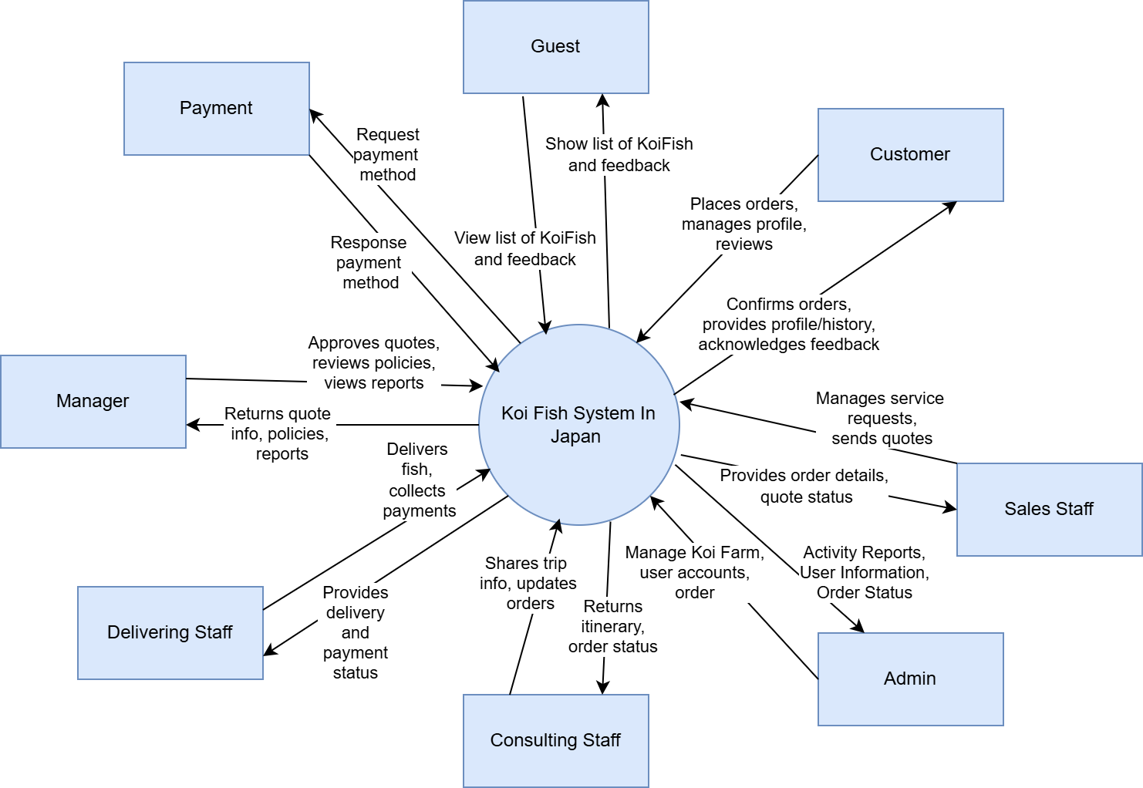

**Context diagram**

## 

## 

## 2. User Requirements

##### **2.1 System Actors**

The actors involved in the system include:

| # | Actor | Description |
| --- | --- | --- |
| 1 | Guest | Views information about Koi farms and fish varieties on the homepage |
| 2 | Customer | Places orders, browses tour options, confirms, and pays for orders |
| 3 | Sales Staff | Finalises itineraries, sends quotes, and tracks order progress |
| 4 | Consulting Staff | Provides trip details, assists with customer check-ins, and updates orders |
| 5 | Delivering Staff | Delivers Koi fish to customers and collects remaining payments |
| 6 | Manager | Approves quotes, manages payment policies, and oversees reports |
| 7 | Admin | Manage Koi Farm Information, Manager user accounts, manage policies, generate reports |

##### **2.2 Use Cases**

**2.2.1 Diagram(s)**

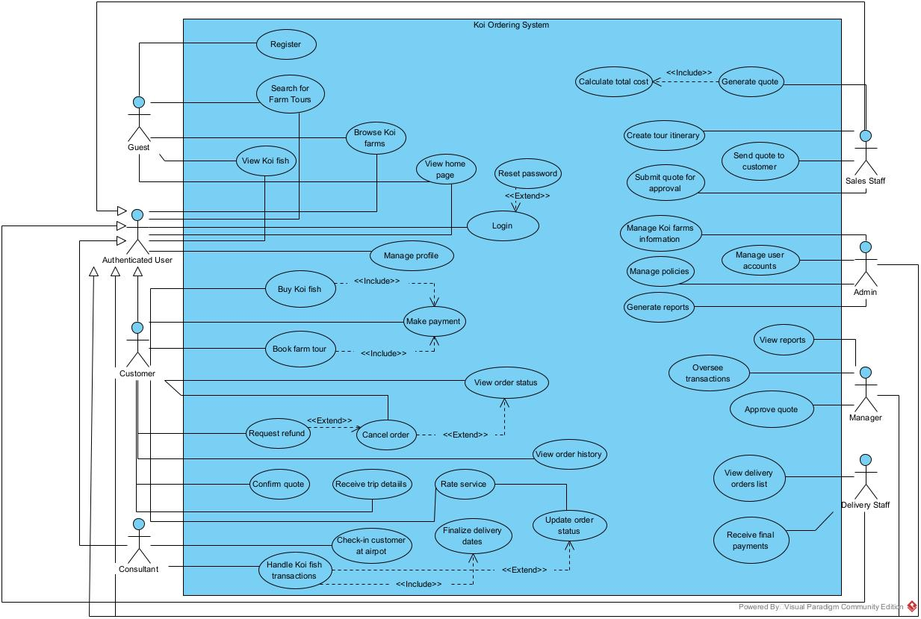

**2.2.2 Descriptions**

| **ID** | **Use Case** | **Actors** | **Description** |
| --- | --- | --- | --- |
| **UC-01** | Register | Guest | A guest can create an account on the system to become an authenticated user. |
| **UC-02** | Search for Farm Tours | Guest | A guest can search for Koi farm tours in Japan using criteria like farm location, Koi fish breed, price range, and duration. |
| **UC-03** | Browse Koi Farms | Guest | A guest can view information about different Koi farms and details about popular Koi fish breeds. |
| **UC-04** | View Koi Fish | Guest | A guest can access detailed information on various Koi fish types available in the system. |
| **UC-05** | View Home Page | Guest | The guest can access the homepage to explore options and basic information on Koi farms, tours, and available services. |
| **UC-06** | Login | Guest | Allows users to sign in to access additional system features. |
| **UC-07** | Forget Password | Authenticated User | Allows users to reset their password if they forget it. |
| **UC-08** | Manage Profile | Authenticated User | Users can update personal information, including contact details and preferences. |
| **UC-09** | Buy Koi Fish | Customer | Customers can purchase Koi Fish, including confirming quotes and making payments. |
| **UC-10** | Make Payment | Customer | Enables customers to make payments for their purchases. |
| **UC-11** | Book Farm Tour | Customer | Customers can book tours to visit Koi Farms. |
| **UC-12** | View Order Status | Customer | Customers can track the status of their fish orders or tour bookings. |
| **UC-13** | Cancel Order | Customer | Allows customers to cancel their orders if needed. |
| **UC-14** | Request Refund | Customer | Customers can request refunds for cancelled or unsatisfactory orders. |
| **UC-15** | View Order History | Customer | Customers can review their past orders and tour bookings. |
| **UC-16** | Confirm Quote | Customer | Customers can confirm the provided quote for purchases or tours. |
| **UC-17** | Receive Trip Details | Customer | Customers receive detailed information about their upcoming tours after booking. |
| **UC-18** | Rate Service | Customer | Customers can provide feedback or rate the services received. |
| **UC-19** | Update Order Status | Customer | Customers are informed when the status of their order or tour booking is updated. |
| **UC-20** | Check-in Customer at Airport | Consultant | Consultants assist customers with airport check-ins for their Koi farm tours. |
| **UC-21** | Handle Koi Fish Transactions | Consultant | Consultants manage the processes related to Koi fish purchases, including customer support. |
| **UC-22** | Generate Quote | Sales Staff | Generates a formal quote for the customer based on the total cost. |
| **UC-23** | Create Tour Itinerary | Sales Staff | Sales staff prepare detailed itineraries for booked tours. |
| **UC-24** | Submit Quote for Approval | Sales Staff | Sends the generated quote to the manager for approval. |
| **UC-25** | Send Quote to Customer | Sales Staff | After approval, the quote is sent to the customer for confirmation. |
| **UC-26** | Manage Koi Farms Information | Admin | Admins can update information on Koi farms, including farm details and available Koi fish breeds. |
| **UC-27** | Manage Policies | Admin | Admins can set and update policies regarding services, payments, and refunds. |
| **UC-28** | Manage User Accounts | Admin | Admins have the ability to add, update, and remove user accounts. |
| **UC-29** | Generate Reports | Admin | Admins can generate reports on system usage, sales, and other metrics. |
| **UC-30** | Oversee Transactions | Manager | Managers monitor transactions and customer interactions to ensure smooth operations. |
| **UC-31** | Approve Quote | Manager | Managers review and approve quotes created by the sales staff before sending them to customers. |
| **UC-32** | View Reports | Manager | Managers can access reports on sales, customer feedback, and system usage to aid in decision-making. |
| **UC-33** | View Delivery Orders List | Delivery Staff | Delivery staff can access a list of orders for delivery. |
| **UC-34** | Receive Final Payments | Delivery Staff | Delivery staff collect final payments from customers upon delivery. |
| **UC-35** | Update Order Status | Delivery Staff | Staff update the order status to reflect completed deliveries or changes. |

**2.2.3 Use Case Specification**

| **ID and Name:** | **UC-01 - Register** | | |
| --- | --- | --- | --- |
| **Created By:** | Nguyễn Huy Hoàng | **Date Created:** | 26/09/2024 |
| **Primary Actor:** | Guest | **Secondary Actors:** | None |
| **Description:** | The guest registers an account on the system by providing required information (e.g., username, password, email). Successful registration enables access to additional features of the Koi Ordering System. | | |
| **Trigger:** | The guest wants to access features available only to registered users. | | |
| **Preconditions:** | 1. The user must have internet access and be on the system’s registration page. | | |
| **Postconditions** | 1. The user is informed of successful registration and prompted to log in.  2. The user’s information is stored in the system database. | | |
| **Normal Flow:** | 1.The guest navigates to the registration page.  2.The system displays the registration form.  3.The guest fills out the form and submits it.  4.The system verifies the information and creates the account.  5.The system confirms successful registration and prompts the user to log in. | | |
| **Alternative Flow:** | **AF-01: Invalid Registration Details**  If the user provides incomplete or invalid information (e.g., an email in the wrong format), the system displays an error message, and the user is prompted to correct their inputs. | | |
| **Exceptions:** | - **E-01: Username Already Exists**  If the username is already in use, the system notifies the user and prompts them to choose a different username.  - **E-02: Technical Error**  If a system error occurs during registration, the system displays a message to try again later or contact support. | | |
| **Priority:** | High | | |
| **Frequency of Use:** | Frequent, as new users will register daily. | | |
| **Business Rules:** | **BR-01** | | |
| **Other Information:** | - Ensure the system encrypts stored passwords and protects user data.  - Monitor registrations to identify unusual activity. | | |
| **Assumptions:** | Users are aware they need an account to access additional features. | | |

| **ID and Name:** | **UC-02 - Search for Farm Tours** | | |
| --- | --- | --- | --- |
| **Created By:** | Huỳnh Nguyễn Ngọc Nguyên | **Date Created:** | 26/09/2024 |
| **Primary Actor:** | Guest | **Secondary Actors:** | None |
| **Description:** | The guest searches for available Koi farm tours in Japan based on criteria like farm name, fish breed, price range, and duration | | |
| **Trigger:** | The guest wants to view available farm tours in Japan. | | |
| **Preconditions:** | 1. The guest is on the system's main page or search page. | | |
| **Postconditions** | 1. The system displays a list of farm tours that match the search criteria. | | |
| **Normal Flow:** | 1. The guest navigates to the search page for farm tours.  2. The system displays the search fields for criteria like farm name, fish breed, price range, and duration.  3. The guest enters their desired search criteria and submits the request.  4. The system retrieves and displays a list of tours that match the criteria. | | |
| **Alternative Flow:** | **AF-01: No Results Found**  If no tours match the criteria, the system displays a message and suggests similar tours. | | |
| **Exceptions:** | **E-01: Technical Error**  If there’s a technical issue, the system displays an error message and prompts the guest to try again later. | | |
| **Priority:** | Medium | | |
| **Frequency of Use:** | Frequent | | |
| **Business Rules:** | **BR-02** | | |
| **Other Information:** | The system should ensure quick retrieval of search results for a smooth user experience. | | |
| **Assumptions:** | Guests are aware of the available criteria for search. | | |

| **ID and Name:** | **UC-03 - Browse Koi Farms** | | |
| --- | --- | --- | --- |
| **Created By:** | Huỳnh Nguyễn Ngọc Nguyên | **Date Created:** | 26/09/2024 |
| **Primary Actor:** | Guest | **Secondary Actors:** | None |
| **Description:** | The guest browses information about Koi farms on the system and views details of famous Koi breeds. | | |
| **Trigger:** | The guest wants to learn more about Koi farms and Koi fish breeds. | | |
| **Preconditions:** | 1. The guest is on the main page or the Koi farm listing page. | | |
| **Postconditions** | 1. The system displays information about various Koi farms and breeds. | | |
| **Normal Flow:** | 1. The guest navigates to the Koi farms page.  2. The system displays a list of Koi farms and their general information.  3. The guest selects a farm to view detailed information about it, including famous Koi breeds available there. | | |
| **Alternative Flow:** | **AF-01: No Farms Available**  If no farms are available, the system displays a message and offers a link to return to the home page. | | |
| **Exceptions:** | **E-01: Technical Error**  If there’s a technical issue, the system displays an error message and prompts the guest to try again later. | | |
| **Priority:** | High | | |
| **Frequency of Use:** | Frequent | | |
| **Business Rules:** | **BR-03** | | |
| **Other Information:** | Information on Koi farms should be accurate and regularly updated. | | |
| **Assumptions:** | The guest is interested in browsing the available farms without specific search criteria. | | |

| **ID and Name:** | **UC-04 - View Koi Fish Details** | | |
| --- | --- | --- | --- |
| **Created By:** | Huỳnh Nguyễn Ngọc Nguyên | **Date Created:** | 27/09/2024 |
| **Primary Actor:** | Guest | **Secondary Actors:** | None |
| **Description:** | The actor views detailed information about various Koi fish breeds available at different farms. | | |
| **Trigger:** | The guest wants to learn about specific Koi fish breeds. | | |
| **Preconditions:** | 1. The guest is on the Koi fish listing page or farm details page. | | |
| **Postconditions** | 1. The system displays detailed information about the selected Koi fish breed. | | |
| **Normal Flow:** | 1. The guest selects a Koi fish breed to view.  2. The system displays detailed information, including pictures, size, age, and price of the Koi fish breed. | | |
| **Alternative Flow:** | **AF-01: No Information Available**  If no details are available for the selected Koi fish, the system displays an appropriate message. | | |
| **Exceptions:** | **E-01: Technical Error**  If there’s a technical issue, the system displays an error message and prompts the guest to try again later. | | |
| **Priority:** | High | | |
| **Frequency of Use:** | Frequent | | |
| **Business Rules:** | **BR-04** | | |
| **Other Information:** | The system should ensure that data on Koi fish is kept up-to-date. | | |
| **Assumptions:** | Guests want to see details of Koi fish breeds for informational purposes. | | |

| **ID and Name:** | **UC-05 - View Home Page** | | |
| --- | --- | --- | --- |
| **Created By:** | Huỳnh Nguyễn Ngọc Nguyên | **Date Created:** | 27/09/2024 |
| **Primary Actor:** | Guest | **Secondary Actors:** | None |
| **Description:** | Guests can access the homepage to explore information about Koi farms and popular Koi breeds. | | |
| **Trigger:** | The guest opens the website or navigates to the homepage. | | |
| **Preconditions:** | * The guest must have internet access. * The system is operational and accessible. | | |
| **Postconditions** | * The homepage is displayed, allowing the guest to browse general information. * The guest can view an overview of Koi farms, tour options, and available services. | | |
| **Normal Flow:** | * The guest visits the homepage. * The system displays information about various Koi farms and available breeds. | | |
| **Alternative Flow:** | **AF-01: Slow Loading Time**   * If the homepage loads slowly, a loading indicator is displayed until the page is fully accessible. | | |
| **Exceptions:** | **E-01: Page Not Available**   * If the homepage is inaccessible due to maintenance or other issues, the system displays an error message with options to retry or contact support. | | |
| **Priority:** | High | | |
| **Frequency of Use:** | Frequent, as all users initially interact with the homepage. | | |
| **Business Rules:** | **BR-05** | | |
| **Other Information:** | Ensure the homepage layout is intuitive, responsive, and provides easy navigation to key areas of interest. | | |
| **Assumptions:** | The guest is generally familiar with basic navigation on websites. | | |

| **ID and Name:** | **UC-06 - Login** | | |
| --- | --- | --- | --- |
| **Created By:** | Nguyễn Huy Hoàng | **Date Created:** | 27/09/2024 |
| **Primary Actor:** | Guest | **Secondary Actors:** | None |
| **Description:** | This use case allows registered users to log in to the system, enabling access to additional features restricted to authenticated users. | | |
| **Trigger:** | The user wants to access features that require login credentials. | | |
| **Preconditions:** | 1. The user must have a registered account with an email and password. | | |
| **Postconditions** | 1. The user is successfully logged in and granted access to additional features.  2. The system logs the user's login activity. | | |
| **Normal Flow:** | 1. The user navigates to the login page. 2. The system prompts for username and password. 3. The user enters their credentials and submits. 4. The system verifies the credentials and grants access. | | |
| **Alternative Flow:** | **AF-01: Incorrect Credentials**   * If the user enters an incorrect username or password, the system displays an error message, prompting them to retry with the correct credentials. | | |
| **Exceptions:** | **E-01: Account Locked**   * If the user has exceeded the maximum login attempts, the system locks the account and displays a message with instructions to unlock it or contact support.   **E-02: Technical Error**   * If a system error occurs during login, the system displays a message advising the user to try again later. | | |
| **Priority:** | High | | |
| **Frequency of Use:** | Frequent, as users will log in daily. | | |
| **Business Rules:** | **BR-06, BR-07** | | |
| **Other Information:** | Ensure the login process is efficient and user-friendly. | | |
| **Assumptions:** | Users understand the need for secure credentials and are familiar with standard login procedures. | | |

| **ID and Name:** | **UC-07 - Reset Password** | | |
| --- | --- | --- | --- |
| **Created By:** | Nguyễn Huy Hoàng | **Date Created:** | 28/09/2024 |
| **Primary Actor:** | Guest | **Secondary Actors:** | None |
| **Description:** | This use case allows users to reset their password if they forget it, helping them regain access to their account securely. | | |
| **Trigger:** | The user can't log in because they forgot their password. | | |
| **Preconditions:** | 1. The user needs to have an internet connection. 2. The user must have a registered account on the system. | | |
| **Postconditions** | 1. The user successfully resets their password. 2. The new password is securely updated in the system, allowing the user to log in with it. | | |
| **Normal Flow:** | 1. The user goes to the login page and clicks on the "Forgot Password?" link. 2. The system displays a form asking for the user's registered email address. 3. The user enters their email and submits the form. 4. The system verifies the email and sends a password reset link to the user's inbox. 5. The user checks their email and clicks on the reset link. 6. The system prompts the user to enter a new password. 7. The user types in their new password and confirms it before submitting. 8. The system updates the password and shows a success message. 9. The user is redirected to the login page to sign in with their new password. | | |
| **Alternative Flow:** | **AF-01: Email Not Found**   * If the user enters an email that's not associated with any account, the system shows an error message indicating that the email is not registered. | | |
| **Exceptions:** | **E-01: Email Delivery Failure**   * If the password reset email can’t be sent, the system displays a message advising the user to try again later or to contact support.   **E-02: Link Expired**   * If the user tries to use an expired password reset link, the system shows an error and prompts them to request a new link. | | |
| **Priority:** | Medium | | |
| **Frequency of Use:** | Occasional, as users may need to reset their passwords from time to time. | | |
| **Business Rules:** | **BR-08, BR-09** | | |
| **Other Information:** | 1. Ensure the password reset process is secure and doesn't expose user information.  2. Consider implementing two-factor authentication for added security during the reset process. | | |
| **Assumptions:** | Users are familiar with the concept of password resets and checking their email. | | |

| **ID and Name:** | **UC-08 - Manage Profile** | | |
| --- | --- | --- | --- |
| **Created By:** | Huỳnh Nguyễn Ngọc Nguyên | **Date Created:** | 29/09/2024 |
| **Primary Actor:** | Authenticated User | **Secondary Actors:** | None |
| **Description:** | Users can update their personal information, including contact details and preferences. | | |
| **Trigger:** | The user wants to update their profile information. | | |
| **Preconditions:** | 1. The user must be logged into their account.  2. The system must be functioning correctly. | | |
| **Postconditions** | 1. The user’s updated information is saved in the system.  2. The user receives confirmation that their profile has been successfully updated. | | |
| **Normal Flow:** | 1. The user navigates to their profile page. 2. The system displays current profile information. 3. The user makes desired changes and submits the updates. 4. The system saves the changes and confirms the update. | | |
| **Alternative Flow:** | **AF-01: Invalid Input**   * If the user enters invalid information (like an incorrectly formatted email), the system displays an error message, prompting the user to correct their input. | | |
| **Exceptions:** | **E-01: Update Failure**   * If there's an error while saving the changes (e.g., a technical issue), the system shows an error message and advises the user to try again later. | | |
| **Priority:** | Medium | | |
| **Frequency of Use:** | Occasional, as users may update their information periodically. | | |
| **Business Rules:** | **BR-10, BR-11** | | |
| **Other Information:** | Make sure the interface is user-friendly, with clear instructions for updating profile information. | | |
| **Assumptions:** | Users understand how to navigate their profile settings and are aware of the information they need to update. | | |

| **ID and Name:** | **UC-09 - Buy Koi Fish** | | |
| --- | --- | --- | --- |
| **Created By:** | Phan Trần Minh Trí | **Date Created:** | 30/09/2024 |
| **Primary Actor:** | Customer | **Secondary Actors:** | None |
| **Description:** | Customers can purchase Koi fish, including confirming quotes and making payments.The system provides a user-friendly interface to browse, select, and buy Koi fish while ensuring secure payment processing. | | |
| **Trigger:** | A customer decides to buy Koi fish. | | |
| **Preconditions:** | The customer has internet access.  The customer may need to be logged into their account or provide necessary information for the purchase.  The customer has a valid payment method available. | | |
| **Postconditions** | * The customer successfully completes their Koi fish purchase. * The system records the transaction and generates a purchase confirmation. * The customer receives a confirmation email with purchase details. | | |
| **Normal Flow:** | * The customer browses Koi fish available for purchase. * The system displays options with details (images, prices, sizes, colours, etc.). * The customer selects a Koi fish and requests a quote. * The system generates a quote and shows it to the customer, including any shipping costs or applicable taxes. * The customer reviews and confirms the order. * The customer enters payment information. * The system processes the payment and confirms the transaction. * The system sends a confirmation email to the customer with order details and estimated delivery date. | | |
| **Alternative Flow:** | **AF-01: Quote Discrepancy**   * If the customer notices an issue with the quote (like incorrect pricing), they can contact support for clarification before proceeding. The customer may choose to modify their order based on feedback. | | |
| **Exceptions:** | **E-01: Payment Failure**   * If the payment cannot be processed (due to insufficient funds, incorrect card details, etc.), the system notifies the customer and prompts them to try again or choose a different payment method.   **E-02: Technical Error**   * If a technical error occurs during the purchasing process, the system displays a message advising the customer to try again later or contact support.   **E-03: Stock Unavailability**   * If the selected Koi fish is no longer in stock after the quote is generated, the system informs the customer and offers alternative options or the ability to wait for restocking. | | |
| **Priority:** | High | | |
| **Frequency of Use:** | Frequent, as customers may purchase Koi fish regularly. | | |
| **Business Rules:** | **BR-12, BR-13, BR-14** | | |
| **Other Information:** | Ensure a user-friendly interface for selecting and purchasing Koi fish, with clear instructions throughout the process. | | |
| **Assumptions:** | * Customers are familiar with online purchasing processes and have the necessary payment methods ready. * Customers are aware of the care requirements for Koi fish and are making informed purchasing decisions. | | |

| **ID and Name:** | **UC-10 - Make Payment** | | |
| --- | --- | --- | --- |
| **Created By:** | Phan Trần Minh Trí | **Date Created:** | 01/10/2024 |
| **Primary Actor:** | Customer | **Secondary Actors:** | None |
| **Description:** | Customers can make payments for their purchases using Payos linked to MBBank. | | |
| **Trigger:** | The customer is ready to proceed with their order and complete the payment process. | | |
| **Preconditions:** | 1.The customer must be logged into their account or have access to the necessary order details.  2.The customer has selected items they wish to purchase. | | |
| **Postconditions** | 1.The payment is successfully processed through Payos, and the customer receives confirmation.  2.The transaction details are recorded in the system. | | |
| **Normal Flow:** | 1. The customer navigates to the checkout page. 2. The system displays the order summary. 3. The customer selects Payos as the payment method. 4. The customer enters their MBBank payment details. 5. The system processes the payment. 6. The customer receives a confirmation of the payment. | | |
| **Alternative Flow:** | **AF-01: Payment Declined**   * If the payment is declined (e.g., insufficient funds or an issue with the MBBank account), the system alerts the customer and provides options to retry or select a different payment method. | | |
| **Exceptions:** | **E-01: Technical Issues**   * If a technical error occurs during the payment process, the system displays an error message, suggesting the customer try again later. | | |
| **Priority:** | High | | |
| **Frequency of Use:** | Frequent | | |
| **Business Rules:** | **BR-15, BR-16** | | |
| **Other Information:** | * Ensure that the integration with Payos and MBBank provides a smooth and user-friendly experience. * Consider providing clear instructions for customers on how to use Payos with their MBBank accounts. | | |
| **Assumptions:** | Customers are comfortable with using Payos for payments and have valid MBBank account information available. | | |

| **ID and Name:** | **UC-11 - Book Farm Tour** | | |
| --- | --- | --- | --- |
| **Created By:** | Phan Trần Minh Trí | **Date Created:** | 01/10/2024 |
| **Primary Actor:** | Customer | **Secondary Actors:** | None |
| **Description:** | This use case enables customers to book tours to visit Koi farms, allowing them to explore the facilities and learn more about Koi fish. | | |
| **Trigger:** | The customer expresses interest in visiting a Koi farm for a tour. | | |
| **Preconditions:** | 1.The customer must have internet access.  2.The customer has to be authorised to book a tour. | | |
| **Postconditions** | 1.The tour is successfully booked, and the customer receives confirmation details.  2.The booking information is recorded in the system for reference. | | |
| **Normal Flow:** | 1.The customer navigates to the farm tour booking section on the website.  2.The system displays available tours, including dates, times, and any special activities.  3.The customer selects their desired tour and date.  4.The system prompts the customer to enter their details (e.g., name, contact information).  5.The customer reviews the booking information and submits the request.  6.The system confirms the availability of the selected tour.  7.The customer receives a confirmation message with tour details, including any necessary instructions. | | |
| **Alternative Flow:** | **AF-01: Tour Fully Booked**   * If the selected tour is fully booked, the system notifies the customer and offers alternative dates or tours. | | |
| **Exceptions:** | **E-01: Booking Error**   * If a technical issue occurs during the booking process, the system displays an error message and suggests the customer try again later. | | |
| **Priority:** | High | | |
| **Frequency of Use:** | Moderate | | |
| **Business Rules:** | **BR-17, BR-18** | | |
| **Other Information:** | 1.Ensure the booking interface is user-friendly, with clear navigation and instructions for customers.  2.Consider offering additional options, such as guided tours or group discounts. | | |
| **Assumptions:** | Customers are interested in learning about Koi fish and are familiar with the booking process for tours. | | |

| **ID and Name:** | **UC-12-View Order Status** | | |
| --- | --- | --- | --- |
| **Created By:** | Phan Trần Minh Trí | **Date Created:** | 01/10/2024 |
| **Primary Actor:** | Customer | **Secondary Actors:** | None |
| **Description:** | Customers can track the status of their fish orders or tour bookings. | | |
| **Trigger:** | The customer wants to check the current status of their order or booking. | | |
| **Preconditions:** | 1.The customer must be logged into their account or have access to their order or booking details. | | |
| **Postconditions** | 1.The customer receives the current status of their order or booking.  2.The system logs the request for status tracking to the actor | | |
| **Normal Flow:** | 1.The customer navigates to the order status page.  2.The system displays a list of the customer’s past and current orders/bookings.  3.The customer selects the specific order or booking they want to check.  4.The system retrieves and displays the current status and relevant details (e.g., processing, shipped, completed). | | |
| **Alternative Flow:** | **AF-01: No Orders Found**   * If the customer has no current or past orders/bookings, the system displays a message indicating that no orders are found. | | |
| **Exceptions:** | **E-01: Technical Issues**   * If a technical error occurs while retrieving order status, the system displays an error message, suggesting the customer try again later. | | |
| **Priority:** | Medium | | |
| **Frequency of Use:** | Frequent | | |
| **Business Rules:** | **BR-19, BR-20** | | |
| **Other Information:** | 1. Ensure that the user interface for viewing order status is intuitive and easy to navigate.  2. Consider including estimated delivery dates or next steps for the customer’s orders or bookings. | | |
| **Assumptions:** | Customers are familiar with how to navigate the order status page and understand the various order statuses. | | |

| **ID and Name:** | **UC-13-Cancel Koi Order** | | |
| --- | --- | --- | --- |
| **Created By:** | Phan Trần Minh Trí | **Date Created:** | 01/10/2024 |
| **Primary Actor:** | Customer | **Secondary Actors:** | None |
| **Description:** | Allows customers to cancel their orders if needed. | | |
| **Trigger:** | The customer decides to cancel an order they have placed. | | |
| **Preconditions:** | 1.The customer must be logged into their account.  2.The order they wish to cancel must be within the allowed cancellation period. | | |
| **Postconditions** | 1.The order is successfully cancelled.  2.The customer receives confirmation of the cancellation.  3.Any applicable refunds are processed according to the store’s policies. | | |
| **Normal Flow:** | 1.The customer navigates to the order history page.  2.The system displays a list of the customer’s past and current orders.  3.The customer selects the order they wish to cancel.  4.The system displays order details and a cancellation option.  5.The customer confirms the cancellation.  6.The system processes the cancellation and updates the order status.  7.The customer receives confirmation of the cancelled order. | | |
| **Alternative Flow:** | **AF-01: Cancellation Not Allowed**   * If the order cannot be cancelled (e.g., it has already been shipped or is outside the cancellation period), the system informs the customer and provides the reasons. | | |
| **Exceptions:** | **E-01: Technical Issues**   * If a technical error occurs during the cancellation process, the system displays an error message, suggesting the customer try again later. | | |
| **Priority:** | Medium | | |
| **Frequency of Use:** | Moderate | | |
| **Business Rules:** | **BR-21,BR-22** | | |
| **Other Information:** | 1.Ensure that the cancellation process is straightforward and user-friendly.  2.Consider providing clear information on the cancellation policy and the expected time for refunds. | | |
| **Assumptions:** | Customers understand the cancellation policy and are aware of the time limits for cancelling orders. | | |

| **ID and Name:** | **UC-14-Request Refund** | | |
| --- | --- | --- | --- |
| **Created By:** | Phan Trần Minh Trí | **Date Created:** | 01/10/2024 |
| **Primary Actor:** | Customer | **Secondary Actors:** | None |
| **Description:** | Customers can request refunds for cancelled or unsatisfactory orders. | | |
| **Trigger:** | The customer has cancelled an order or received a product that did not meet their expectations. | | |
| **Preconditions:** | * The customer must be logged into their account. * The order for which the refund is requested must be eligible for a refund according to the store’s policy. | | |
| **Postconditions** | * The refund request is successfully submitted. * The customer receives confirmation of the refund request. * The system processes the refund according to the established policies. | | |
| **Normal Flow:** | 1. The customer navigates to the order history or refund request page. 2. The system displays a list of the customer’s past orders. 3. The customer selects the order they wish to request a refund for. 4. The system displays order details and a refund request option. 5. The customer provides a reason for the refund and submits the request. 6. The system processes the refund request and updates the order status. 7. The customer receives confirmation of the refund request and information about the next steps. | | |
| **Alternative Flow:** | **AF-01: Refund Not Eligible**   * If the order is not eligible for a refund (e.g., outside the return period or non-refundable items), the system informs the customer and provides the reasons. | | |
| **Exceptions:** | E-01: Technical Issues   * If a technical error occurs while submitting the refund request, the system displays an error message, suggesting the customer try again later. | | |
| **Priority:** | High | | |
| **Frequency of Use:** | Moderate | | |
| **Business Rules:** | **BR-23, BR-24** | | |
| **Other Information:** | * Ensure that the refund request process is clear and straightforward for customers. * Consider providing detailed information on the refund policy, including eligible items and processing times. | | |
| **Assumptions:** | Customers are familiar with the refund process and understand the eligibility criteria for requesting refunds. | | |

| **ID and Name:** | **UC-15-View Order History** | | |
| --- | --- | --- | --- |
| **Created By:** | Phan Trần Minh Trí | **Date Created:** | 02/10/2024 |
| **Primary Actor:** | Customer | **Secondary Actors:** | None |
| **Description:** | Customers can review their past orders and tour bookings. | | |
| **Trigger:** | The customer wants to check their previous purchases or bookings. | | |
| **Preconditions:** | 1.The customer must be logged into their account. | | |
| **Postconditions** | 1.The customer successfully views a list of their past orders and tour bookings.  2.The system logs the request for order history retrieval. | | |
| **Normal Flow:** | 1.The customer navigates to the order history page.  2.The system displays a list of the customer’s past orders and tour bookings, including relevant details (e.g., order date, items, status).  3.The customer selects a specific order or booking for more details.  4.The system displays detailed information about the selected order or booking. | | |
| **Alternative Flow:** | **AF-01: No Order History Found**   * If the customer has no past orders or bookings, the system displays a message indicating that no history is available. | | |
| **Exceptions:** | **E-01: Technical Issues**   * If a technical error occurs while retrieving order history, the system displays an error message, suggesting the customer try again later. | | |
| **Priority:** | Medium | | |
| **Frequency of Use:** | Frequent | | |
| **Business Rules:** | **BR-25, BR-26** | | |
| **Other Information:** | * Ensure that the order history page is user-friendly and easy to navigate. * Consider including options for customers to sort or filter their order history for easier review. | | |
| **Assumptions:** | Customers understand how to access and interpret their order history. | | |

| **ID and Name:** | **UC-16-Confirm Quote** | | |
| --- | --- | --- | --- |
| **Created By:** | Phan Trần Minh Trí | **Date Created:** | 02/10/2024 |
| **Primary Actor:** | Customer | **Secondary Actors:** | None |
| **Description:** | Customers can confirm the provided quote for purchases or tours. | | |
| **Trigger:** | The customer receives a quote for their desired purchase or tour and decides to confirm it. | | |
| **Preconditions:** | 1.The customer must be logged into their account or have access to the quote.  2.A valid quote must have been provided to the customer. | | |
| **Postconditions** | 1.The quote is successfully confirmed by the customer.  2.The system updates the order status to reflect the confirmation.  3.The customer receives confirmation of the quote acceptance. | | |
| **Normal Flow:** | 1.The customer receives a quote for a product or tour.  2.The customer reviews the quote details, including prices, terms, and conditions.  3.The customer navigates to the quote confirmation page.  4.The customer selects the option to confirm the quote.  5.The system processes the confirmation and updates the order status.  6.The customer receives a confirmation message or email regarding the accepted quote. | | |
| **Alternative Flow:** | **AF-01: Quote Expired**   * If the quote has expired, the system informs the customer that the quote is no longer valid and provides options to request a new quote. | | |
| **Exceptions:** | **E-01: Technical Issues**   * If a technical error occurs during the quote confirmation process, the system displays an error message, suggesting the customer try again later. | | |
| **Priority:** | High | | |
| **Frequency of Use:** | Moderate | | |
| **Business Rules:** | **BR-27, BR-28** | | |
| **Other Information:** | * Ensure that the quote confirmation process is clear and user-friendly. * Consider providing additional information on what happens after the quote is confirmed, such as payment options or next steps. | | |
| **Assumptions:** | Customers are familiar with the quoting process and understand the terms associated with the quote. | | |

| **ID and Name:** | **UC-17-Receive Trip Details** | | |
| --- | --- | --- | --- |
| **Created By:** | Phan Trần Minh Trí | **Date Created:** | 02/10/2024 |
| **Primary Actor:** | Customer | **Secondary Actors:** | None |
| **Description:** | Customers receive detailed information about their upcoming tour(s) after booking. | | |
| **Trigger:** | The customer completes a tour booking and expects to receive detailed trip information. | | |
| **Preconditions:** | * The customer must be logged into their account or have completed a tour booking. * The booking must be confirmed and processed by the system. | | |
| **Postconditions** | * The customer receives detailed trip information, including itinerary, meeting points, and any special instructions. * The system logs the delivery of trip details. | | |
| **Normal Flow:** | The customer completes the booking for a tour.  The system processes the booking and prepares trip details.  The customer receives an email or notification containing detailed information about the upcoming tour, including:   * Itinerary * Meeting point and time * Contact information for the tour guide * Cancellation and refund policies   The customer can access the trip details through their account on the website or app. | | |
| **Alternative Flow:** | **AF-01: Trip Details Not Received**   * If the customer does not receive the trip details within a specified time frame, they can navigate to their account to manually retrieve the information or contact customer support. | | |
| **Exceptions:** | **E-01: Technical Issues**   * If a technical error occurs while sending the trip details, the system displays an error message, suggesting the customer try again later. | | |
| **Priority:** | High | | |
| **Frequency of Use:** | Frequent | | |
| **Business Rules:** | **BR-29, BR-30** | | |
| **Other Information:** | * Ensure that the trip details are comprehensive and easy to understand. * Consider providing links to additional resources, such as FAQs or packing lists, that may be helpful for the customer. | | |
| **Assumptions:** | Customers expect to receive timely and accurate trip details after booking. | | |

| **ID and Name:** | **UC-18-Rate Service** | | |
| --- | --- | --- | --- |
| **Created By:** | Phan Trần Minh Trí | **Date Created:** | 03/10/2024 |
| **Primary Actor:** | Customer | **Secondary Actors:** | None |
| **Description:** | Customers can provide feedback or rate the services received after completing their tour or purchase. | | |
| **Trigger:** | The customer completes a service (e.g., tour, product delivery) and wishes to provide feedback or a rating | | |
| **Preconditions:** | * The customer must be logged into their account or have received a service. * The service must have been completed to enable rating and feedback. | | |
| **Postconditions** | * The customer's feedback and rating are successfully submitted and recorded in the system. * The customer receives confirmation that their feedback has been received. | | |
| **Normal Flow:** | 1.The customer navigates to the feedback or rating page after completing a service.  2.The system displays options for rating the service (e.g., star ratings, thumbs up/down).  3.The customer selects a rating and provides additional comments or feedback.  4.The customer submits the feedback.  5.The system processes the feedback and records it.  6.The customer receives a confirmation message indicating that their feedback has been successfully submitted. | | |
| **Alternative Flow:** | **AF-01: No Feedback Provided**   * If the customer chooses not to provide feedback, they can skip this step, and the system will return them to the previous page. | | |
| **Exceptions:** | **E-01: Technical Issues**   * If a technical error occurs during the feedback submission process, the system displays an error message, suggesting the customer try again later. | | |
| **Priority:** | Medium | | |
| **Frequency of Use:** | Moderate | | |
| **Business Rules:** | **BR-31, BR-32** | | |
| **Other Information:** | * Ensure that the feedback submission process is user-friendly and straightforward. * Consider including prompts or questions to guide customers in providing constructive feedback. | | |
| **Assumptions:** | Customers are encouraged to provide feedback and feel comfortable sharing their experiences. | | |

| **ID and Name:** | **UC-19-Update Order Status** | | |
| --- | --- | --- | --- |
| **Created By:** | Phan Trần Minh Trí | **Date Created:** | 03/10/2024 |
| **Primary Actor:** | Customer | **Secondary Actors:** | None |
| **Description:** | Customers are informed when the status of their order or tour booking is updated. | | |
| **Trigger:** | The status of the customer’s order or tour booking changes (e.g., processing, shipped, completed, cancelled). | | |
| **Preconditions:** | 1. The customer must have an active order or tour booking in the system. 2. The system must be able to track and update the status of orders or bookings. | | |
| **Postconditions:** | 1. The customer receives notification regarding the updated status of their order or booking. 2. The system logs the notification sent to the customer. | | |
| **Normal Flow:** | The system updates the status of an order or tour booking based on processing events (e.g., shipment, confirmation of attendance).  The system triggers a notification to the customer, which may include:   * Status change details * Estimated delivery dates or next steps * Any relevant actions the customer may need to take   The customer receives the notification via their preferred method (e.g., email, SMS, app notification). | | |
| **Alternative Flow:** | **AF-01: Notification Delivery Failed**   * If the notification fails to deliver (e.g., due to incorrect contact information), the system logs the error and attempts to resend the notification later. | | |
| **Exceptions:** | **E-01: Technical Issues**   * If a technical error occurs while updating the status or sending notifications, the system displays an error message, suggesting the customer try again later. | | |
| **Priority:** | Medium | | |
| **Frequency of Use:** | Frequent | | |
| **Business Rules:** | **BR-33, BR-34** | | |
| **Other Information:** | * Ensure that the notification system is reliable and provides clear, concise information about the status changes. * Consider including links for customers to view detailed information about their orders or bookings directly from the notification. | | |
| **Assumptions:** | Customers expect timely updates regarding their order or booking status and are familiar with the notification methods available. | | |

| **ID and Name:** | **UC-20-Check-in Customer at Airport** | | |
| --- | --- | --- | --- |
| **Created By:** | Huỳnh Nguyễn Ngọc Nguyên | **Date Created:** | 04/10/2024 |
| **Primary Actor:** | Consultant | **Secondary Actors:** | Customer |
| **Description:** | Consultants assist customers with airport check-ins for their Koi farm tours. | | |
| **Trigger:** | The customer arrives at the airport for their scheduled Koi farm tour. | | |
| **Preconditions:** | 1.The customer must have a confirmed booking for the Koi farm tour.  2.The consultant must have access to the customer’s booking information. | | |
| **Postconditions** | 1.The customer is successfully checked in for their flight.  2.The system logs the check-in details and confirms the customer’s boarding status. | | |
| **Normal Flow:** | 1.The customer arrives at the airport and approaches the consultant.  2.The consultant verifies the customer’s booking details and identification.  3.The consultant assists the customer with the check-in process, which may include:   * Completing any necessary forms or documentation * Providing boarding passes * Informing the customer about flight details and next steps   4.The consultant confirms the customer’s check-in status and provides any additional assistance as needed (e.g., baggage handling, security procedures).  5.The customer receives confirmation of their check-in and boarding information. | | |
| **Alternative Flow:** | **AF-01: Booking Not Found**   * If the consultant cannot find the customer’s booking, they inform the customer and check for potential issues, such as a missed payment or incorrect booking details. | | |
| **Exceptions:** | **E-01: Technical Issues**   * If a technical error occurs during the check-in process, the consultant displays an error message and provides alternative solutions (e.g., contacting customer service). | | |
| **Priority:** | High | | |
| **Frequency of Use:** | Frequent | | |
| **Business Rules:** | **BR-35, BR-36** | | |
| **Other Information:** | * Ensure that the consultant is well-trained in the check-in process and familiar with the airline policies. * Consider providing customers with a checklist of items to prepare for their airport check-in. | | |
| **Assumptions:** | Customers expect a seamless check-in experience and are aware of the necessary documentation required for their tour. | | |

| **ID and Name:** | **UC-21-Handle Koi Fish Transactions** | | |
| --- | --- | --- | --- |
| **Created By:** | Huỳnh Nguyễn Ngọc Nguyên | **Date Created:** | 03/10/2024 |
| **Primary Actor:** | Consultant | **Secondary Actors:** | Customer |
| **Description:** | Consultants manage the processes related to Koi fish purchases, including customer support. | | |
| **Trigger:** | A customer expresses interest in purchasing Koi fish or requires assistance with an existing transaction. | | |
| **Preconditions:** | 1.The customer must have access to Koi fish inventory or previous transaction records.  2.The consultant must be trained in Koi fish care and the purchasing process. | | |
| **Postconditions** | 1.The transaction is successfully processed, and the customer receives confirmation of their purchase.  2.The system updates the inventory and logs transaction details.  3.The customer receives support related to Koi fish care or transaction inquiries. | | |
| **Normal Flow:** | 1.The customer approaches the consultant with a request to purchase Koi fish or ask for support.  2.The consultant verifies the customer’s request and accesses the Koi fish inventory.  3.The consultant provides information about available Koi fish, including pricing, care instructions, and selection options.  4.The customer selects the Koi fish they wish to purchase.  5.The consultant processes the transaction, which may include:   * Completing purchase forms * Processing payment through the designated method * Scheduling delivery or pick-up   6.The system updates the inventory and logs the transaction details.  7.The customer receives confirmation of their purchase, including any relevant care instructions and contact information for further support. | | |
| **Alternative Flow:** | **AF-01: Transaction Declined**   * If the transaction cannot be completed (e.g., payment issues or insufficient stock), the consultant informs the customer of the issue and suggests alternatives. | | |
| **Exceptions:** | **E-01: Technical Issues**   * If a technical error occurs during the transaction process, the consultant displays an error message and provides alternative solutions (e.g., manual processing of the order). | | |
| **Priority:** | High | | |
| **Frequency of Use:** | Frequent | | |
| **Business Rules:** | **BR-37, BR-38** | | |
| **Other Information:** | * Ensure that consultants are knowledgeable about different Koi fish varieties and their care needs. * Consider implementing a customer feedback mechanism to improve transaction processes and support. | | |
| **Assumptions:** | Customers are interested in purchasing Koi fish and are seeking guidance on the process and care requirements. | | |

| **ID and Name:** | **UC-22-Generate Quote** | | |
| --- | --- | --- | --- |
| **Created By:** | Huỳnh Nguyễn Ngọc Nguyên | **Date Created:** | 04/10/2024 |
| **Primary Actor:** | Sales Staff | **Secondary Actors:** | Customer |
| **Description:** | Sales staff generate a formal quote for the customer based on the total cost of their order or tour. | | |
| **Trigger:** | The customer requests a formal quote for their selected items or tour package. | | |
| **Preconditions:** | 1. The customer must have discussed their order or tour details with the sales staff. 2. The total cost of the order or tour must have been calculated. | | |
| **Postconditions** | 1. A formal quote is generated and provided to the customer. 2. The system logs the quote details for future reference. | | |
| **Normal Flow:** | 1. The sales staff confirms the details of the customer’s order or tour package. 2. The sales staff inputs the total cost and any other relevant information into the quote generation system, including:  * Customer information (name, contact details) * Itemised list of products or services * Applicable discounts and taxes * Terms and conditions  1. The system generates a formal quote document, which may include:  * Quote number * Date of issue * Expiration date of the quote * Signature field for customer acceptance  1. The sales staff reviews the generated quote for accuracy. 2. The sales staff provides the quote to the customer, either digitally or in print. 3. The customer can review the quote and ask any questions before making a decision. | | |
| **Alternative Flow:** | **AF-01: Modifications Requested**   * If the customer requests changes to the order or tour details after the quote has been generated, the sales staff updates the quote accordingly and regenerates the document. | | |
| **Exceptions:** | **E-01: Technical Issues**   * If a technical error occurs during the quote generation process, the sales staff informs the customer and attempts to resolve the issue, possibly creating the quote manually if necessary. | | |
| **Priority:** | High | | |
| **Frequency of Use:** | Frequent | | |
| **Business Rules:** | **BR-39, BR-40** | | |
| **Other Information:** | * Ensure that the quote generation system is user-friendly and accessible to sales staff. * Consider implementing a follow-up mechanism to check with customers regarding the quotes provided. | | |
| **Assumptions:** | Customers expect timely and accurate quotes to assist them in their purchasing decisions. | | |

| **ID and Name:** | **UC-23-Create Tour Itinerary** | | |
| --- | --- | --- | --- |
| **Created By:** | Huỳnh Nguyễn Ngọc Nguyên | **Date Created:** | 04/10/2024 |
| **Primary Actor:** | Sales Staff | **Secondary Actors:** | Customer |
| **Description:** | Sales staff prepare detailed itineraries for booked tours, outlining all relevant information for customers. | | |
| **Trigger:** | A customer books a tour and requests a detailed itinerary. | | |
| **Preconditions:** | 1. The customer must have a confirmed booking for the tour. 2. The sales staff must have access to the tour details, including schedules, locations, and activities. | | |
| **Postconditions** | 1. A detailed tour itinerary is created and provided to the customer. 2. The system logs the itinerary details for future reference. | | |
| **Normal Flow:** | 1. The sales staff accesses the booking details for the customer's tour. 2. The sales staff compiles the relevant information, which may include:  * Tour schedule (dates and times for activities) * Locations and descriptions of attractions * Transportation details (pick-up and drop-off times, modes of transport) * Contact information for tour guides or coordinators * Recommended packing lists and tips for the tour  1. The sales staff formats the itinerary in a clear, organised manner. 2. The sales staff reviews the itinerary for accuracy and completeness. 3. The sales staff provides the completed itinerary to the customer, either digitally or in print. 4. The customer can review the itinerary and ask any questions or request modifications if necessary. | | |
| **Alternative Flow:** | **AF-01: Customer Requests Modifications**   * If the customer wishes to make changes to the itinerary (e.g., additional activities or altered schedules), the sales staff updates the itinerary accordingly and regenerates the document. | | |
| **Exceptions:** | **E-01: Information Not Available**   * If certain details (e.g., specific activity times) are not yet confirmed, the sales staff communicates this to the customer and provides an estimated itinerary, followed by updates once details are finalised.   **E-02: Technical Issues**   * If a technical error occurs while creating the itinerary, the sales staff informs the customer and may create the itinerary manually if necessary. | | |
| **Priority:** | High | | |
| **Frequency of Use:** | Frequent | | |
| **Business Rules:** | **BR-41, BR-42** | | |
| **Other Information:** | * Consider providing a checklist for the sales staff to ensure all necessary information is included in the itinerary. * Implement a mechanism for customer feedback on the itineraries provided to improve future offerings. | | |
| **Assumptions:** | Customers expect detailed itineraries that clearly outline their upcoming tours, helping them prepare effectively. | | |

| **ID and Name:** | **UC-24-Submit Quote for Approval** | | |
| --- | --- | --- | --- |
| **Created By:** | Huỳnh Nguyễn Ngọc Nguyên | **Date Created:** | 04/10/2024 |
| **Primary Actor:** | Sales Staff | **Secondary Actors:** | Manager |
| **Description:** | Sales staff submit the generated quote to the manager for approval before finalising it for the customer. | | |
| **Trigger:** | A quote has been prepared for a customer and requires managerial approval prior to being sent. | | |
| **Preconditions:** | * The quote must have been generated and reviewed by the sales staff. * The sales staff must have access to the manager's approval process. | | |
| **Postconditions** | * The quote is submitted to the manager for approval. * The system logs the submission details for tracking and reference. | | |
| **Normal Flow:** | 1. The sales staff prepares the quote and reviews it for accuracy. 2. The sales staff accesses the approval system or communication tool to submit the quote. 3. The sales staff enters or attaches the quote document along with any relevant notes for the manager. 4. The sales staff submits the quote for approval. 5. The manager receives a notification regarding the pending quote approval. 6. The manager reviews the quote and may provide feedback or ask for modifications if necessary. 7. Once approved, the manager communicates the approval back to the sales staff. | | |
| **Alternative Flow:** | **AF-01: Manager Requests Modifications**   * If the manager finds issues with the quote, they may request modifications, prompting the sales staff to update the quote accordingly and resubmit it for approval. | | |
| **Exceptions:** | **E-01: Submission Errors**   * If a technical error occurs while submitting the quote (e.g., system downtime), the sales staff informs the manager via an alternative method and attempts to resubmit later.   **E-02: Delayed Response**   * If the manager does not respond within a specified timeframe, the sales staff follows up to ensure the quote is reviewed. | | |
| **Priority:** | High | | |
| **Frequency of Use:** | Frequent | | |
| **Business Rules:** | **BR-43, BR-44** | | |
| **Other Information:** | * Consider implementing an automated tracking system for quote approvals to streamline the process and maintain transparency. * Ensure that both sales staff and managers are trained on the approval process and system functionalities. | | |
| **Assumptions:** | Sales staff and managers are familiar with the approval process and understand the importance of timely communication regarding quotes. | | |

| **ID and Name:** | **UC-25-Send Quote to Customer** | | |
| --- | --- | --- | --- |
| **Created By:** | Huỳnh Nguyễn Ngọc Nguyên | **Date Created:** | 04/10/2024 |
| **Primary Actor:** | Sales Staff | **Secondary Actors:** | Customer |
| **Description:** | After receiving managerial approval, the sales staff sends the generated quote to the customer for confirmation. | | |
| **Trigger:** | The quote has been approved by the manager and is ready to be sent to the customer. | | |
| **Preconditions:** | 1. The quote must have been approved by the manager. 2. The sales staff must have access to the customer’s contact information. | | |
| **Postconditions** | 1. The customer receives the approved quote for their review and confirmation. 2. The system logs the sending of the quote for tracking and reference. | | |
| **Normal Flow:** | 1. The sales staff retrieves the approved quote from the system. 2. The sales staff prepares an email or message to send to the customer, including:  * A brief introduction and context for the quote * The approved quote document attached or embedded in the message * Instructions on how to confirm the quote or next steps  1. The sales staff sends the quote to the customer. 2. The system sends a notification confirming that the quote has been sent. 3. The customer receives the quote and reviews it for accuracy. | | |
| **Alternative Flow:** | **AF-01: Customer Asks Questions**   * If the customer has questions or requests clarifications regarding the quote, the sales staff addresses these inquiries promptly. | | |
| **Exceptions:** | **E-01: Delivery Errors**   * If there are issues sending the quote (e.g., email delivery failure), the sales staff attempts to resend it or contact the customer through an alternative method.   **E-02: Technical Issues**   * If a technical error occurs during the process of sending the quote, the sales staff informs the customer and resolves the issue as soon as possible. | | |
| **Priority:** | High | | |
| **Frequency of Use:** | Frequent | | |
| **Business Rules:** | **BR-45, BR-46** | | |
| **Other Information:** | * Consider tracking customer responses to quotes to improve follow-up strategies and customer engagement. * Ensure that sales staff are trained in effective communication practices when sending quotes. | | |
| **Assumptions:** | Customers expect to receive timely and accurate quotes following approval and are prepared to confirm their interest. | | |

| **ID and Name:** | **UC-26-Manage Koi Farms Information** | | |
| --- | --- | --- | --- |
| **Created By:** | Bùi Bảo Khang | **Date Created:** | 05/10/2024 |
| **Primary Actor:** | Admin | **Secondary Actors:** | None |
| **Description:** | Admins can update information on Koi farms, including farm details and available Koi fish breeds, to ensure accurate and current data is available to customers and staff. | | |
| **Trigger:** | An admin identifies the need to update Koi farm information or receives a request for changes from staff or management. | | |
| **Preconditions:** | * The admin must have the appropriate permissions to access and modify Koi farm information. * Relevant data on Koi farms and breeds must be available for updates. | | |
| **Postconditions** | * Koi farm information is successfully updated in the system. * The system reflects the latest details regarding Koi fish breeds and farm operations. | | |
| **Normal Flow:** | 1. The admin logs into the management system. 2. The admin navigates to the Koi farms information section. 3. The admin reviews the existing details of Koi farms and available breeds. 4. The admin selects a specific farm or breed to update. 5. The admin modifies the necessary information, which may include:  * Farm location and contact details * Available Koi fish breeds and their characteristics * Breeding and care practices * Pricing information for Koi fish  1. The admin saves the changes in the system. 2. The system confirms that the updates have been successfully saved. 3. The admin may log any changes made for future reference. | | |
| **Alternative Flow:** | **AF-01: Cancel Updates**   * If the admin decides not to proceed with the changes, they can cancel the update, and no changes will be saved. | | |
| **Exceptions:** | **E-01: Unauthorised Access**   * If the admin attempts to access restricted areas without proper permissions, the system displays an error message and denies access.   **E-02: Technical Issues**   * If a technical error occurs during the update process, the admin is informed of the issue and can retry later. | | |
| **Priority:** | High | | |
| **Frequency of Use:** | Regular | | |
| **Business Rules:** | **BR-47, BR-48** | | |
| **Other Information:** | * Ensure that admins are trained on the system used for managing Koi farms to minimise errors during updates. * Consider implementing a notification system to alert relevant staff when Koi farm information has been updated. | | |
| **Assumptions:** | Admins have a clear understanding of the Koi farm operations and breeds to make informed updates. | | |

| **ID and Name:** | **UC-27-Manage Policies** | | |
| --- | --- | --- | --- |
| **Created By:** | Bùi Bảo Khang | **Date Created:** | 05/10/2024 |
| **Primary Actor:** | Admin | **Secondary Actors:** | None |
| **Description:** | Admins can set and update policies regarding services, payments, and refunds to ensure clarity and compliance with company standards. | | |
| **Trigger:** | The need arises to create or modify existing policies based on business requirements, customer feedback, or regulatory changes. | | |
| **Preconditions:** | 1. The admin must have appropriate permissions to access and modify policy documents. 2. Relevant information regarding current policies and changes must be available for review. | | |
| **Postconditions** | 1. Policies regarding services, payments, and refunds are successfully updated in the system. 2. The system reflects the latest policy information accessible to staff and customers. | | |
| **Normal Flow:** | 1. The admin logs into the management system. 2. The admin navigates to the policies management section. 3. The admin reviews existing policies related to services, payments, and refunds. 4. The admin selects a specific policy to update or chooses to create a new policy. 5. The admin modifies or enters the necessary policy information, which may include:  * Service terms and conditions * Payment processing guidelines * Refund request procedures and eligibility criteria  1. The admin saves the changes or newly created policy in the system. 2. The system confirms that the updates have been successfully saved. 3. The admin may notify relevant staff about the policy changes for awareness and implementation. | | |
| **Alternative Flow:** | **AF-01: Cancel Updates**   * If the admin decides not to proceed with the changes, they can cancel the update, and no changes will be saved. | | |
| **Exceptions:** | **E-01: Unauthorised Access**   * If the admin attempts to access or modify restricted policies without proper permissions, the system displays an error message and denies access.   **E-02: Technical Issues**   * If a technical error occurs during the update process, the admin is informed of the issue and can retry later. | | |
| **Priority:** | High | | |
| **Frequency of Use:** | Regular | | |
| **Business Rules:** | **BR-49, BR-50** | | |
| **Other Information:** | * Ensure that admins are trained on policy management to facilitate effective updates and maintain consistency. * Consider implementing a version control system for policies to track changes over time. | | |
| **Assumptions:** | Admins have a clear understanding of the operational and legal implications of the policies they are managing. | | |

| **ID and Name:** | **UC-28-Manage User Accounts** | | |
| --- | --- | --- | --- |
| **Created By:** | Bùi Bảo Khang | **Date Created:** | 05/10/2024 |
| **Primary Actor:** | Admin | **Secondary Actors:** | None |
| **Description:** | Admins have the ability to add, update, and remove user accounts to maintain control over access and permissions within the system. | | |
| **Trigger:** | The need arises to create new user accounts, update existing accounts, or deactivate accounts that are no longer needed. | | |
| **Preconditions:** | * The admin must have appropriate permissions to manage user accounts. * User account details (such as usernames, roles, and permissions) must be available for updates or deletions. | | |
| **Postconditions** | * User accounts are successfully added, updated, or removed from the system. * The system reflects the current status of user accounts and their permissions. | | |
| **Normal Flow:** | 1. The admin logs into the management system. 2. The admin navigates to the user accounts management section. 3. The admin reviews the existing user accounts. 4. The admin selects an action to perform:  * Add User Account:   + The admin inputs the new user’s details, including:     - Username     - Email address     - Role (e.g., Sales Staff, Consultant, Customer)     - Initial password   + The admin saves the new account, and the system sends a confirmation to the new user. * Update User Account:   + The admin selects a user account to update.   + The admin modifies the necessary details (e.g., role change, password reset).   + The admin saves the changes, and the system confirms the update. * Remove User Account:   + The admin selects a user account to remove.   + The admin confirms the deletion, and the system permanently removes the account.  1. The system logs all changes made for accountability. | | |
| **Alternative Flow:** | **AF-01: Cancel Action**   * If the admin decides not to proceed with an action (adding, updating, or removing an account), they can cancel, and no changes will be saved. | | |
| **Exceptions:** | **E-01: Unauthorised Access**   * If the admin attempts to manage user accounts without proper permissions, the system displays an error message and denies access.   **E-02: Input Errors**   * If there are errors in the input data (e.g., invalid email format), the system prompts the admin to correct the issues before proceeding. | | |
| **Priority:** | High | | |
| **Frequency of Use:** | Regular | | |
| **Business Rules:** | **BR-51, BR-52** | | |
| **Other Information:** | * Ensure that admins are trained on the user account management process to minimise errors and maintain system integrity. * Consider implementing notifications for users when their accounts are created, updated, or removed. | | |
| **Assumptions:** | Admins have a clear understanding of user roles and access levels within the system. | | |

| **ID and Name:** | **UC-29-Generate Reports** | | |
| --- | --- | --- | --- |
| **Created By:** | Bùi Bảo Khang | **Date Created:** | 10/10/2024 |
| **Primary Actor:** | Admin | **Secondary Actors:** | None |
| **Description:** | Admins can generate reports on system usage, sales, and other relevant metrics to analyse performance and make informed decisions. | | |
| **Trigger:** | The need arises to review system performance, sales data, or other metrics for analysis and decision-making. | | |
| **Preconditions:** | * The admin must have appropriate permissions to access reporting tools. * Relevant data must be available within the system for reporting. | | |
| **Postconditions** | * Reports are successfully generated based on specified criteria. * The generated reports can be reviewed, saved, or shared with relevant stakeholders. | | |
| **Normal Flow:** | 1. The admin logs into the management system. 2. The admin navigates to the reports generation section. 3. The admin selects the type of report to generate, which may include:  * System usage reports * Sales performance reports * Customer feedback reports * Koi farm inventory reports  1. The admin specifies the criteria for the report, such as:  * Date range * Specific metrics or KPIs to include * Filters (e.g., by user role, product category)  1. The admin submits the request to generate the report. 2. The system processes the request and compiles the data. 3. The admin receives the generated report, which may be in a downloadable format (e.g., PDF, Excel). 4. The admin reviews the report for accuracy and relevance. | | |
| **Alternative Flow:** | **AF-01: Modify Report Criteria**   * If the admin wants to adjust the report criteria before generating, they can modify the selection and resubmit the request. | | |
| **Exceptions:** | **E-01: Data Retrieval Errors**   * If there are issues retrieving data (e.g., system downtime), the admin is notified and may attempt to generate the report later.   **E-02: Input Errors**   * If the criteria specified are invalid (e.g., incorrect date range), the system prompts the admin to correct the issues before proceeding. | | |
| **Priority:** | High | | |
| **Frequency of Use:** | Regular | | |
| **Business Rules:** | **BR-53, BR-54** | | |
| **Other Information:** | Consider implementing templates for common report types to streamline the reporting process.  Ensure that admins are trained in data analysis and interpretation to effectively utilise the reports generated. | | |
| **Assumptions:** | Admins have a clear understanding of the metrics and data relevant to their reporting needs. | | |

| **ID and Name:** | **UC-30-Oversee Transactions** | | |
| --- | --- | --- | --- |
| **Created By:** | Bùi Bảo Khang | **Date Created:** | 10/10/2024 |
| **Primary Actor:** | Manager | **Secondary Actors:** | None |
| **Description:** | Managers monitor transactions and customer interactions to ensure smooth operations, identify potential issues, and maintain a high level of service quality. | | |
| **Trigger:** | A need arises for the manager to review transaction activity, customer interactions, or address operational concerns. | | |
| **Preconditions:** | * The manager must have access to transaction data and customer interaction records. * All transaction and interaction records are available and up-to-date in the system. | | |
| **Postconditions** | * Transactions and customer interactions are successfully monitored for quality assurance. * Any identified issues are addressed or flagged for further action. | | |
| **Normal Flow:** | 1. The manager logs into the management system. 2. The manager navigates to the transactions and interactions monitoring section. 3. The manager reviews recent transactions, including details such as:  * Transaction ID * Customer details * Payment method and amount * Status (e.g., completed, pending, failed)  1. The manager can also review specific customer interactions, such as:  * Customer service logs * Order histories * Feedback or complaints  1. If issues are identified, the manager can:  * Flag transactions for further review * Contact relevant staff for resolution * Update or annotate transaction records as needed  1. The manager saves any changes or annotations made to the records. | | |
| **Alternative Flow:** | **AF-01: Filter or Refine Data View**   * If the manager needs to refine the data view (e.g., filtering by transaction type or date), they can adjust the criteria before reviewing the records. | | |
| **Exceptions:** | **E-01: Unauthorised Access**   * If the manager attempts to access restricted transaction data without proper permissions, the system displays an error message and denies access.   **E-02: Data Load Issues**   * If transaction data fails to load due to system errors, the manager is notified and may retry later. | | |
| **Priority:** | High | | |
| **Frequency of Use:** | Frequent | | |
| **Business Rules:** | **BR-55, BR-56** | | |
| **Other Information:** | * Consider implementing automated alerts for unusual transaction patterns to assist managers in overseeing operations. * Ensure that managers are trained on transaction and customer interaction protocols for effective oversight. | | |
| **Assumptions:** | Managers understand transaction workflows and customer service standards to assess and address issues effectively. | | |

| **ID and Name:** | **UC-31-Approve Quote** | | |
| --- | --- | --- | --- |
| **Created By:** | Bùi Bảo Khang | **Date Created:** | 11/10/2024 |
| **Primary Actor:** | Manager | **Secondary Actors:** | None |
| **Description:** | Managers review and approve quotes created by the sales staff to ensure accuracy and alignment with pricing policies before sending them to customers. | | |
| **Trigger:** | A sales staff member submits a quote for managerial approval. | | |
| **Preconditions:** | * The manager must have access to the quote management system. * The quote must be completed by the sales staff and ready for review. | | |
| **Postconditions** | * The quote is either approved and marked as ready for customer distribution or sent back for revision. * The customer is notified upon approval and can review the quote. | | |
| **Normal Flow:** | 1. The manager logs into the quote management system. 2. The manager navigates to the pending quotes section. 3. The manager selects a quote submitted by sales staff for review. 4. The manager reviews the quote details, including:  * Itemised products or services listed * Pricing and discounts applied * Terms and conditions  1. The manager can either:  * Approve the Quote: If accurate and complete, the manager approves the quote, marking it ready to be sent to the customer. * Request Revisions: If changes are needed, the manager provides feedback and sends it back to the sales staff for adjustments.  1. The system logs the manager’s decision and updates the quote status. 2. If approved, the system sends a notification to the sales staff to proceed with sending the quote to the customer. | | |
| **Alternative Flow:** | **AF-01: Modify Approval Criteria**   * If the manager needs additional criteria (e.g., special discounts or additional terms) before approval, they can adjust or add these criteria before approving the quote. | | |
| **Exceptions:** | **E-01: Incomplete Information**   * If essential details are missing from the quote, the manager is notified, and the quote is sent back to sales staff for completion.   **E-02: System Errors**   * If the system encounters errors while accessing or updating the quote, the manager is notified to retry later. | | |
| **Priority:** | High | | |
| **Frequency of Use:** | Frequent | | |
| **Business Rules:** | **BR-57, BR-58** | | |
| **Other Information:** | * Ensure managers have training on company pricing guidelines and discount policies for effective quote approval. * Consider implementing automated reminders for managers to review pending quotes within a specified timeframe. | | |
| **Assumptions:** | Managers have a clear understanding of pricing structures, terms, and conditions to review quotes effectively | | |

| **ID and Name:** | **UC-32-View Reports** | | |
| --- | --- | --- | --- |
| **Created By:** | Bùi Bảo Khang | **Date Created:** | 11/10/2024 |
| **Primary Actor:** | Manager | **Secondary Actors:** | None |
| **Description:** | Managers can access and review reports on sales, customer feedback, and system usage to analyse performance and make informed business decisions. | | |
| **Trigger:** | A manager needs to review data on sales performance, customer satisfaction, or system usage to evaluate current strategies or operational needs. | | |
| **Preconditions:** | * The manager must have access permissions to view reports. * Relevant data for reporting (e.g., sales records, feedback logs) is updated and available in the system. | | |
| **Postconditions** | * The manager gains insights from reviewing the reports, supporting better decision-making. * Any identified trends or issues can be addressed or escalated as necessary. | | |
| **Normal Flow:** | 1. The manager logs into the reporting system. 2. The manager navigates to the reports section. 3. The manager selects the report type they wish to view, such as:  * Sales reports (e.g., daily, weekly, monthly) * Customer feedback summaries * System usage analytics  1. The manager applies any specific filters (e.g., date range, product category) to refine the report view. 2. The system retrieves and displays the relevant report data. 3. The manager reviews the data presented, which may include:  * Sales totals, trends, and performance comparisons * Summaries of customer feedback, including ratings and comments * User activity and engagement metrics  1. The manager can download or print the report if needed. | | |
| **Alternative Flow:** | **AF-01: Adjust Report Filters**   * If the manager needs to modify filters or criteria (e.g., change date range or focus on specific feedback types), they can adjust the settings and reload the report. | | |
| **Exceptions:** | **E-01: Insufficient Permissions**   * If the manager lacks the necessary permissions to view a specific report, the system displays an error message and restricts access.   **E-02: Data Loading Errors**   * If the system encounters an error retrieving the data, the manager is informed of the issue and may retry or seek assistance. | | |
| **Priority:** | Medium | | |
| **Frequency of Use:** | Regular | | |
| **Business Rules:** | **BR-59, BR-60** | | |
| **Other Information:** | * Consider implementing automated report summaries to help managers quickly identify key insights. * Ensure managers are trained in data interpretation to make effective use of the reports. | | |
| **Assumptions:** | Managers have a strong understanding of performance metrics and customer satisfaction indicators relevant to their decision-making needs. | | |

| **ID and Name:** | **UC-33-View Delivery Orders List** | | |
| --- | --- | --- | --- |
| **Created By:** | Bùi Bảo Khang | **Date Created:** | 12/10/2024 |
| **Primary Actor:** | Delivery Staff | **Secondary Actors:** | None |
| **Description:** | Delivery staff can access a list of orders assigned for delivery, allowing them to efficiently manage their deliveries. | | |
| **Trigger:** | A delivery staff member needs to check their list of scheduled deliveries. | | |
| **Preconditions:** | 1. The delivery staff must have access permissions to view delivery orders. 2. The system contains an updated list of orders assigned for delivery. | | |
| **Postconditions** | 1. Delivery staff can view the list of delivery orders and plan their routes accordingly. 2. Any updates made to the delivery status are saved in the system. | | |
| **Normal Flow:** | 1. The delivery staff logs into the delivery management system. 2. The delivery staff navigates to the "Delivery Orders" section. 3. The system displays a list of assigned delivery orders, which includes:  * Order ID * Customer details (e.g., name, address, contact information) * Delivery time and special instructions  1. The delivery staff reviews the list and can select individual orders for more detailed information if needed. 2. The delivery staff updates the status of each order as they proceed with deliveries (e.g., "Missed," "Completed"). 3. The system records status updates for tracking and customer notification. | | |
| **Alternative Flow:** | **AF-01: Filter Orders**   * If the delivery staff wants to view orders within a specific time frame or geographic area, they can apply filters to narrow down the list. | | |
| **Exceptions:** | **E-01: Access Issues**   * If the delivery staff lacks permissions to view the delivery list, the system displays an error message and restricts access.   **E-02: Data Sync Error**   * If there is a synchronisation issue and the delivery list doesn’t load properly, the delivery staff is notified and may retry later. | | |
| **Priority:** | Medium | | |
| **Frequency of Use:** | Frequent | | |
| **Business Rules:** | **BR-61, BR-62** | | |
| **Other Information:** | * Consider implementing route optimization features in the system to assist delivery staff with efficient delivery planning. * Ensure delivery staff are trained in using the system for timely status updates. | | |
| **Assumptions:** | Delivery staff are familiar with the order management system and can accurately update delivery statuses | | |

| **ID and Name:** | **UC-34-Receive Final Payments** | | |
| --- | --- | --- | --- |
| **Created By:** | Bùi Bảo Khang | **Date Created:** | 15/10/2024 |
| **Primary Actor:** | Delivery Staff | **Secondary Actors:** | Customer |
| **Description:** | Delivery staff collect final payments from customers upon delivering their orders, ensuring transaction completion before handing over the items. | | |
| **Trigger:** | The delivery staff arrives at the customer’s location and is required to collect the final payment to complete the order. | | |
| **Preconditions:** | * The customer has chosen a payment-on-delivery option for the order. * Delivery staff have the necessary tools to record the payment (e.g., mobile device or point-of-sale terminal). | | |
| **Postconditions** | * The final payment is successfully collected, and the transaction is marked as complete in the system. * The customer receives a confirmation of payment. | | |
| **Normal Flow:** | 1. The delivery staff arrives at the customer’s location with the order. 2. The delivery staff confirms the order details with the customer. 3. The customer provides the final payment using their preferred method (e.g., cash, card). 4. The delivery staff records the payment in the system, ensuring the amount matches the order total. 5. The system updates the order status to "Paid" and "Completed." 6. The customer receives a payment confirmation receipt (digital or physical). 7. The delivery staff hands over the order to the customer. | | |
| **Alternative Flow:** | **AF-01: Payment Adjustment Needed**   * If there is a discrepancy in the payment amount, the delivery staff clarifies with the customer and ensures the correct amount is collected before proceeding. | | |
| **Exceptions:** | **E-01: Payment Declined**   * If the customer’s payment method is declined (e.g., card transaction fails), the delivery staff informs the customer and provides options for retrying or using a different payment method.   **E-02: System Error**   * If there is a system error while recording the payment, the delivery staff may manually note the transaction details and update the system later. | | |
| **Priority:** | Medium | | |
| **Frequency of Use:** | Regular | | |
| **Business Rules:** | **BR-63, BR-64** | | |
| **Other Information:** | * Consider equipping delivery staff with mobile point-of-sale systems to facilitate card and digital payments. * Ensure delivery staff are trained in handling payment issues and customer queries. | | |
| **Assumptions:** | Delivery staff are familiar with the payment collection process and can troubleshoot common payment issues if they arise. | | |

| **ID and Name:** | **UC-35-Update Order Status** | | |
| --- | --- | --- | --- |
| **Created By:** | Bùi Bảo Khang | **Date Created:** | 12/10/2024 |
| **Primary Actor:** | Delivery Staff | **Secondary Actors:** | Customer |
| **Description:** | Delivery staff update the order status in the system to reflect completed deliveries or other relevant changes, ensuring accurate and real-time tracking of order fulfilment. | | |
| **Trigger:** | The delivery staff completes a delivery or needs to reflect a change in the order’s status. | | |
| **Preconditions:** | 1. Delivery staff must have access to the order management system.  2. The delivery status must be updated accurately to reflect the current state of the order (e.g., "Missed", "Completed"). | | |
| **Postconditions** | 1. The order status is successfully updated in the system. 2. The customer receives a notification (if applicable) reflecting the updated status of their order. | | |
| **Normal Flow:** | 1. The delivery staff logs into the order management system. 2. The delivery staff navigates to the specific order they wish to update. 3. The delivery staff selects the appropriate status to reflect the current state of the delivery, such as:  * "Missed" when starting the delivery * "Completed" once the delivery is completed * "Delivery Attempted" if the customer is unavailable to receive the order  1. The system records the status update and timestamps the change. 2. The system may trigger a notification to inform the customer of the updated status. | | |
| **Alternative Flow:** | **AF-01: Adjust Order Status Due to Delay**   * If the delivery is delayed, the delivery staff can select a status such as "Delayed" and provide additional notes if necessary. | | |
| **Exceptions:** | **E-01: System Access Error**   * If the delivery staff cannot access the order management system, they may log the status manually and update the system later.   **E-02: Incorrect Status Selection**   * If an incorrect status is accidentally selected, the delivery staff can correct it with supervisor approval or following a system protocol. | | |
| **Priority:** | High | | |
| **Frequency of Use:** | Frequent | | |
| **Business Rules:** | **BR-65, BR-66** | | |
| **Other Information:** | * Consider adding options for automated status updates to reduce manual entry and improve efficiency. * Ensure that customers are promptly notified of major status changes (e.g., "Missed," "Completed"). | | |
| **Assumptions:** | Delivery staff understand the importance of timely and accurate status updates for customer satisfaction. | | |

## 3. Functional Requirements

### 3.1 System Functional Overview

##### **3.1.1 Screen Flow**

The Koi Ordering System in Japan includes essential screens for both users and Koi fish farms, designed to streamline the ordering experience for customers purchasing Koi fish in Japan.

* **User Screens:**
  + **Login**: Provides secure user authentication.
  + **Forgot Password**: Allows users to reset their password if forgotten.
  + **Change Password**: Accessible through the "Forgot Password" process, enabling secure password updates.
  + **Log Out**: Users can log out from the *Account Information* screen.
  + **Home Page**:
    - **Account Information**: Accessible via the "Account" icon, where users can view and update their profile details.
    - **Koi Fish List**: Displays a list of available Koi fish with clickable details for each fish.
    - **Farm List**: Shows a list of Koi farms, each with further details available upon selection.
    - **Order History**: Allows users to view past orders with options to view detailed information for each order.
    - **Trips (Confirmed Schedule)**: Displays confirmed trip schedules, allowing users to review itinerary details related to farm visits and orders.

**KoiFish Screens :**

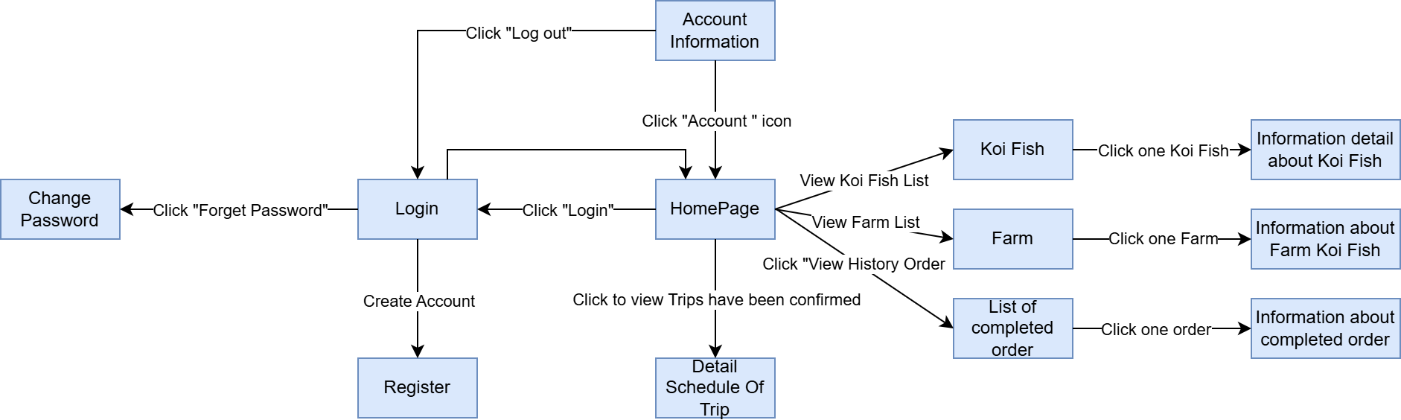

##### **3.1.2 Screen Descriptions**

**User Screens:**

* **Login:** Allows registered users to enter their credentials and access the system.
* **Forgot Password:** Provides a way for users to reset their passwords if forgotten.
* **Account Information:** Displays user profile details and allows for profile updates and logging out.
* **HomePage:** The main dashboard where users can navigate to view lists of Koi fish, farms, order history, and confirmed trip schedules.
* **Koi Fish List:** Displays all available Koi fish with options to view individual details by clicking on a specific Koi fish.
* **Farm List:** Shows all farms associated with Koi fish, allowing users to access detailed information about each farm.
* **History Orders:** Lists all completed orders with an option to view specific order details.
* **Confirmed Trip Schedule:** Provides detailed schedule information for any confirmed trips related to the user’s orders or interests.

**KoiFish Screens:**

| **#** | **Screen** | **Feature** | **Description** |
| --- | --- | --- | --- |
| **FR-01** | **Login** | Login | Allows users to log in to the system. |
| **FR-02** | **Forgot Password** | Reset Password | Provides an option for users to reset their password if they have forgotten it.. |
| **FR-03** | **Change Password** | Update Password | Allows users to securely update their password through the Forgot Password flow. |
| **FR-04** | **HomePage** | Main Dashboard | The main page where users can access different features like Koi Fish list, Farm list, and more. |
| **FR-05** | **Account Information** | User Profile | Allows users to view and update their account information, accessible by clicking "Account" icon. |
| **FR-06** | **Koi Fish List** | List of Koi Fish | Displays all available Koi fish for users to view; selecting a fish shows detailed information. |
| **FR-07** | **Farm List** | List of Farms | Displays all farms associated with Koi Fish; selecting a farm shows farm details. |
| **FR-08** | **History Orders** | Order History | Shows a list of completed orders; users can view detailed information on each order. |
| **FR-09** | **Detail Schedule Of Trip** | Trip Schedule | Displays confirmed trip schedules for users to view trip details. |
| **FR-10** | **Information about Koi Fish** | Koi Fish Details | Shows detailed information for a selected Koi fish. |
| **FR-11** | **Information about Farm** | Farm Details | Shows details of the selected farm where Koi fish are raised. |
| **FR-12** | **Information about Completed Order** | Completed Order Details | Provides detailed information on a selected completed order. |
| **FR-13** | **Register** | Register | Allow user to create new account |

##### **3.1.3 Screen Authorization**

| **Screen** | **Customer** | **Sales Staff** | **Consulting Staff** | **Delivering Staff** | **Manager** |
| --- | --- | --- | --- | --- | --- |
| Home Page | Read-Only | Read-Only | Read-Only | N/A | Read-Only |
| Login | Create/Read | N/A | N/A | N/A | Create/Read |
| Forgot Password | Update | N/A | Update | N/A | Update |
| Change Password | Update | N/A | Update | N/A | Update |
| Account Information | CRUD | N/A | N/A | N/A | CRUD |
| Koi Fish List | Read-Only | CRUD | Read-Only | N/A | CRUD |
| Farm List | Read-Only | CRUD | Read-Only | N/A | CRUD |
| History Orders | Read-Only | Read-Only | Read-Only | Read-Only | CRUD |
| Confirmed Trip Schedule | Read-Only | CRUD | CRUD | Read-Only | CRUD |
| Order Details | CRUD | CRUD | Read-Only | Read-Only | CRUD |

**Legend:**

* **CRUD**: Create, Read, Update, Delete
* **N/A**: Not applicable

##### **3.1.4 Entity Relationship Diagram (ERD)**

Entities in the system include Users, Farms, Orders, and Koi Fish. The relationships are as follows:

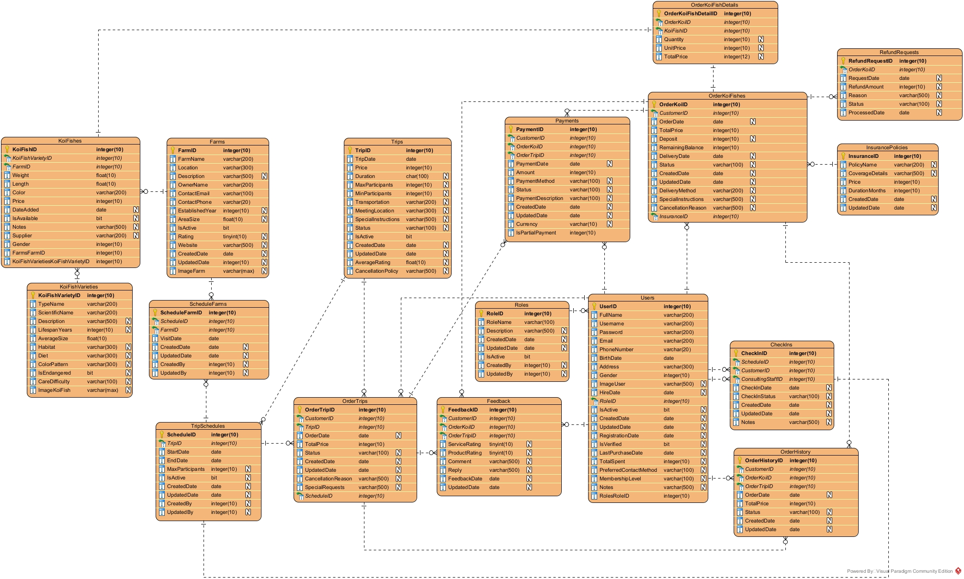

##### 

##### 

##### 

##### 

##### 

##### 

##### 

##### **3.1.5 Entities Description**

| **No** | **Table** | **Description** |
| --- | --- | --- |
| **1** | **Roles** | **Primary keys:** RoleID(int)  **Foreign keys:**  **Properties:**  RoleName(nvarchar(100))  Description(nvarchar(500))  CreatedDate(datetime)  UpdatedDate(datetime)  IsActive(datetime)  CreatedBy(datetime)  UpdatedBy(datetime) |
| **2** | **Users** | **Primary keys:** UserID(int)  **Foreign keys:** RoleID(int)  **Properties:**  FullName(nvarchar(200))  UserName(nvarchar(200))  Password(nvarchar(200))  Email(nvarchar(200))  PhoneNumber(nvarchar(20))  BirthDate(date)  Address(nvarchar(300))  Gender(int)  ImageUser(nvarchar(500))  HireDate(date)  IsActive(bit)  CreatedDate(datetime)  UpdatedDate(datetime)  RegistrationDate(datetime)  IsVerified(bit)  LastPurchaseDate(datetime)  TotalSpent(money)  PreferredContactMethod(nvarchar(100))  MembershipLevel(nvarchar(100))  Notes(nvarchar(500)) |
| **3** | **Farms** | **Primary keys:** FarmID(int)  **Foreign keys:**  **Properties:**  FarmName(nvarchar(200))  Location(nvarchar(300))  Description(nvarchar(500))  OwnerName(nvarchar(200))  ContactEmail(nvarchar(100))  ContactPhone(nvarchar(20))  EstablishedYear(int)  AreaSize(float)  IsActive(bit)  Rating(tinyint)  Website (nvarchar(500))  CreatedDate(datetime)  UpdatedDate(datetime)  ImageFarm(varchar(500)) |
| **4** | **KoiFishVarieties** | **Primary keys:** KoiFishVarietyID(int)  **Foreign keys:**  **Properties:**  TypeName(nvarchar(200))  ScientificName(nvarchar(200))  Description(nvarchar(500))  LifespanYears(int)  AverageSize(float)  Habitat(nvarchar(300))  Diet(nvarchar(300))  ColorPattern(nvarchar(300))  IsEndangered(bit)  CareDifficulty(nvarchar(100)) |
| **5** | **KoiFishes** | **Primary keys:** KoiFishID(int)  **Foreign keys:**  KoiFishVarietyID(int)  FarmID(int)  **Properties:**  Weight(float)  Length(float)  Color(nvarchar(200))  Price(money)  DateAdded(datetime)  IsAvailable(bit)  Notes(nvarchar(500))  Supplier(nvarchar(200))  Gender(int)  ImageUser(nvarchar(500)) |
| **6** | **Trips** | **Primary keys:** TripID(int)  **Foreign keys:**  **Properties:**  TripDate(date)  Price(money)  Duration(nvarchar(100))  MaxParticipants(int)  MinParticipants(int)  Transportation(nvarchar(200))  MeetingLocation(nvarchar(300))  SpecialInstructions(nvarchar(500))  Status(nvarchar(100))  IsActive(bit)  CreatedDate(datetime)  UpdatedDate(datetime)  AverageRating(float)  CancellationPolicy(nvarchar(500)) |
| **7** | **TripSchedules** | **Primary keys:** ScheduleID(int)  **Foreign keys:**TripID(int)  **Properties:**  StartDate(date)  EndDate(date)  MaxParticipants(int)  IsActive(bit)  CreatedDate(datetime)  UpdatedDate(datetime)  CreatedBy(int)  UpdatedBy(int) |
| **8** | **ScheduleFarms** | **Primary keys:** ScheduleFarmID(int)  **Foreign keys:**  ScheduleID(int)  FarmID(int)  **Properties:**  VisitDate(date)  CreatedDate(datetime)  UpdatedDate(datetime)  CreatedBy(int)  UpdatedBy(int) |
| **9** | **CheckIns** | **Primary keys:**CheckInID(int)  **Foreign keys:**  CustomerID(int)  ConsultingStaffID(int)  **Properties:**  TripID(int)  CheckInDate(datetime)  CheckInStatus(nvarchar(100))  CreatedDate(datetime)  UpdatedDate(datetime)  Notes(nvarchar(500)) |
| **10** | **OrderTrips** | **Primary keys:** OrderTripID(int)  **Foreign keys:**  TripID(int)  CustomerID(int)  ScheduleID(int)  **Properties:**  OrderDate(datetime)  TotalPrice(money)  Status(nvarchar(100))  CreatedDate(datetime)  UpdatedDate(datetime)  CancellationReason(nvarchar(500))  SpecialRequests(nvarchar(500)) |
| **11** | **InsurancePolicies** | **Primary keys:** InsuranceID(int)  **Foreign keys:**  **Properties:**  PolicyName(nvarchar(200))  CoverageDetails(nvarchar(500))  Price(money)  DurationMonths(int)  CreatedDate(datetime)  UpdatedDate(datetime) |
| **12** | **OrderKoiFishes** | **Primary keys:** OrderKoiID(int)  **Foreign keys:**  CustomerID(int)  KoiFishID(int)  InsuranceID(int)  **Properties:**  OrderDate(datetime)  Quantity(int)  TotalPrice(money)  Deposit(money)  RemainingBalance(money)  DeliveryDate(date)  Status(nvarchar(100))  CreatedDate(datetime)  UpdatedDate(datetime)  DeliveryMethod(nvarchar(200)  SpecialInstructions(nvarchar(500))  CancellationReason(nvarchar(500)) |
| **13** | **OrderKoiFishDetails** | **Primary keys:** OrderKoiFishDetailID(int)  **Foreign keys:**  OrderKoiID(int)  KoiFishID(int)  **Properties:**  Quantity(int)  UnitPrice(int)  TotalPrice(int) |
| **14** | **RefundRequests** | **Primary keys:** RefundRequestID(int)  **Foreign keys:**OrderKoiID(int)  **Properties:**  RequestDate(datetime)  RefundAmount(money)  Reason(nvarchar(500))  Status(nvarchar(100))  ProcessedDate(datetime) |
| **15** | **Payments** | **Primary keys:** PaymentID(int)  **Foreign keys:**  CustomerID(int)  OrderKoiID(int)  OrderTripID(int)  **Properties:**  PaymentDate(datetime)  Amount(money)  PaymentMethod(nvarchar(100))  Status(nvarchar(100))  PaymentDescription(nvarchar(500))  CreatedDate(datetime)  UpdatedDate(datetime)  Currency(nvarchar(10)) |
| **16** | **OrderHistory** | **Primary keys:** OrderHistoryID(int)  **Foreign keys:**  CustomerID(int)  OrderKoiID(int)  OrderTripID(int)  **Properties:**  OrderDate(datetime)  TotalPrice(money)  Status(nvarchar(100))  CreatedDate(datetime)  UpdatedDate(datetime) |
| **17** | **Feedback** | **Primary keys:** FeedbackID(int)  **Foreign keys:**  CustomerID(int)  OrderKoiID(int)  OrderTripID(int)  **Properties:**  ServiceRating(tinyint)  ProductRating(tinyint)  Comment(nvarchar(500))  Reply(nvarchar(500))  FeedbackDate(datetime)  UpdatedDate(datetime) |

##### **3.1.6 Activity Diagram**

###### Book Tour & Check-In

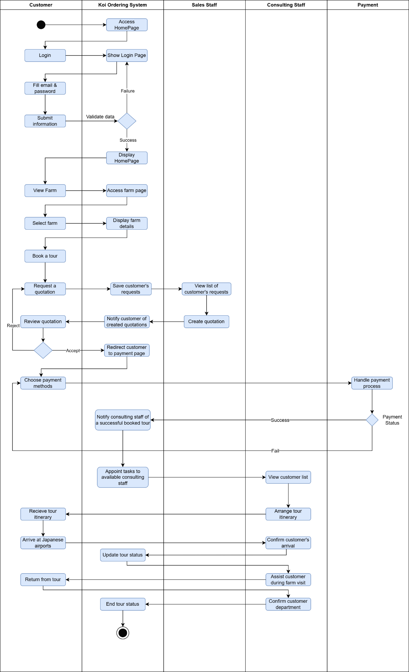

### Buy Koi Fish, Delivery and Final Payment

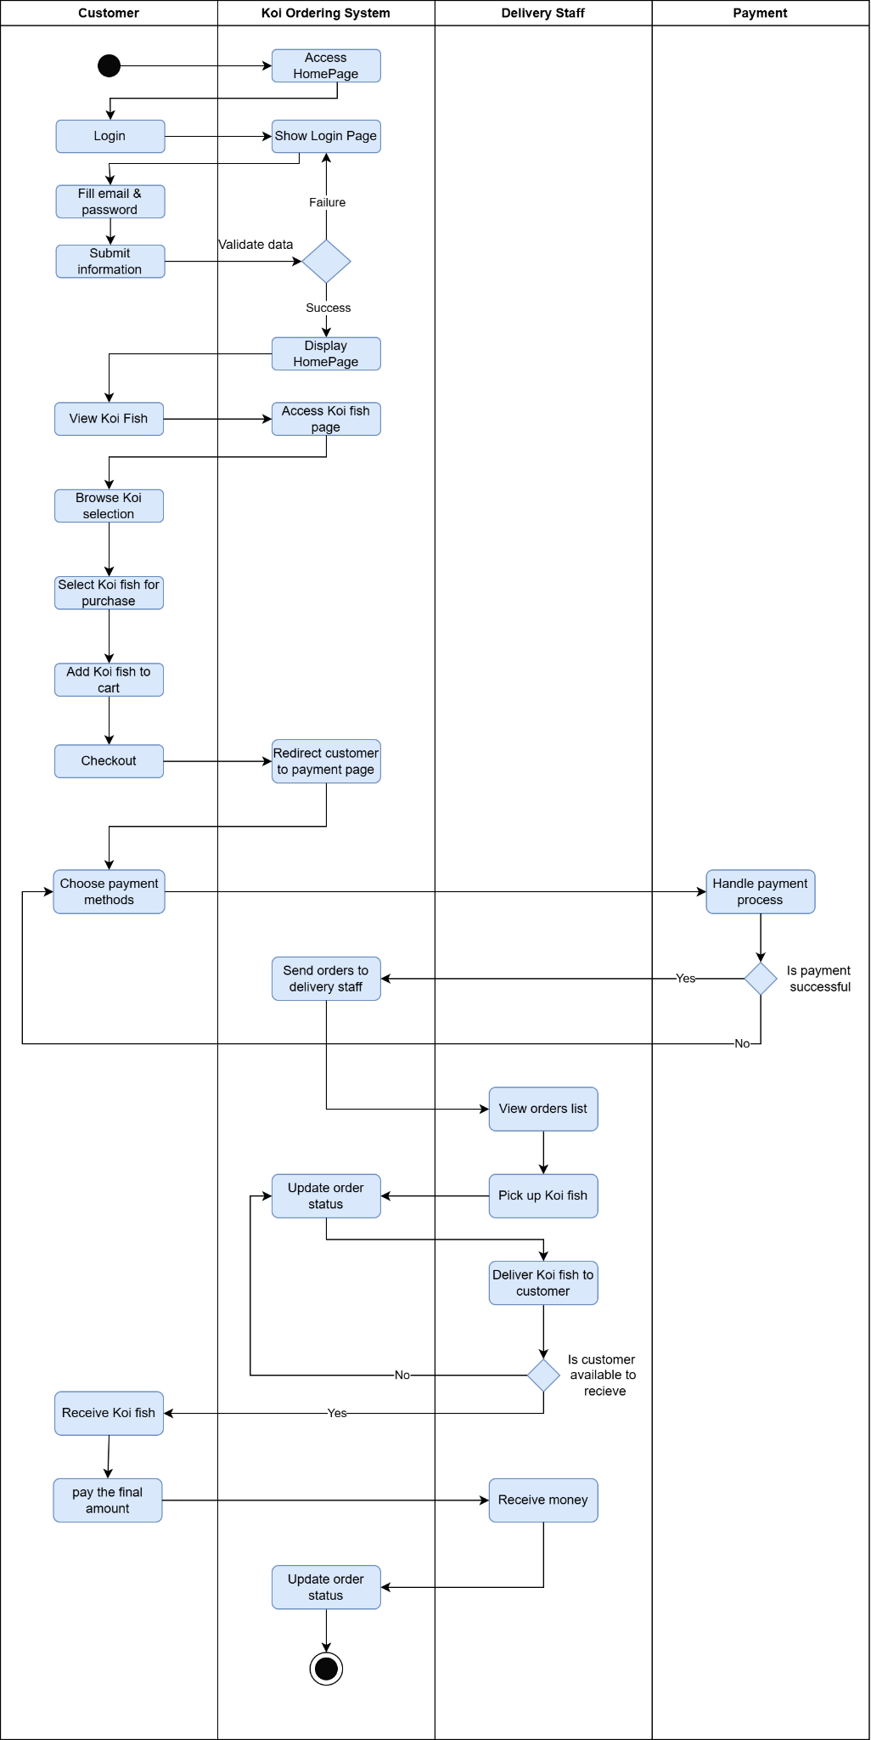

### Cancel Order and Refund Policy

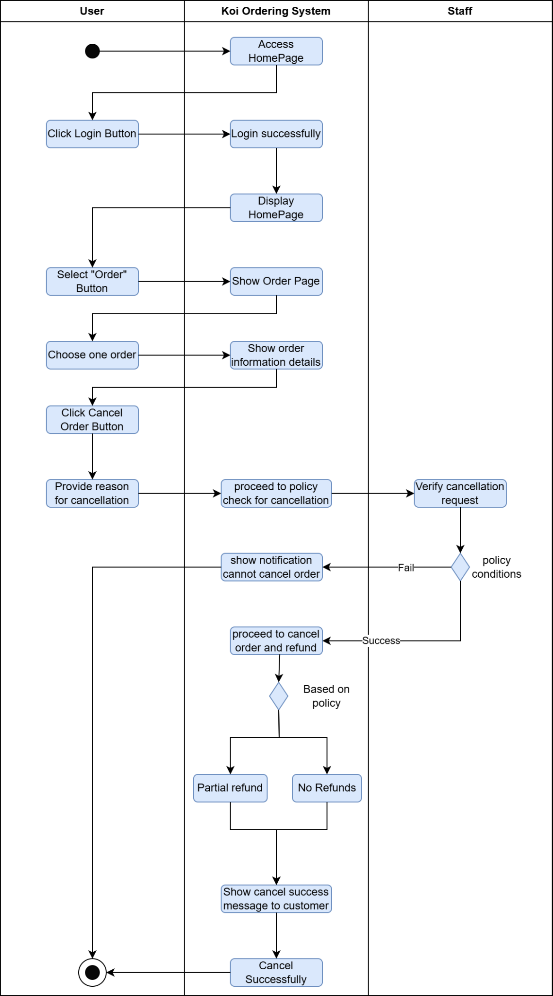

## 4. Non-Functional Requirements

### 4.1 External Interfaces

The system integrates with:

* **Payment Gateway API**: For handling transactions.

### 4.2 Quality Attributes

###### 4.2.1 Usability

The system will provide an intuitive user interface, requiring minimal training for customers. Farm managers and staff will have access to support materials for managing orders.

###### 4.2.2 Reliability

The system will maintain 99% uptime, with an estimated **Mean Time Between Failures (MTBF)** of 10,000 hours. **Mean Time to Repair (MTTR)** should not exceed 2 hours for critical failures.

###### 4.2.3 Performance

Response time for customer transactions should not exceed 2 seconds. The system should handle up to 500 simultaneous orders.

## 5. Requirement Appendix

### 5.1 Business Rules

| **Code** | **Description** |
| --- | --- |
| ***BR-01*** | The registration form must include validation for unique username and valid email format. |
| ***BR-02*** | The system must filter tours according to the criteria provided by the guest. |
| ***BR-03*** | The system should categorise Koi farms for easy browsing. |
| ***BR-04*** | Information about Koi fish should be accurate, including availability and pricing. |
| ***BR-05*** | The homepage should load within 5 seconds and display essential navigation options. |
| ***BR-06*** | Passwords must be encrypted and securely stored |
| ***BR-07*** | The system must log failed login attempts to monitor for potential unauthorised access |
| ***BR-08*** | The password reset link should have an expiration time (e.g., 30 minutes). |
| ***BR-09*** | New passwords must meet certain security requirements (e.g., length, complexity). |
| ***BR-10*** | Profile updates must ensure data integrity and validate required fields. |
| ***BR-11*** | Users must be notified of successful updates. |
| ***BR-12*** | Quotes must be valid for a specified time period before requiring re-confirmation (e.g., 24 hours). |
| ***BR-13*** | Payments must be securely processed to protect customer information (compliance with PCI DSS standards). |
| ***BR-14*** | Display clear information about shipping options and estimated delivery times during checkout. |
| ***BR-15*** | All transactions must adhere to security protocols to ensure customer information is protected. |
| ***BR-16*** | Customers should be promptly notified of successful payments, along with detailed transaction information. |
| ***BR-17*** | Tour bookings should be confirmed within a specific time frame to ensure availability. |
| ***BR-18*** | Customers should receive all necessary information about the tour, including cancellation policies. |
| ***BR-19*** | Customers must have valid order or booking information to view status. |
| ***BR-20*** | The system should provide real-time updates on order statuses. |
| ***BR-21*** | Orders can only be cancelled within a specific time frame as defined by the store’s policies. |
| ***BR-22*** | Customers must be notified of successful cancellations and any refund details. |
| ***BR-23*** | Refund requests must comply with the store's return and refund policy. |
| ***BR-24*** | Customers must be notified of the status of their refund requests and any applicable timelines for processing. |
| ***BR-25*** | Customers should be able to access their order history for a specified duration (e.g., last 12 months). |
| ***BR-26*** | The system should ensure the privacy and security of customer order details. |
| ***BR-27*** | Quotes must be confirmed within a specified time frame to remain valid. |
| ***BR-28*** | The system should ensure the customer receives timely notifications regarding their quote status. |
| ***BR-29*** | Trip details must be sent within a specified time frame after booking confirmation. |
| ***BR-30*** | The information provided should adhere to company policies and ensure clarity for the customer. |
| ***BR-31*** | All feedback must adhere to community guidelines and be appropriate for public display. |
| ***BR-32*** | The system should allow customers to edit or delete their feedback within a specified timeframe after submission. |
| ***BR-33*** | Notifications must be sent promptly following any change in order or booking status. |
| ***BR-34*** | The system should allow customers to specify their preferred notification method. |
| ***BR-35*** | Check-in procedures must comply with airline and tour company policies. |
| ***BR-36*** | The consultant must ensure that all customer information is handled securely and confidentially. |
| ***BR-37*** | All transactions must comply with the company’s sales policies and procedures. |
| ***BR-38*** | Consultants must provide accurate information regarding Koi fish care and handling. |
| ***BR-39*** | Quotes must adhere to company policies and include all required legal information. |
| ***BR-40*** | The generated quote should be clear, itemised, and free from errors to avoid customer confusion. |
| ***BR-41*** | Itineraries must comply with company policies and provide accurate, up-to-date information. |
| ***BR-42*** | All itineraries should be clear and easy to understand, ensuring customers can follow them easily. |
| ***BR-43*** | All submitted quotes must comply with company guidelines for approval. |
| ***BR-44*** | The approval process should be completed in a timely manner to avoid delaying the customer’s purchase. |
| ***BR-45*** | All communications with customers must maintain professionalism and clarity. |
| ***BR-46*** | Quotes must be sent in a timely manner to facilitate the customer's decision-making process. |
| ***BR-47*** | All updates to Koi farm information must be accurate and comply with company policies. |
| ***BR-48*** | Changes should be logged for accountability and transparency. |
| ***BR-49*** | All policy updates must comply with legal and regulatory standards. |
| ***BR-50*** | Changes to policies should be communicated to relevant staff promptly to ensure compliance. |
| ***BR-51*** | User accounts must be managed according to company policies and security standards. |
| ***BR-52*** | All changes to user accounts should be logged for auditing purposes. |
| ***BR-53*** | Reports must be generated in compliance with company policies and data privacy regulations. |
| ***BR-54*** | Generated reports should be accessible for a defined period and securely stored. |
| ***BR-55*** | Managers must monitor transactions and interactions regularly to ensure compliance with company policies and quality standards. |
| ***BR-56*** | Any flagged issues must be documented and addressed in a timely manner. |
| ***BR-57*** | All quotes must adhere to the company’s pricing and discount policies before approval. |
| ***BR-58*** | Managers must review quotes for accuracy and completeness before approving them for customer review. |
| ***BR-59*** | Reports should be accessed and reviewed regularly to support continuous improvement and performance tracking. |
| ***BR-60*** | Data displayed in reports must comply with company privacy policies, particularly for sensitive information. |
| ***BR-61*** | Delivery staff must only access orders assigned to them to ensure data privacy. |
| ***BR-62*** | The system should provide accurate, real-time updates on delivery status. |
| ***BR-63*** | Delivery staff must follow security and verification protocols to ensure the correct payment is collected. |
| ***BR-64*** | The system must update payment and order status in real-time to maintain accurate records. |
| ***BR-65*** | Status updates should be made in real-time to provide accurate tracking for customers. |
| ***BR-66*** | The system should allow delivery staff to make notes if specific issues arise during delivery (e.g., customer unavailable). |

### 5.2 Common Requirements

* **Performance Requirements**: Minimum performance standards (e.g., response times, load times) expected throughout the application.
* **Security Requirements**: Security measures that apply across the application, such as authentication, encryption standards, and data handling protocols.
* **Usability Requirements**: Consistency in user experience across various modules, such as standardised navigation, accessibility standards, or design guidelines.
* **Reliability Requirements**: Expectations for system uptime, error handling, and backup procedures that apply universally.
* **Compliance Requirements**: Any regulatory or legal standards that the software must comply with, such as GDPR, HIPAA, or other industry-specific guidelines.
* **Scalability Requirements**: Design considerations for the software to handle growth, whether in user base, data volume, or functional expansion.
* **Compatibility Requirements**: Specifications on compatible devices, operating systems, or integrations with third-party services.

# IV. Software Design Description

## 1. System Design

### 1.1 System Architecture

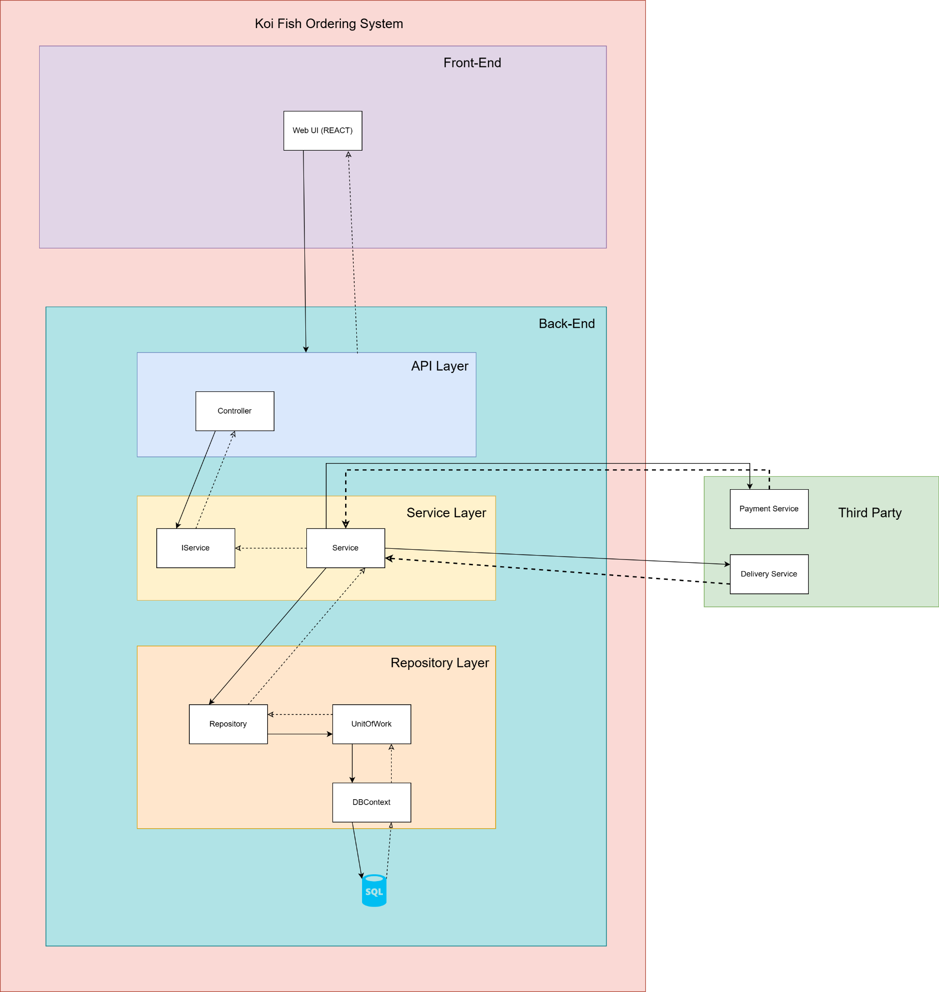

## 2. Database Design

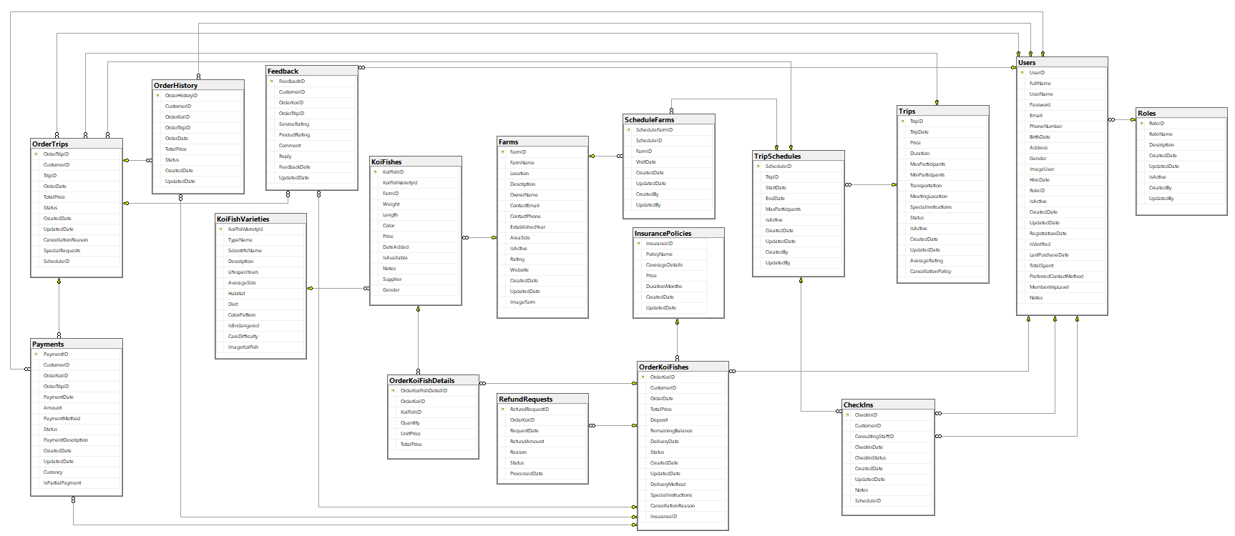

**Table Descriptions:**

* **Roles:** Manages user roles with details like role name, description, and status, allowing categorization of users by responsibilities (e.g., admin, customer, or sales staff).
* **Users**: Stores user information, including personal details, role ID (linking to *Roles*), contact preferences, and membership level, identifying users as customers, consultants, or other staff.
* **Farms**: Contains koi farm details, such as location, owner, and rating. Linked to *KoiFishes* to specify fish origins, supporting farm visit information for trips.
* **KoiFishVarieties**: Defines koi fish varieties by characteristics like scientific name, colour pattern, and care difficulty, linking to *KoiFishes* to classify individual fish by type.
* **KoiFishes**: Stores individual koi fish details (e.g., weight, length, color) and farm origin, linking to *Farms* and *KoiFishVarieties* to track available stock and characteristics.
* **Trips**: Holds trip information, including date, location, and cancellation policy. Connects to *OrderTrips* for bookings, *CheckIns* for attendance, and *TripSchedules* for itinerary planning.
* **TripSchedules**: Manages the detailed schedules of trips, linking *Trips* to their scheduled start and end dates and connecting to *ScheduleFarms* for farm visit details.
* **ScheduleFarms**: Specifies farms included in a trip schedule, linking schedule and farm IDs, along with visit dates, to build detailed itineraries.
* **CheckIns**: Tracks customer check-in statuses by linking customers, schedule details, and consulting staff to monitor attendance on trips.
* **OrderTrips**: Stores trip booking details, including customer information, trip ID, pricing, and status, connecting to *Trips* and *TripSchedules* to support trip bookings and custom requests.
* **InsurancePolicies**: Defines insurance policies available for koi orders, detailing coverage, cost, and duration, with potential linking to koi orders through *OrderKoiFishes*.
* **OrderKoiFishes**: Manages koi fish orders by customers, including attributes such as quantity, unit price, insurance details, delivery status, and links to KoiFishes and Users. Supports detailed order tracking and fulfilment.
* **OrderKoiFishDetails**: Stores detailed line items of koi fish orders, including quantity, unit price, and calculated total for each type of fish. Links to OrderKoiFishes and KoiFishes for managing order details and stock control.
* **RefundRequests**: Records refund requests related to koi orders, including refund amount, status, and reason, with a link to *OrderKoiFishes* for financial tracking.
* **Payments**: Tracks payment records for koi fish orders and trips, detailing payment method, status, and amount, linking to *OrderKoiFishes*, *OrderTrips*, and *Users* for comprehensive payment management.
* **OrderHistory**: Logs historical records of completed and cancelled orders, linking customers to their orders in *OrderKoiFishes* and *OrderTrips* for order tracking and auditing.
* **Feedback**: Stores customer feedback on products or services, capturing ratings and comments, and linking to relevant *OrderKoiFishes* or *OrderTrips* for review and improvement purposes.

## 3. Detailed Design

### 3.1<Login>

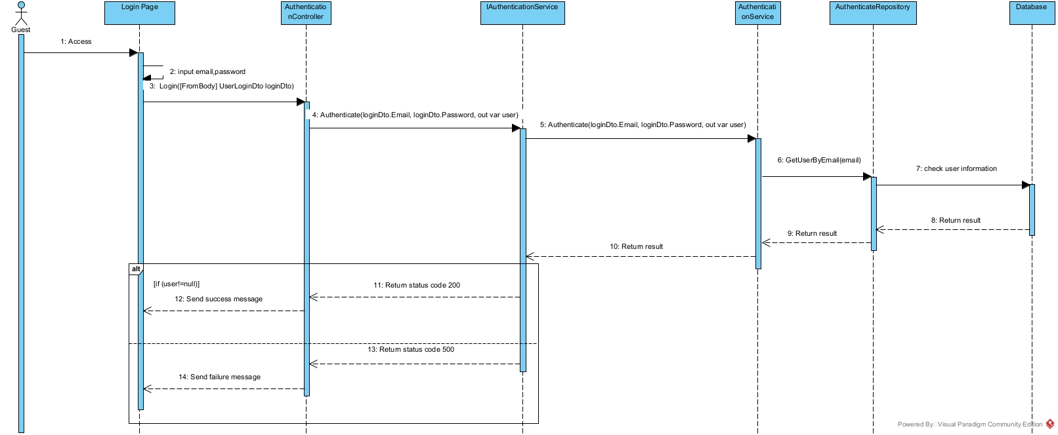

### 3.2<Register>

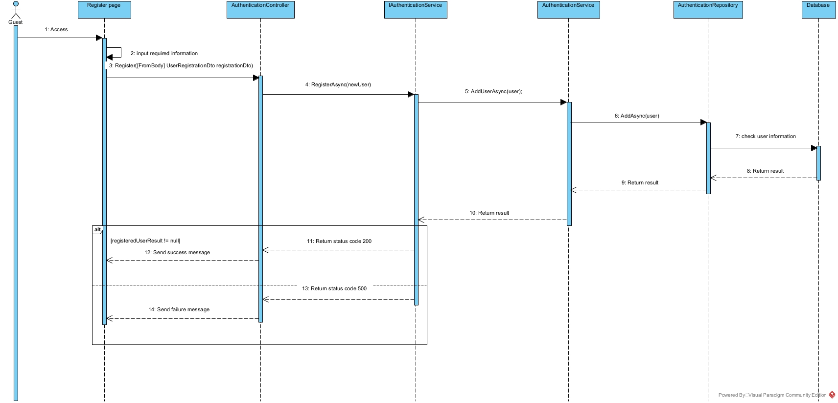

### 3.3 < Get All User>

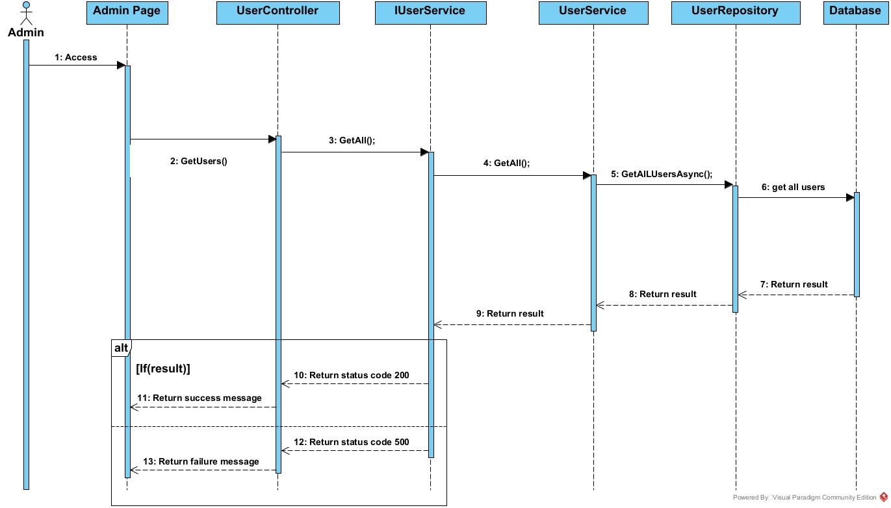

### 3.4 < Delete user>

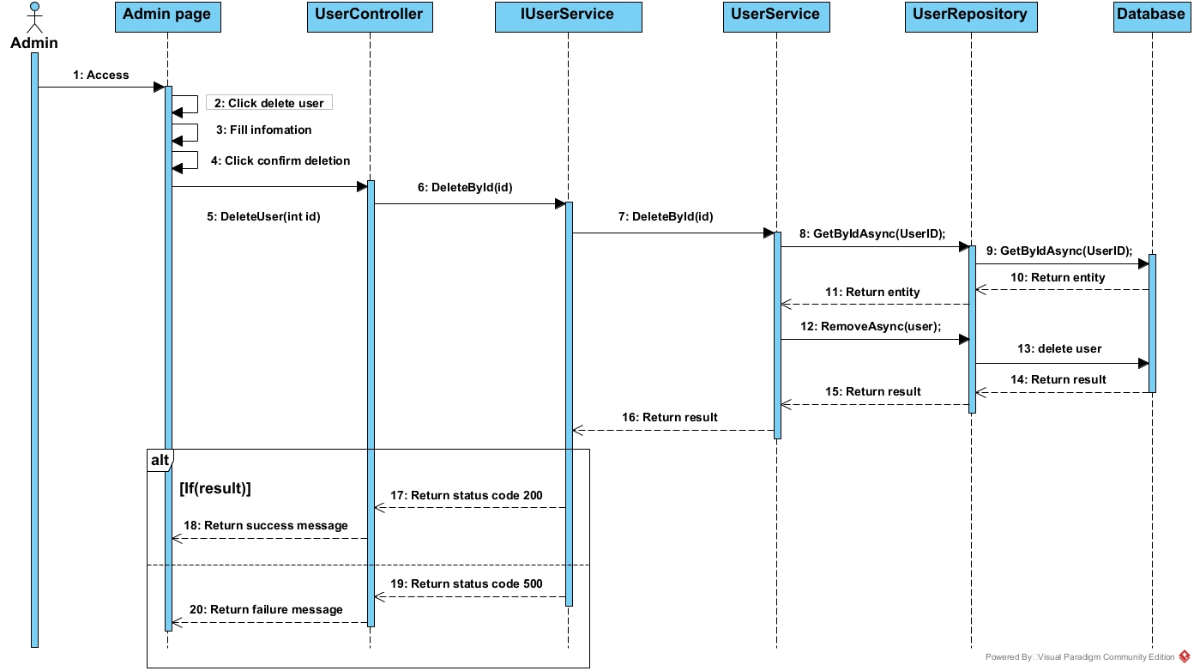

### 3.5 <Create User>

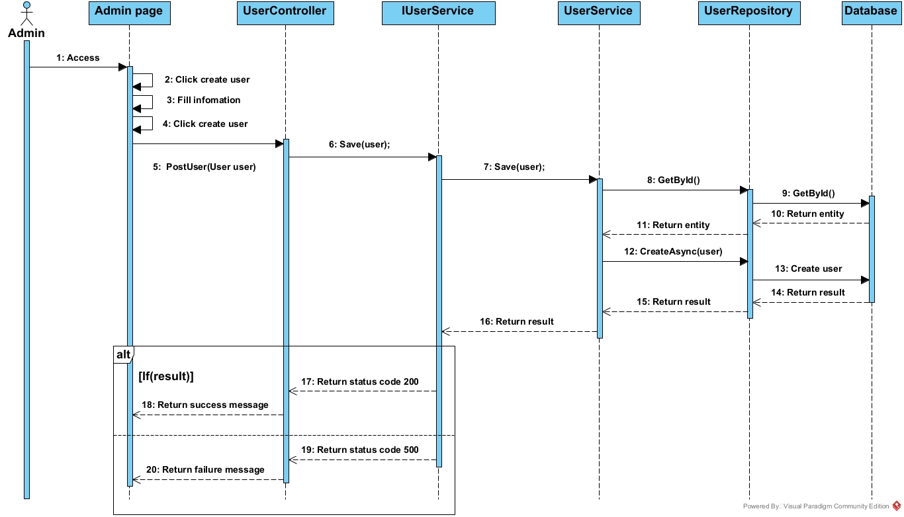

### 3.6 <Update user>

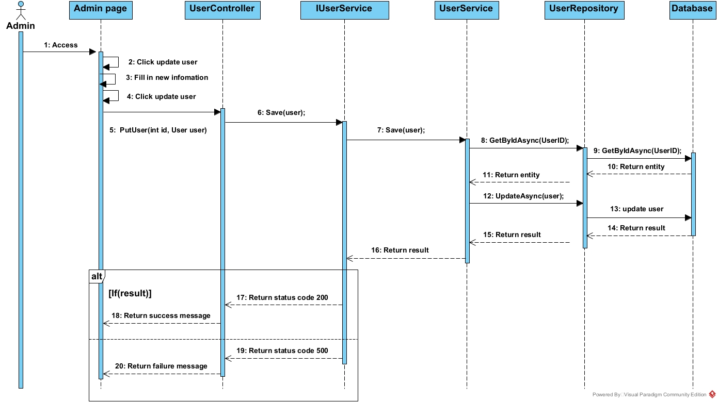

### 3.7 <View koi’s detail>

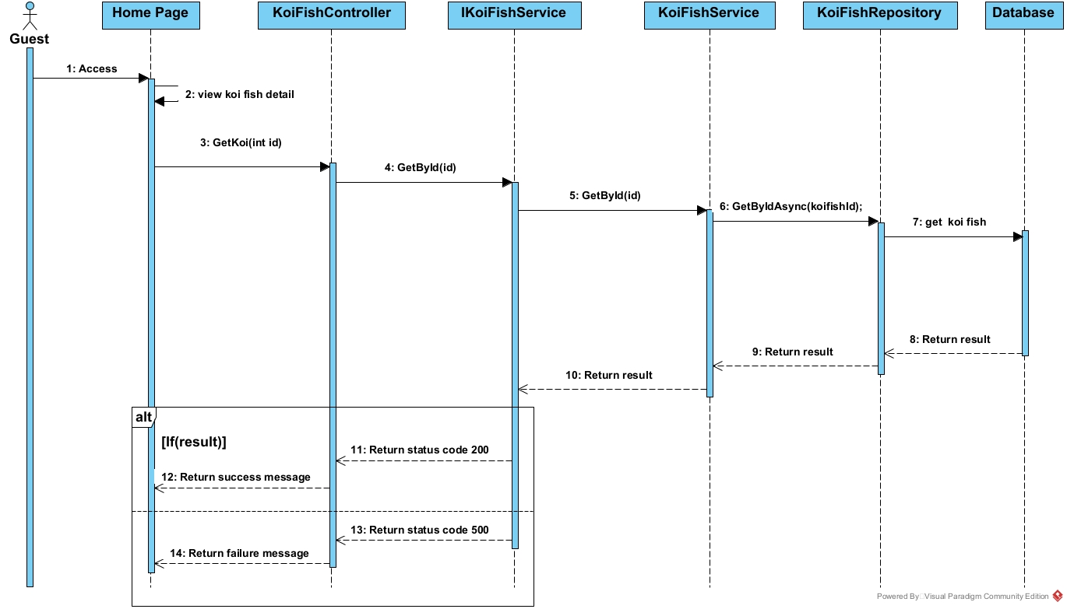

### 3.8 <Get all koi >

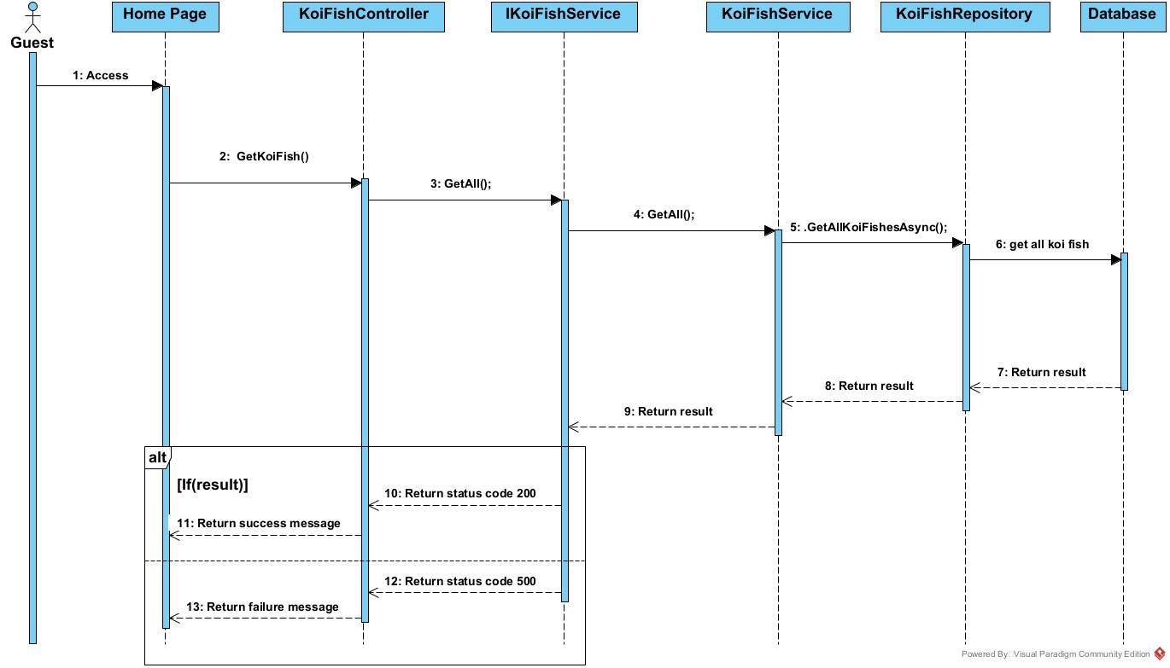

### 3.9 <Get one trip>

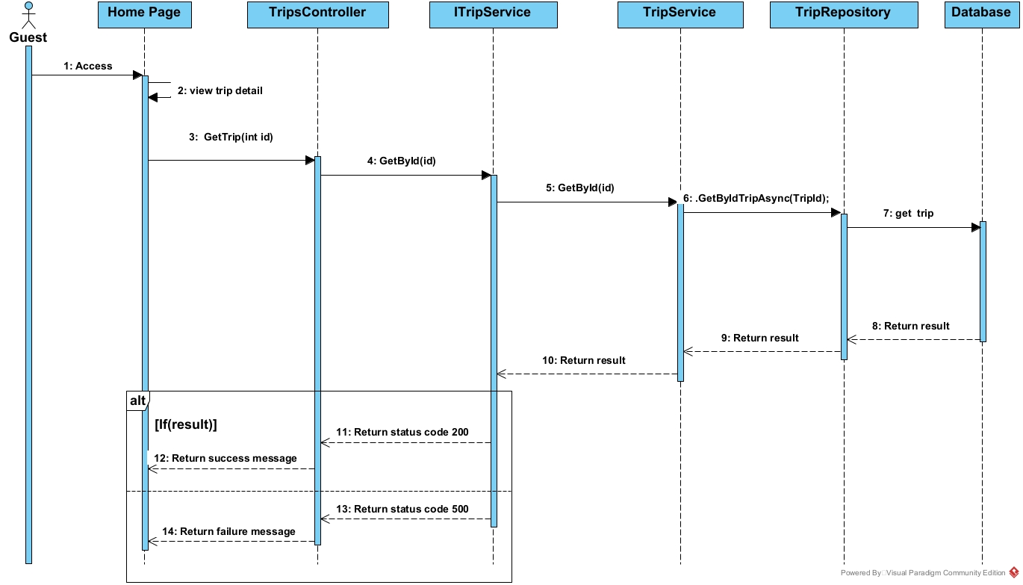

### 

### 

### 3.10. <Get all trip>

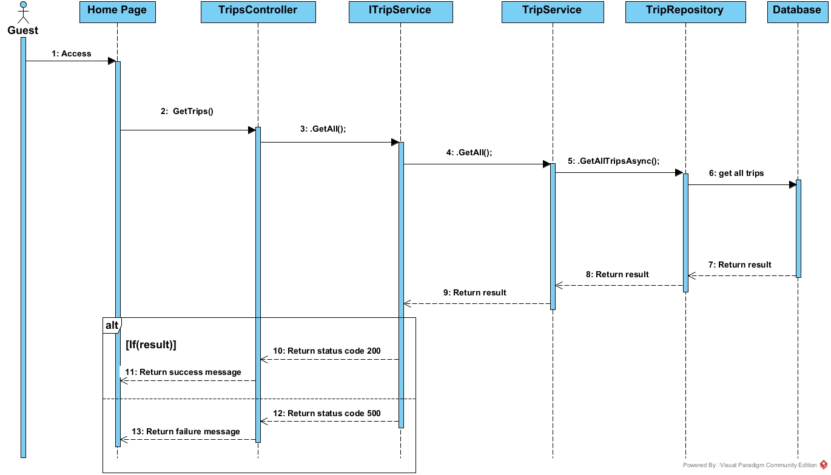

### 3.11. <View all feedback>

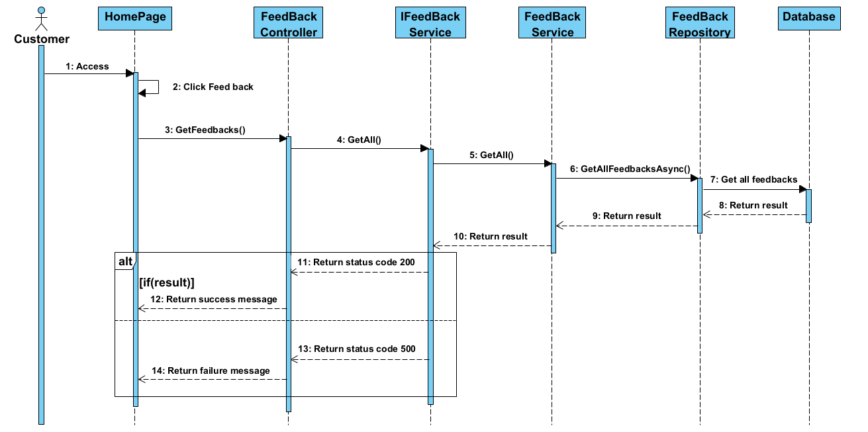

### 3.12<Create Feedback>

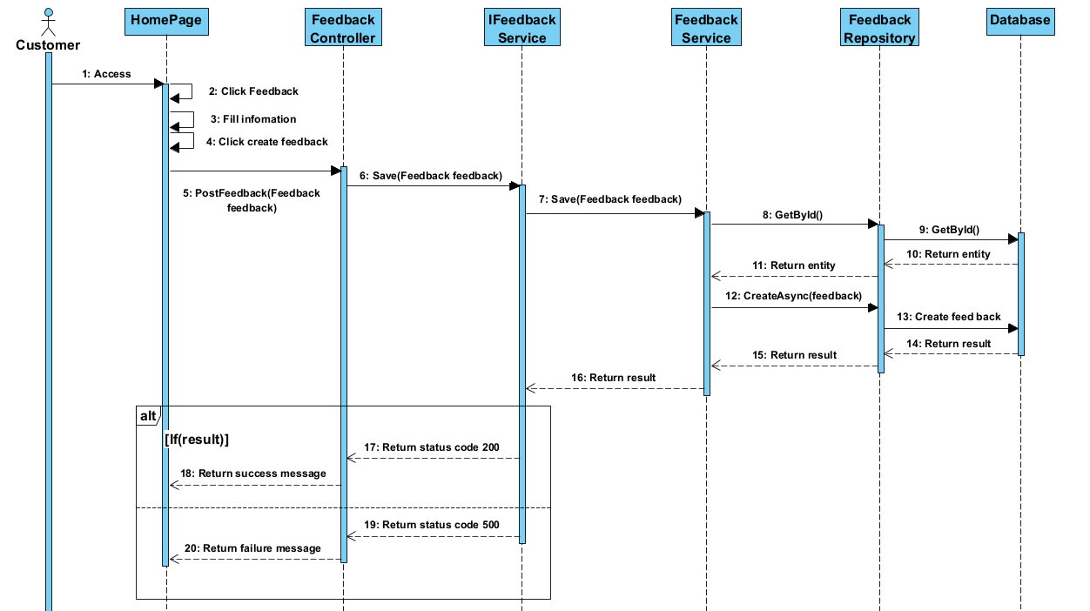

### 3.13<Delete Feedback>

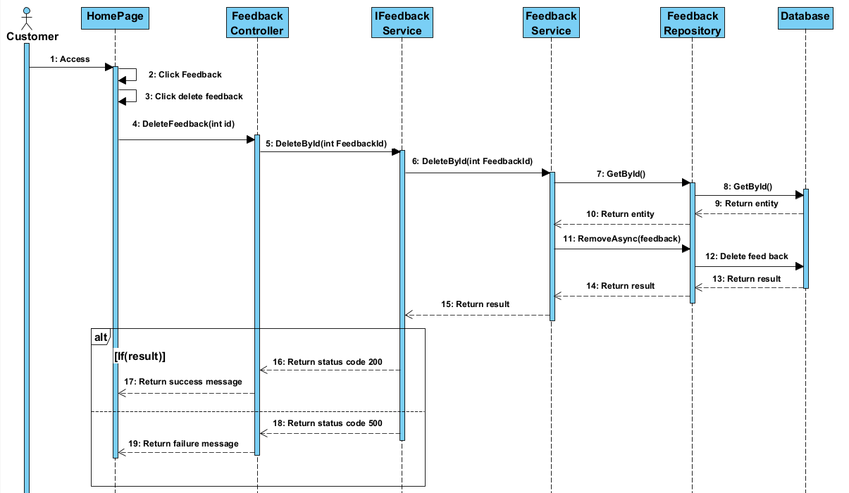

### 3.14 <Update Feedback>

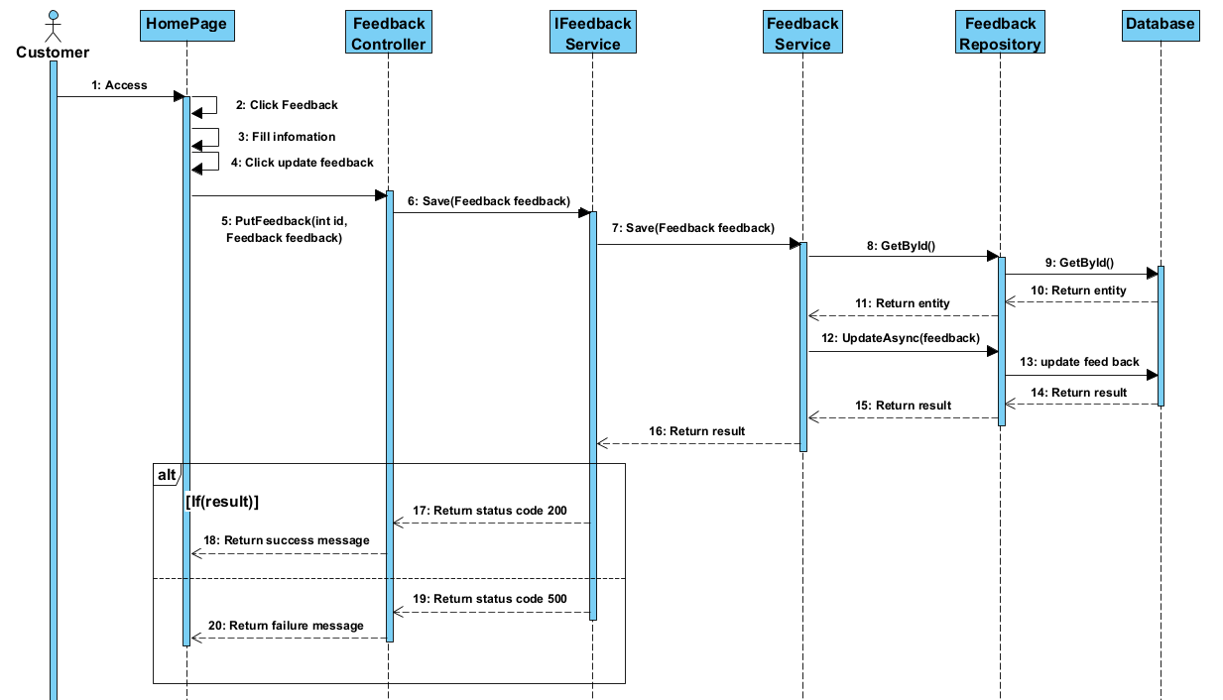

### 3.15.<Get Feedback by Id>

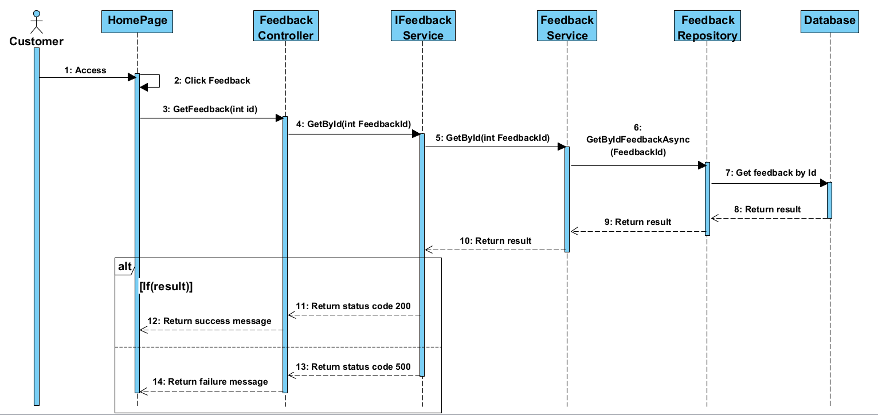

### 3.16 <Get all farm>

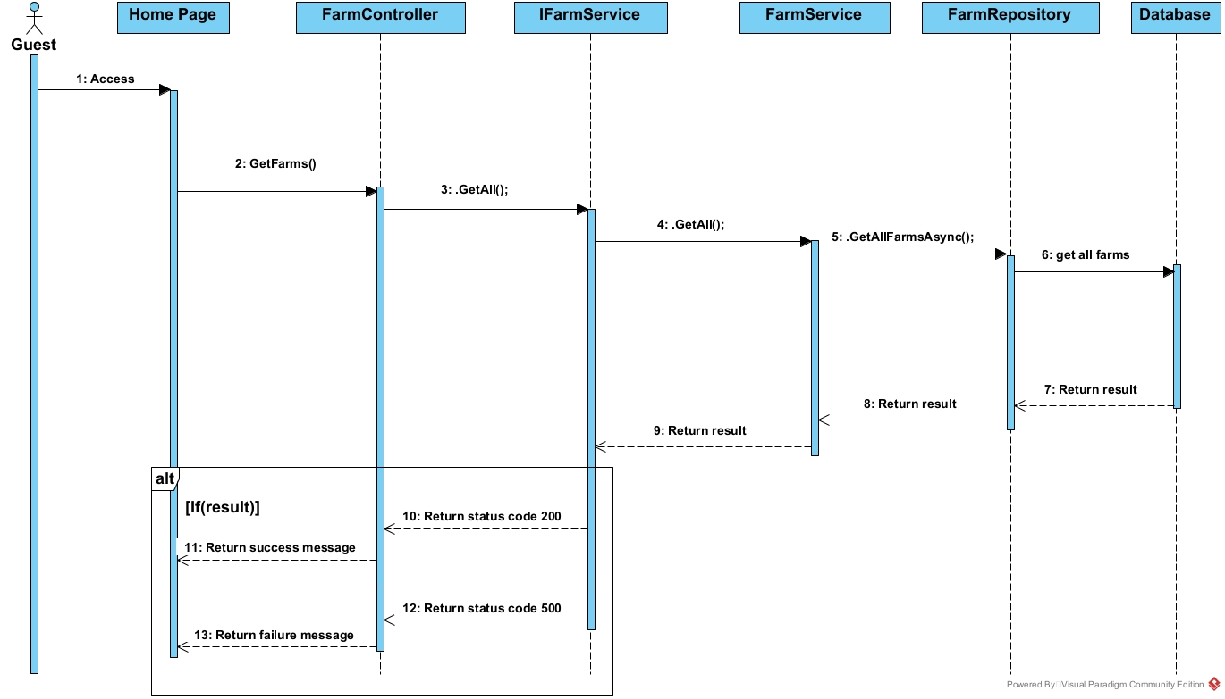

### 3.17 <Add farm>

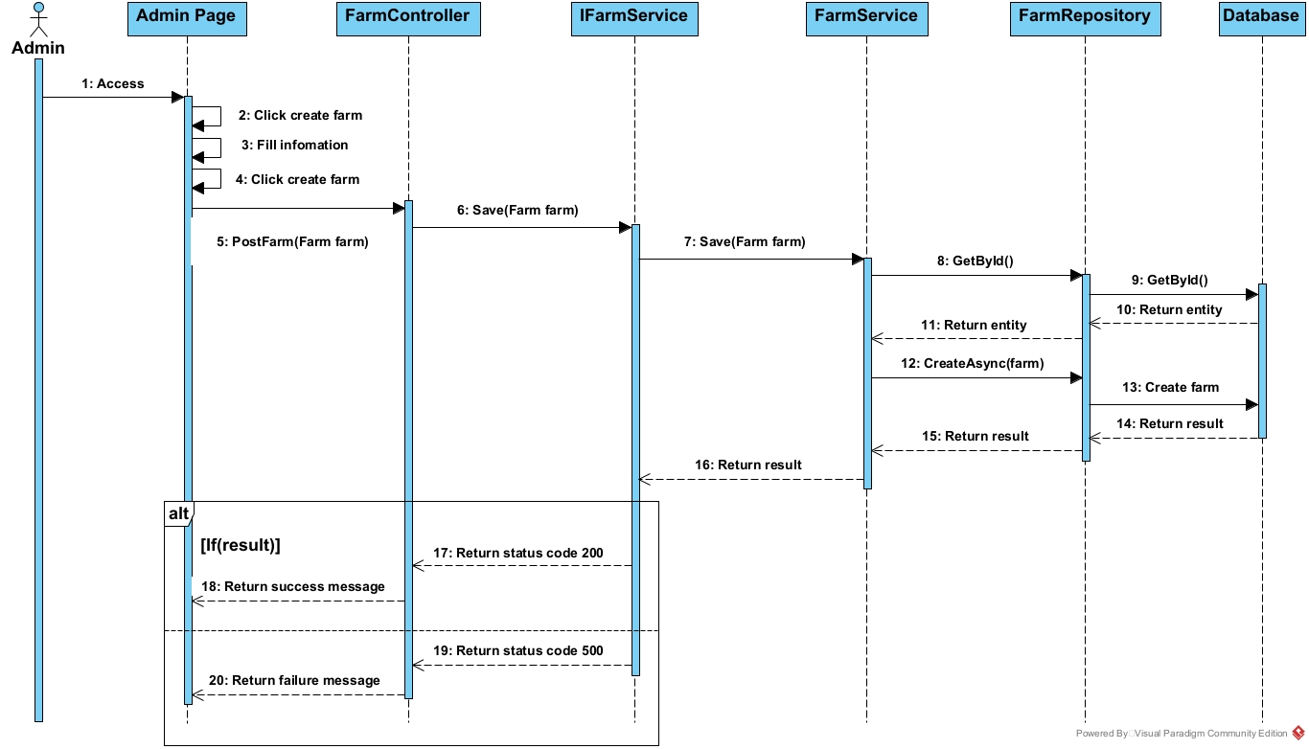

### 

### 

### 

### 

### 3.18<Delete farm>

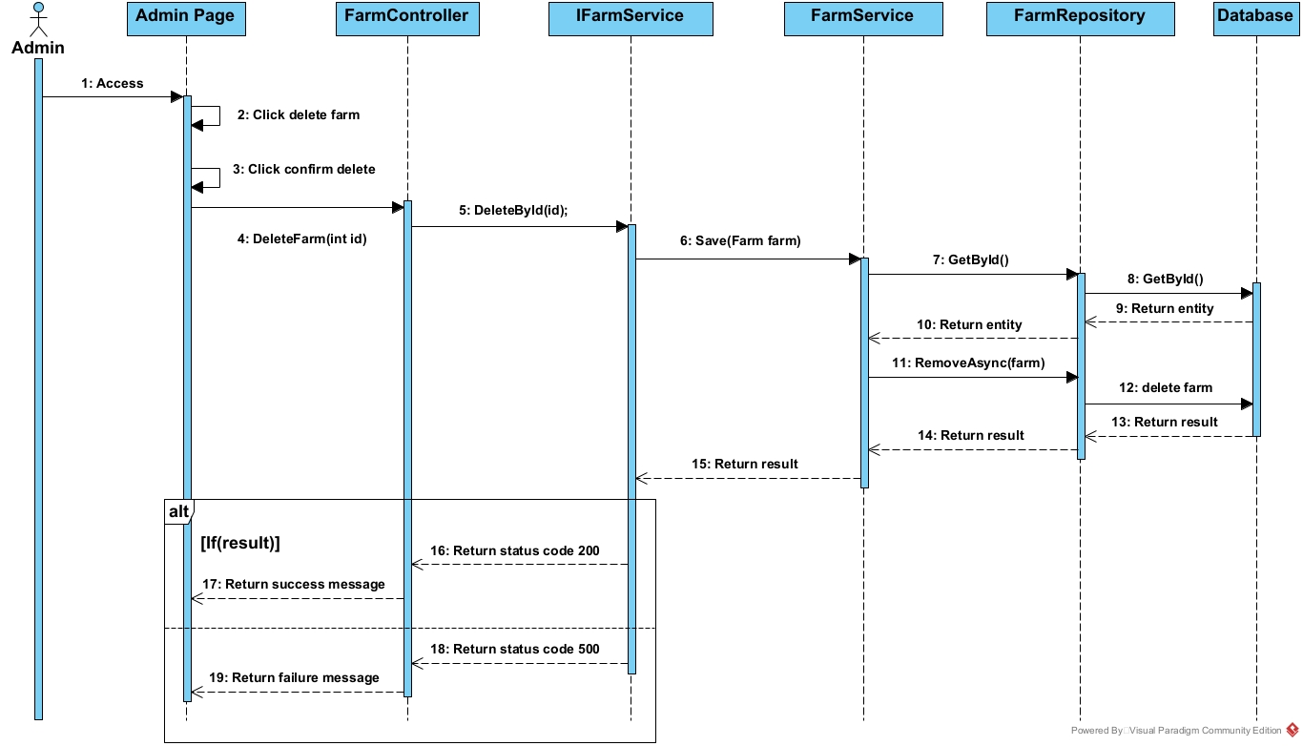

### 3.19<Update farm>

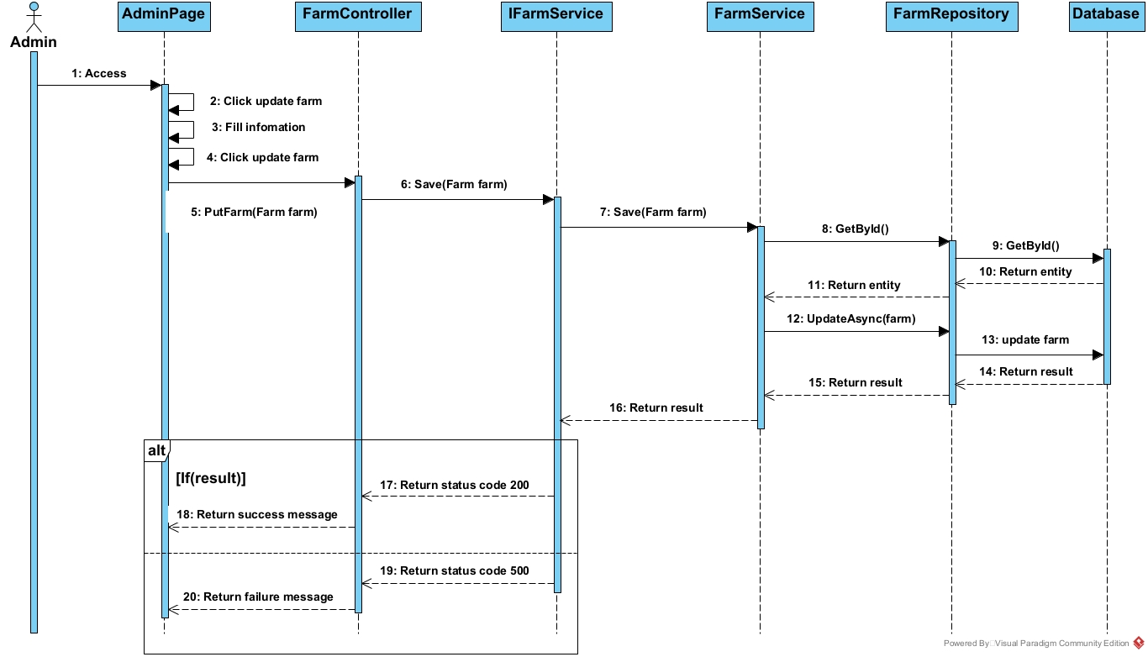

### 3.20 <Create Order Koi Fish>

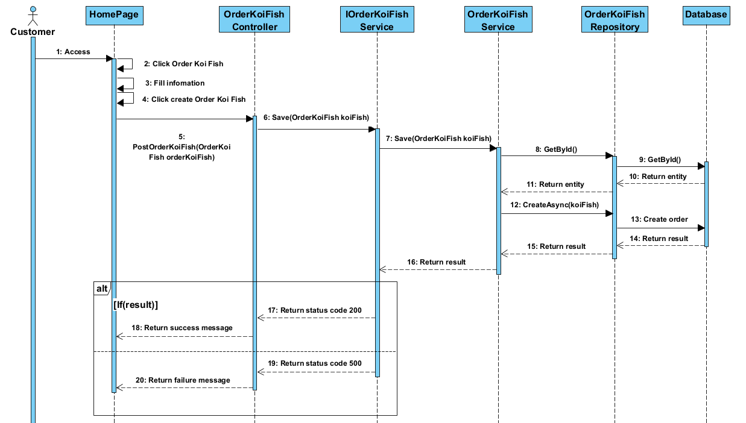

### 3.21 <Update Order Koi Fish>

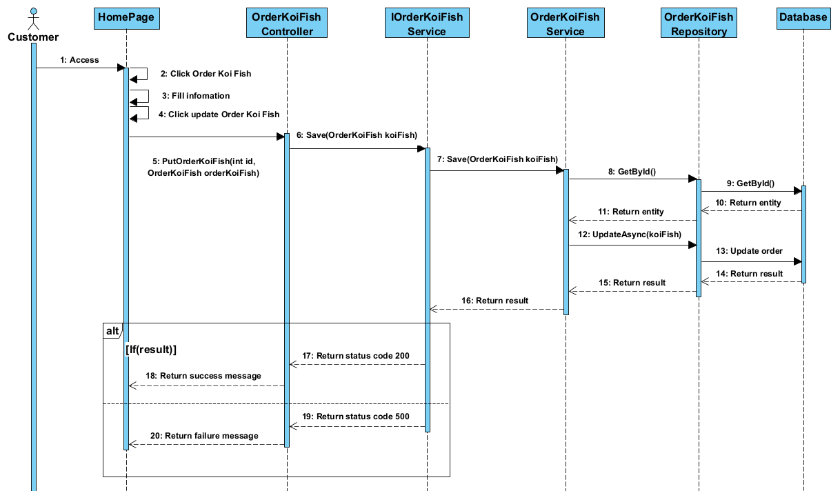

### 3.22 <Delete Order Koi Fish>

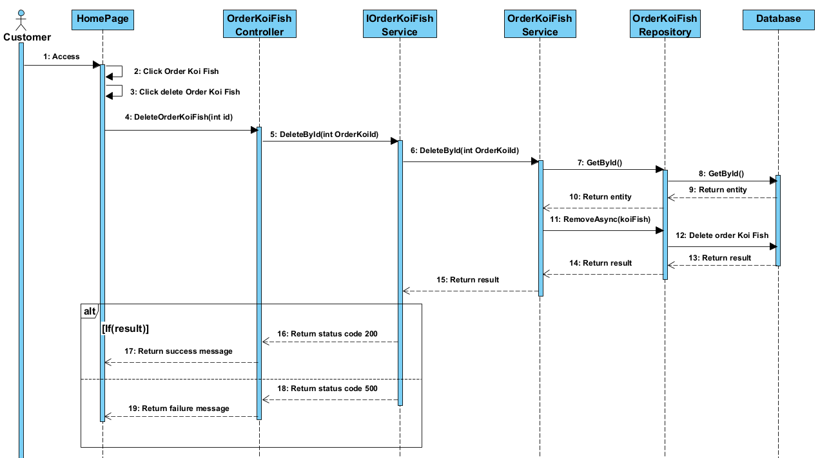

### 

### 

### 3.23<Get All Order Koi Fish>

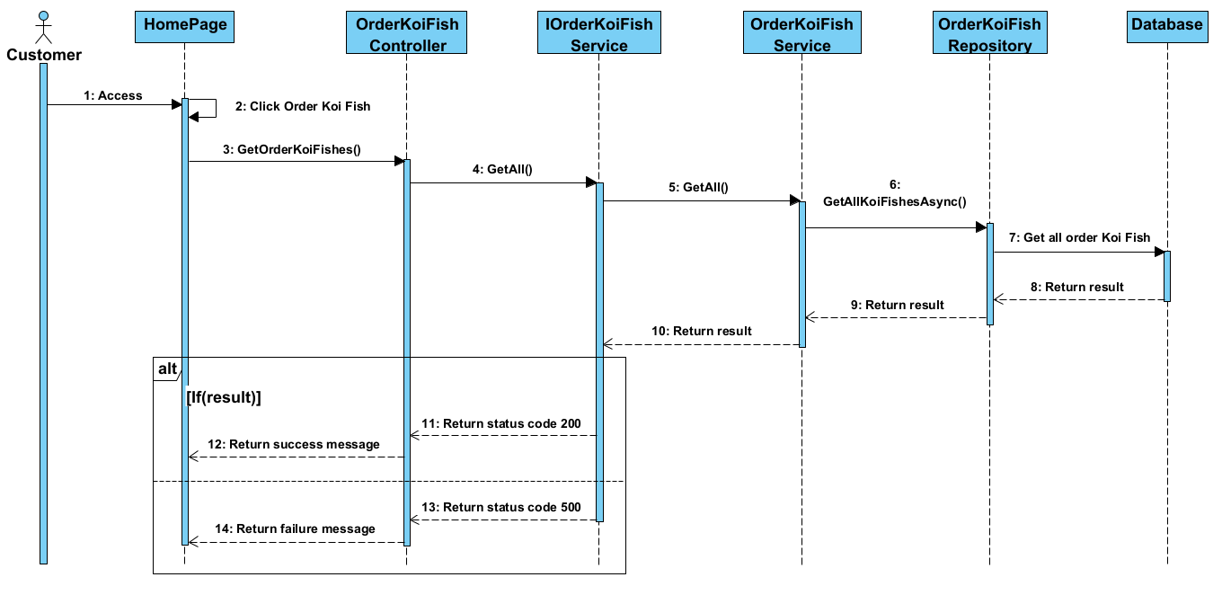

### 3.24.<Get Order Koi Fish By Id>

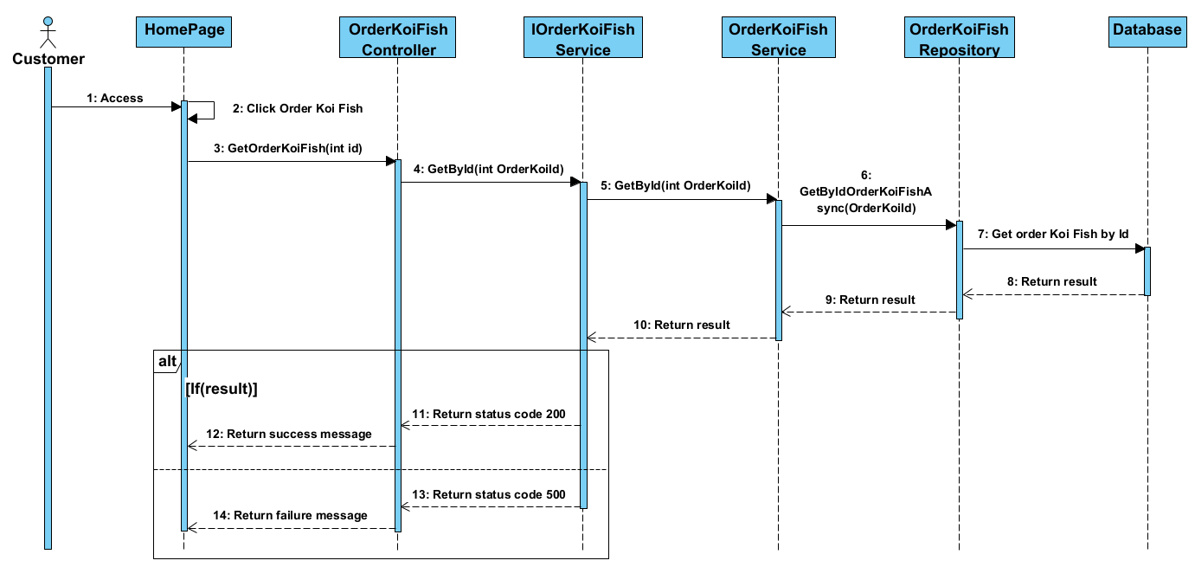

### 3.25 <Get All Order Trip>

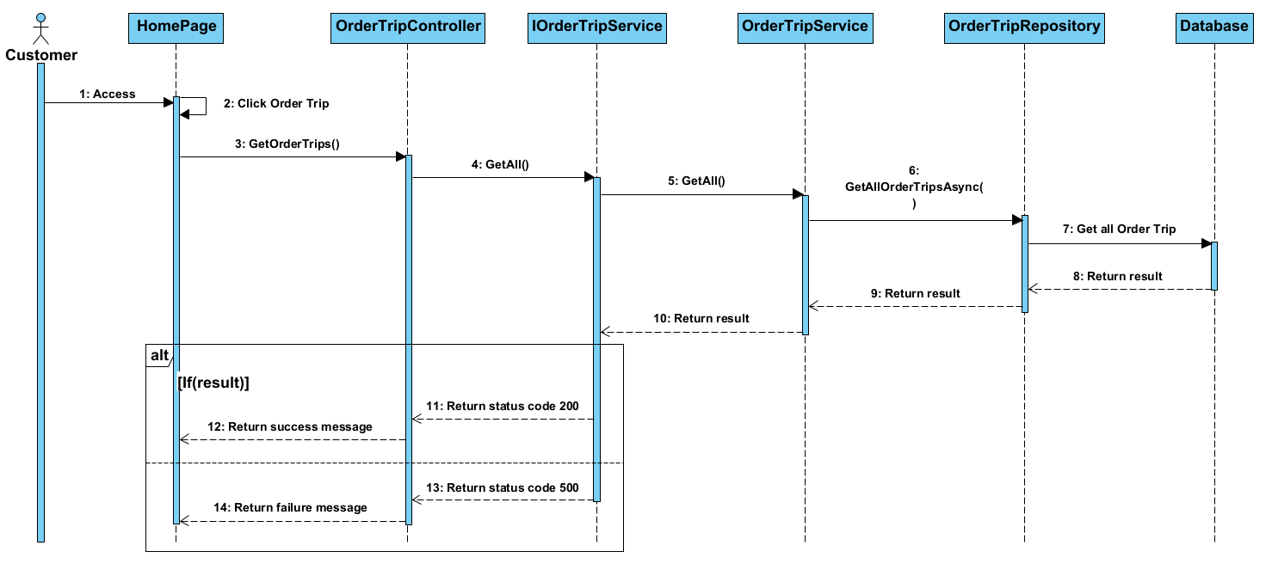

### 3.26<Get Order Trip By Id>

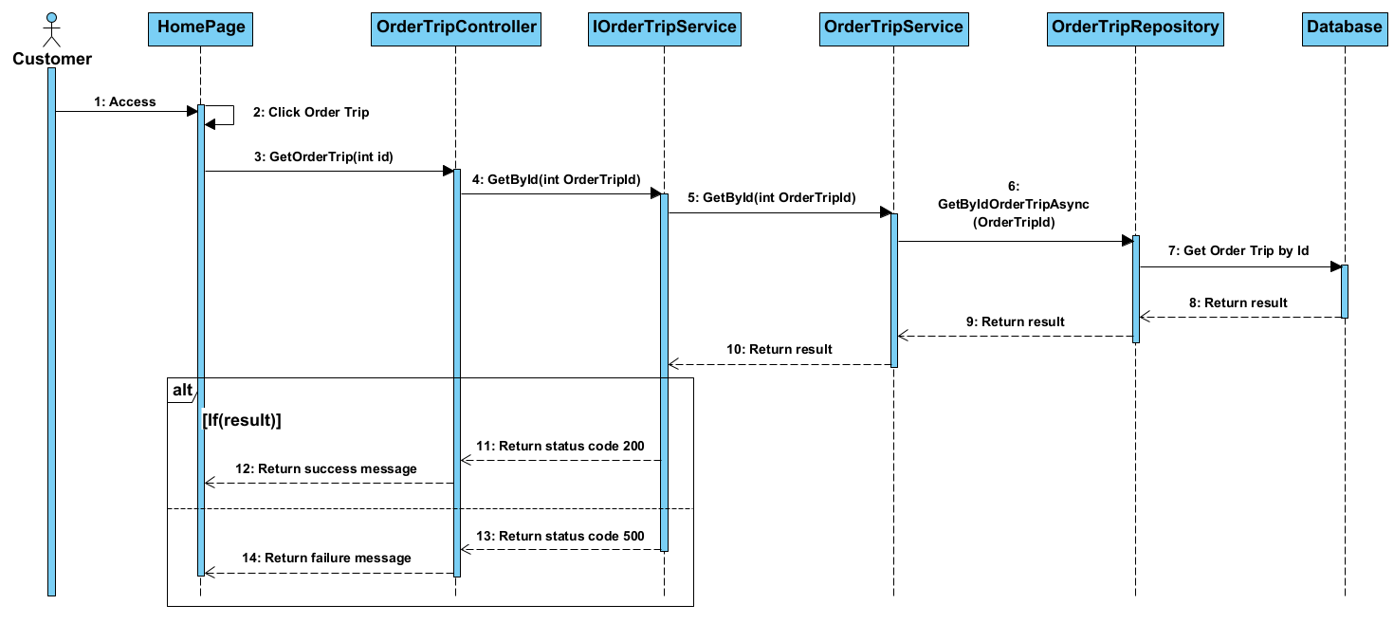

### 3.27 <Create Order Trip>

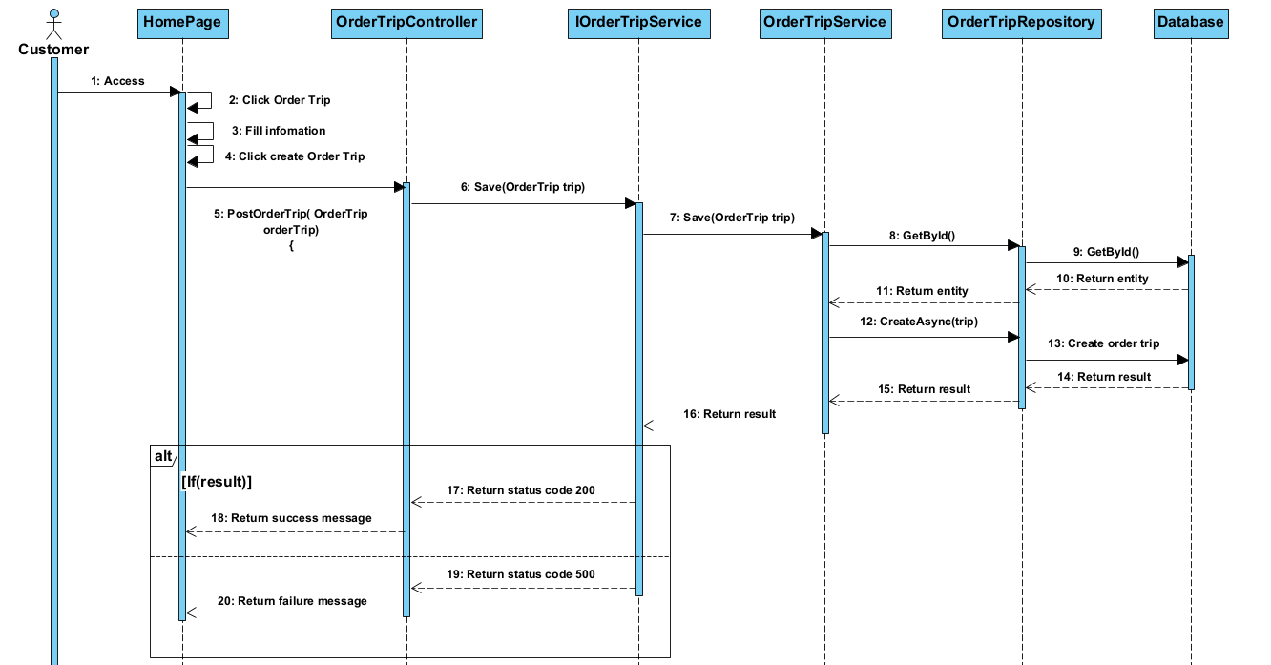

### 3.28 <Delete Order Trip>

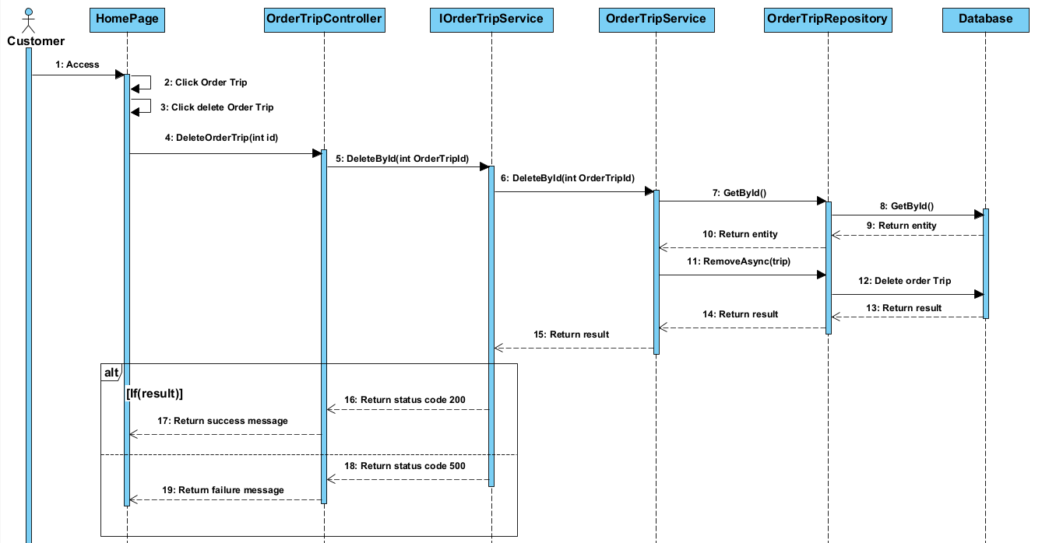

### 3.29< Update Order Trip >

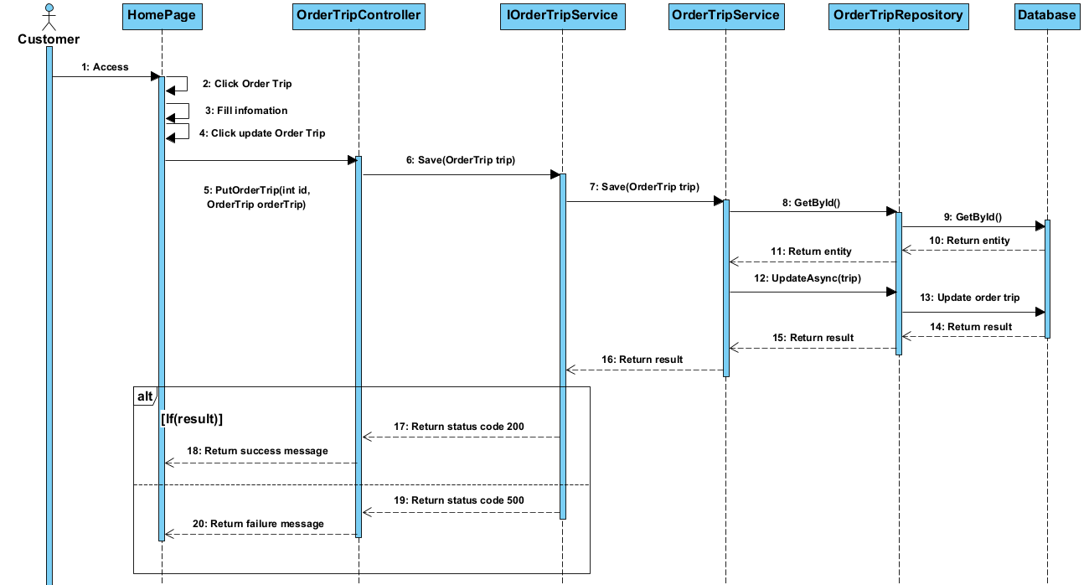

### 3.30. <Get All Order Histories>

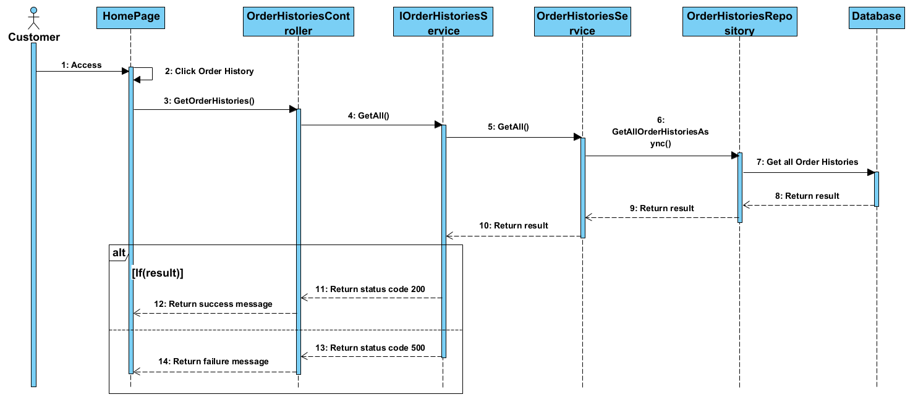

### 3.31. < Get Order History by Id>

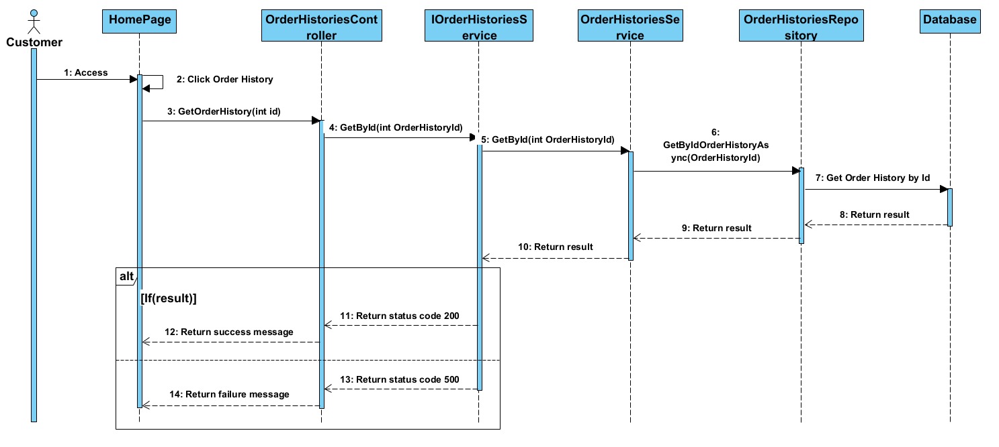

### 3.32. <Create Order History>

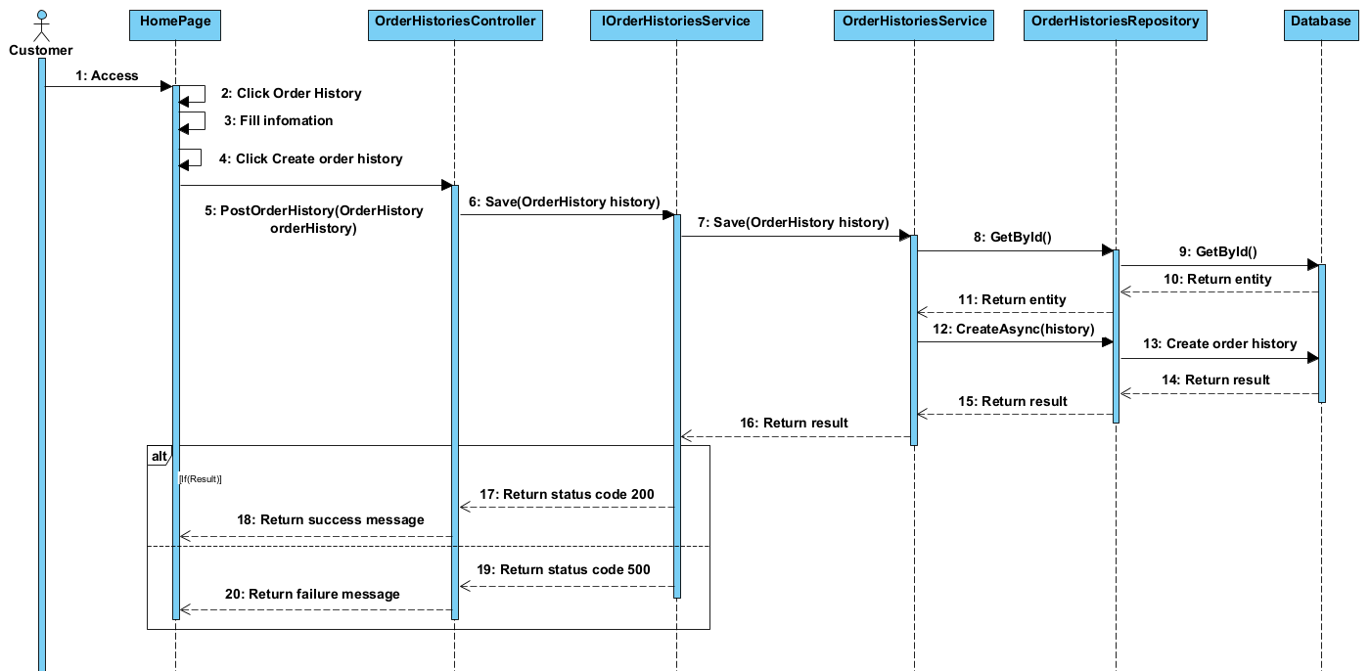

### 3.33. <Update Order History>

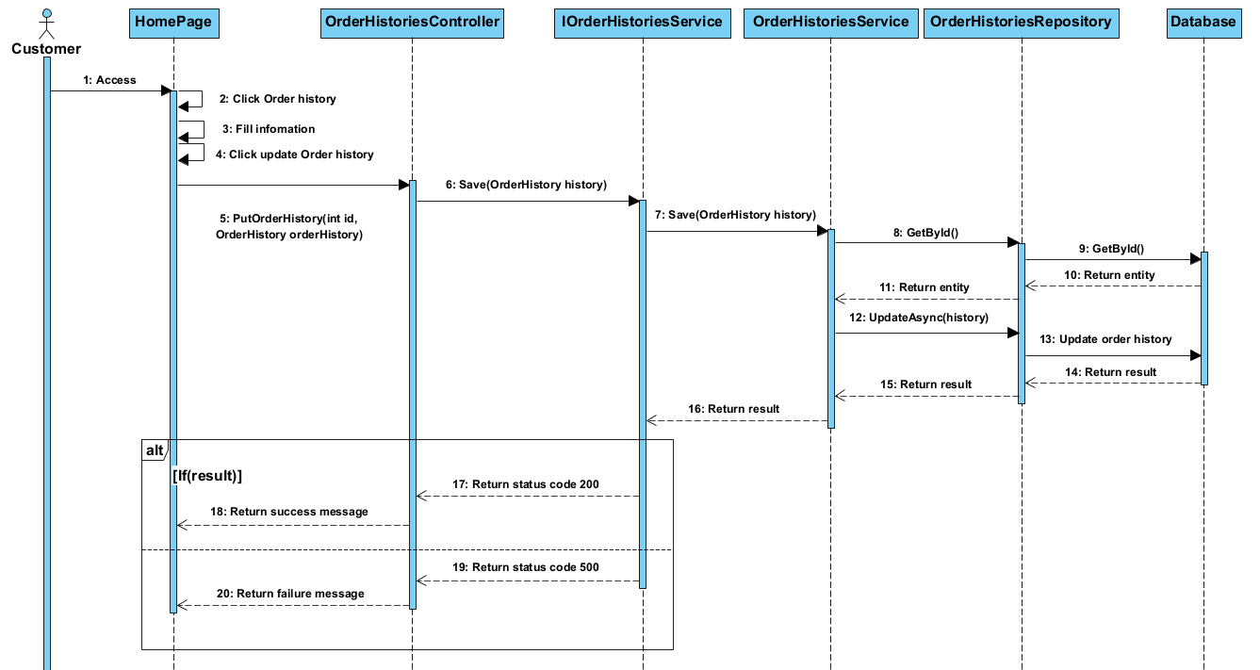

### 3.34 <Delete Order History>

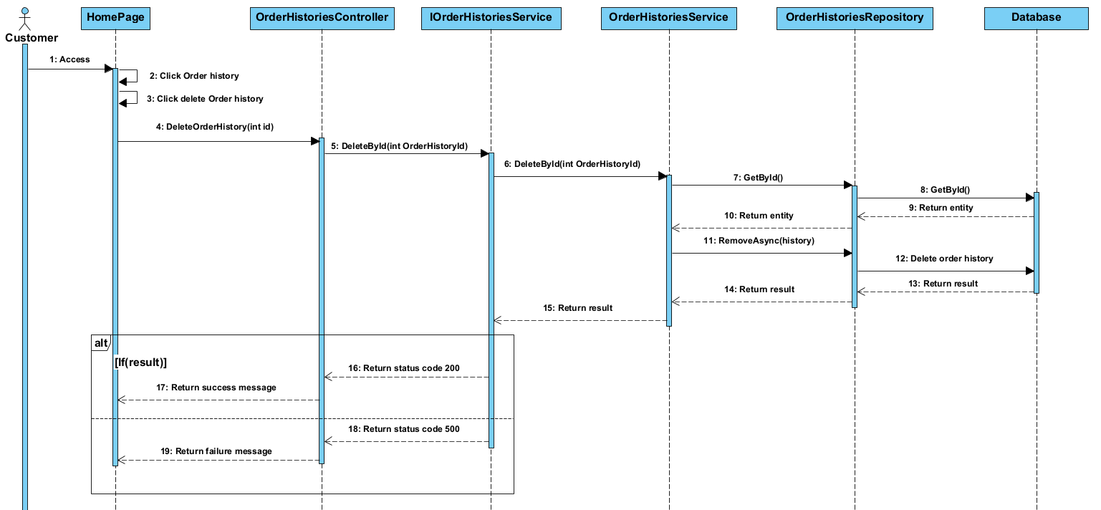

### 3.35<Delete Insurance Policies >

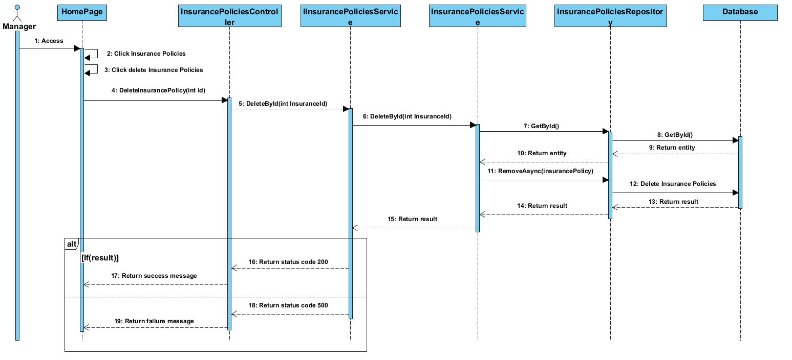

### 3.36<Create Insurance Policies >

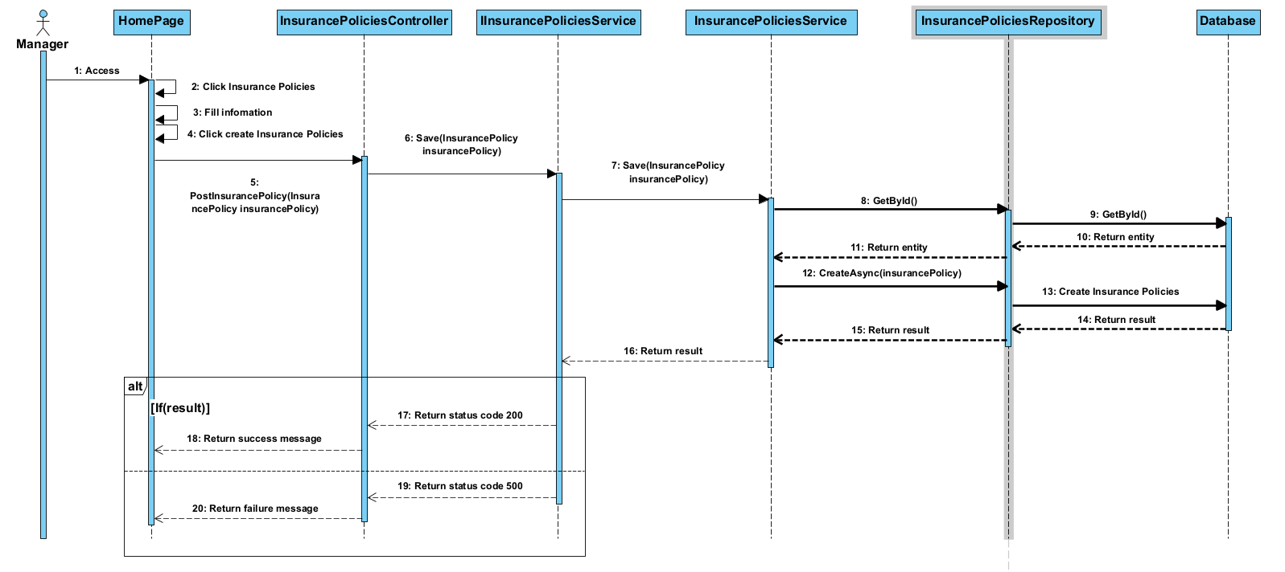

### 3.37 <Update Insurance Policies>

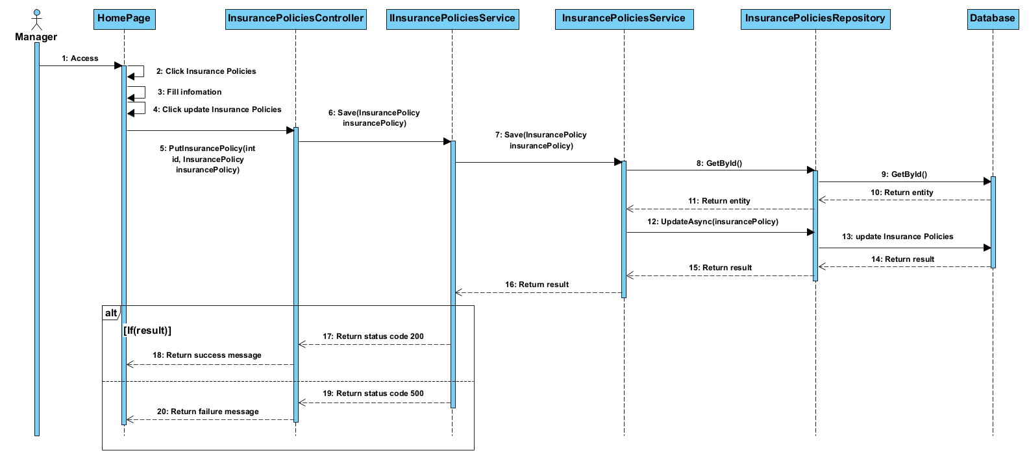

### 3.38 < View All Insurance Policies>

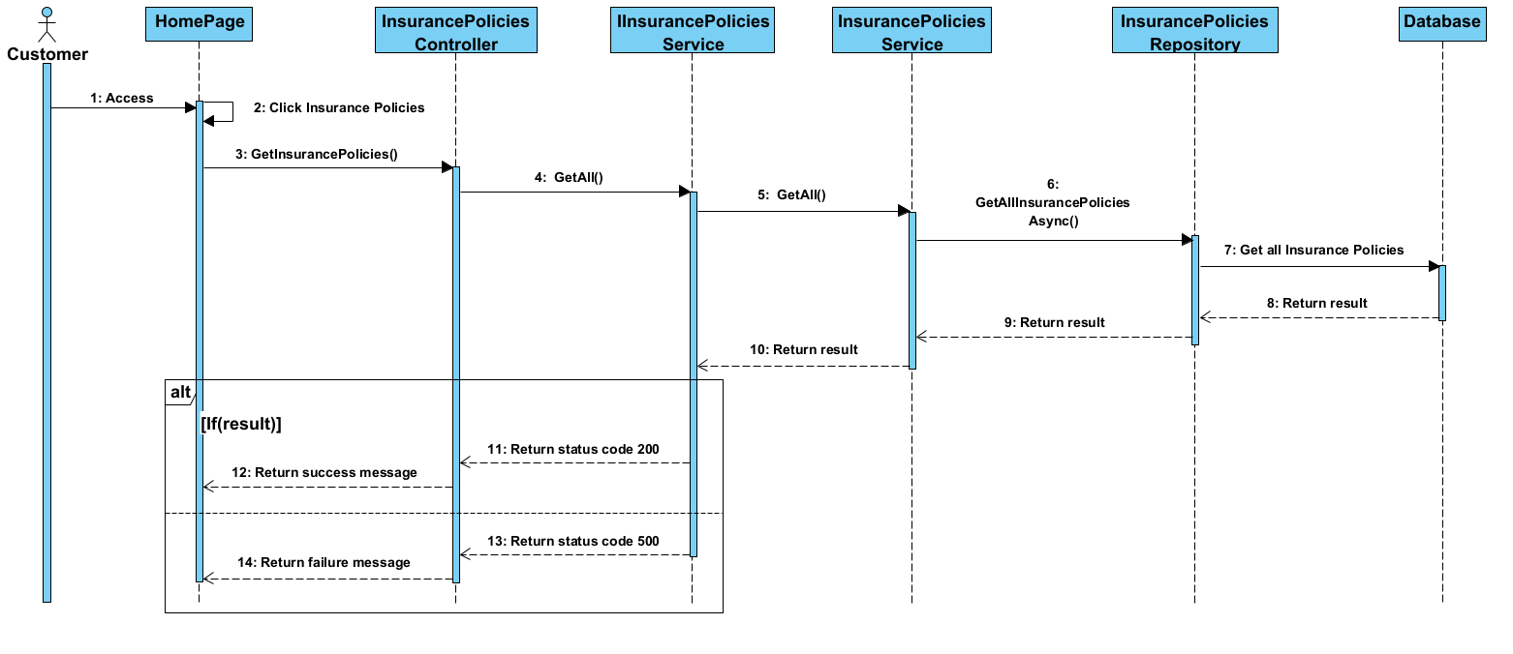

### 3.39.< View Insurance Policies By Id>

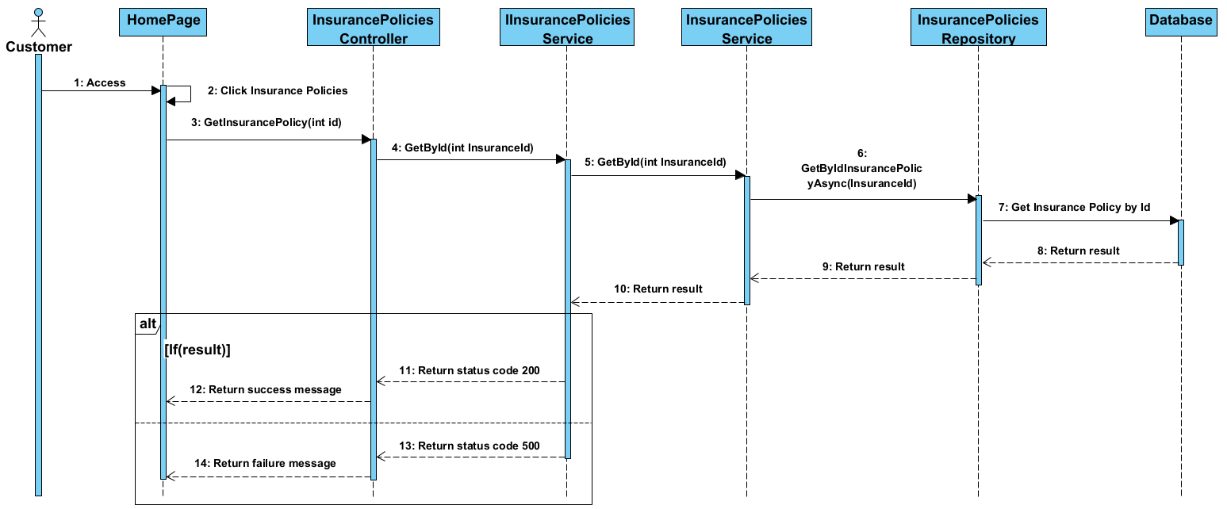

### 3.40 <Create CheckIns>

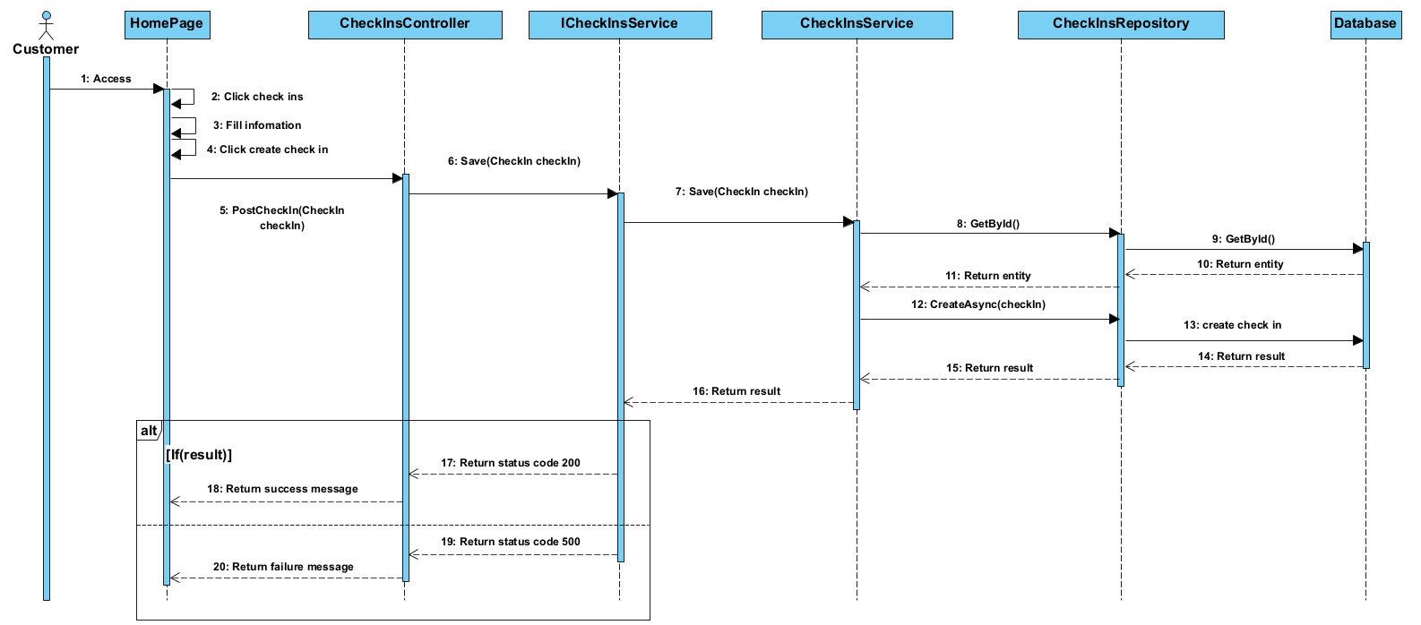

### 3.41. <Update CheckIns>

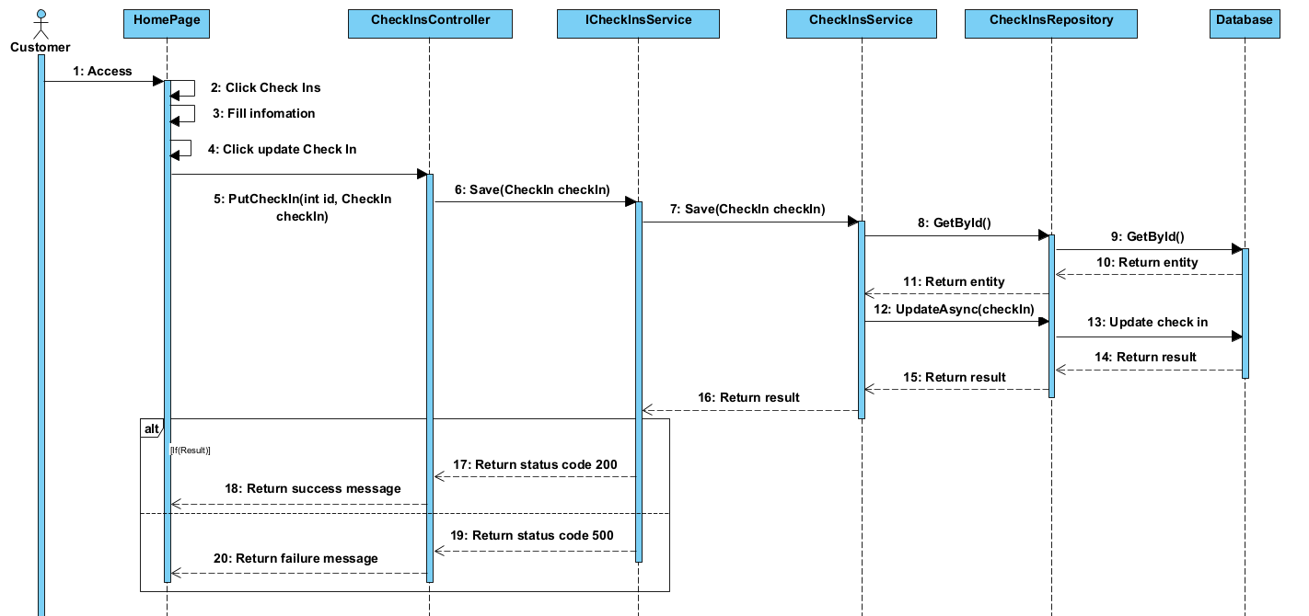

### 3.42 <Delete CheckIns>

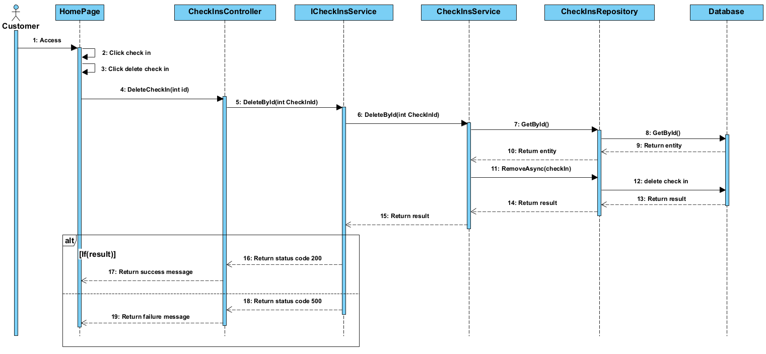

### 3.43<View All Check Ins>

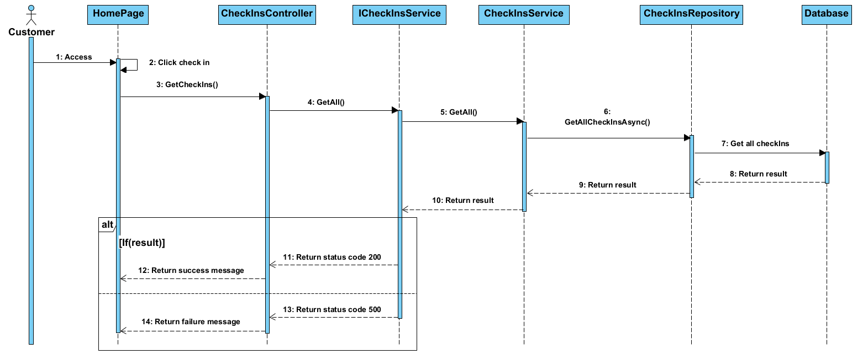

### 3.44.<View Check In By Id>

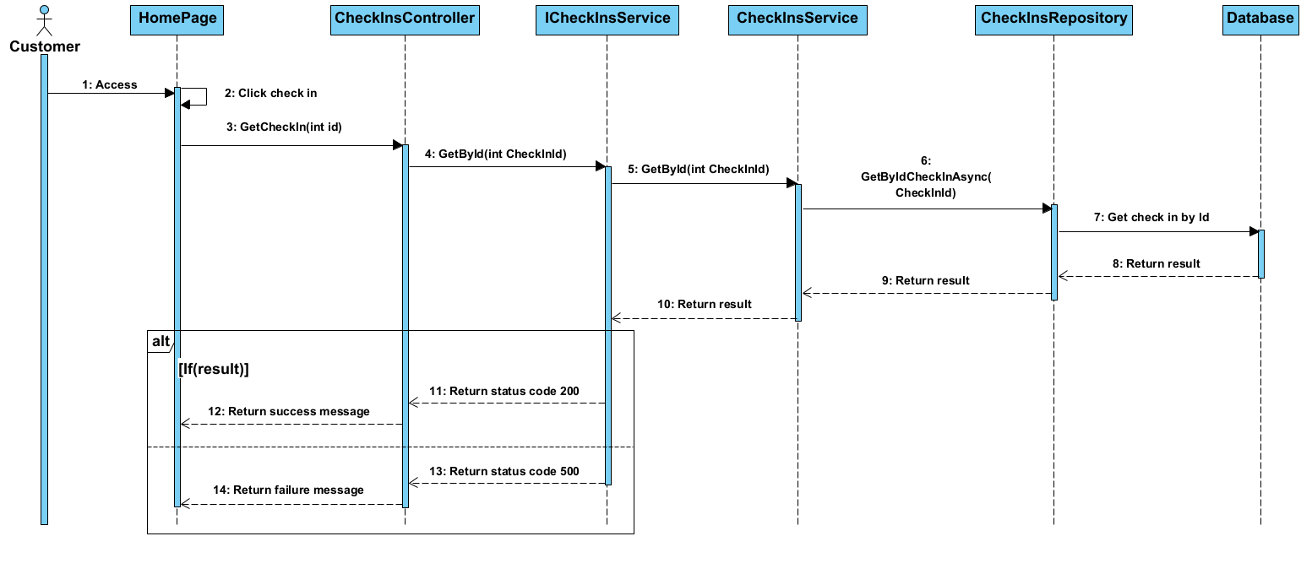

### 3.45 <Delete Refund Request>

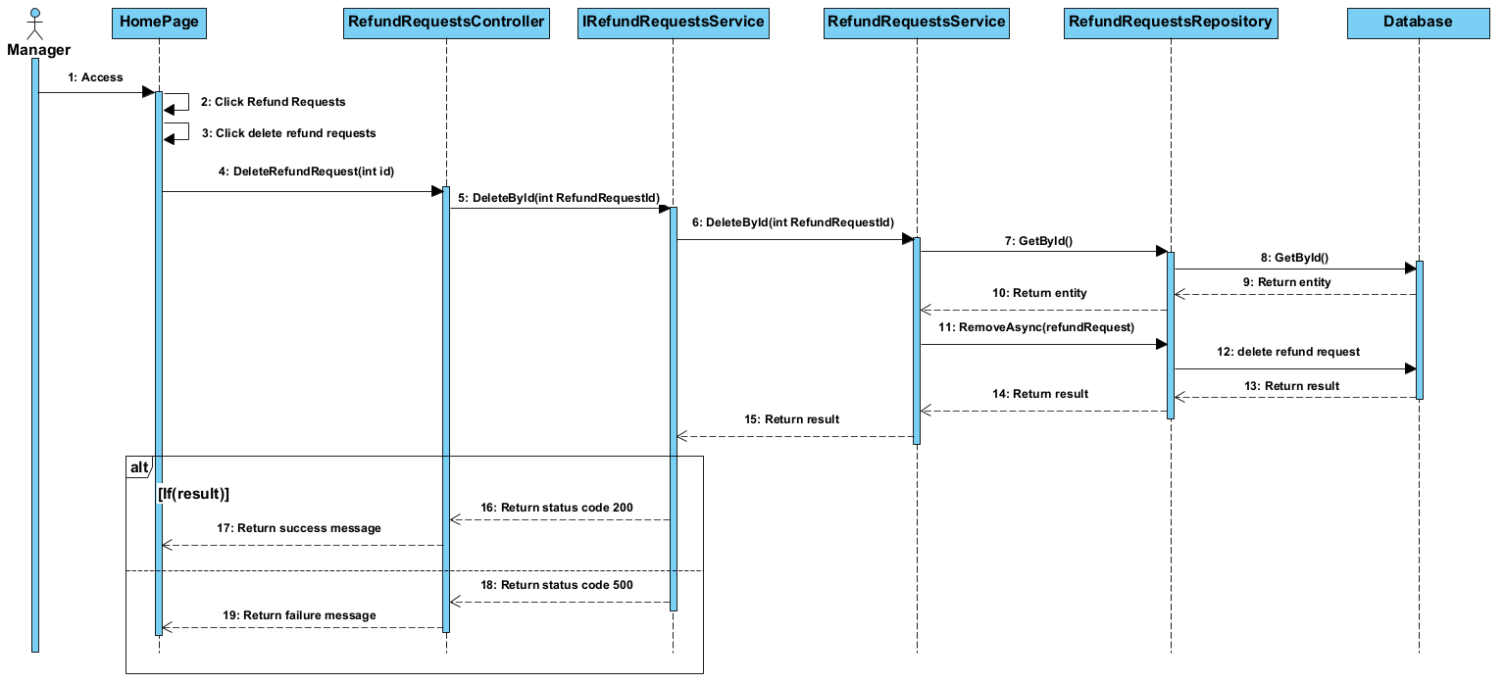

### 3.46 <Update Refund Request>

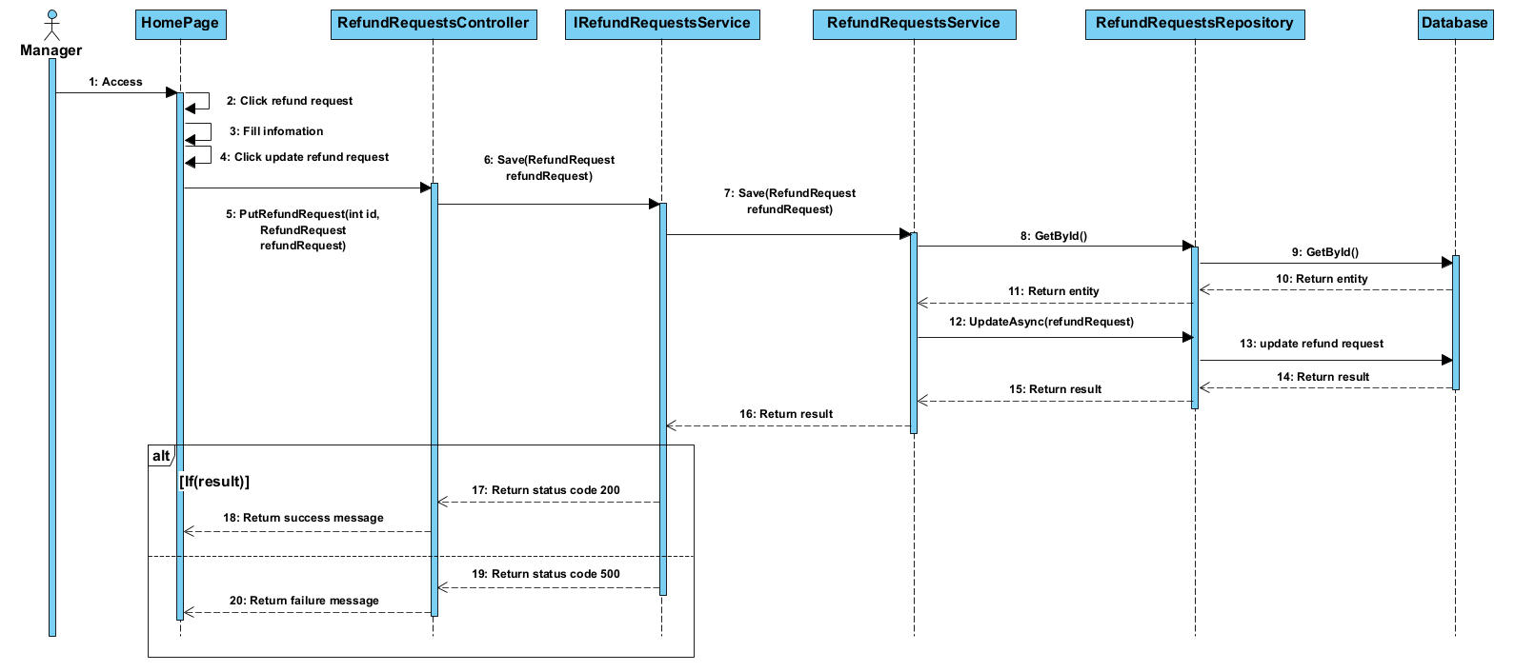

### 3.47 <Create Refund Request>

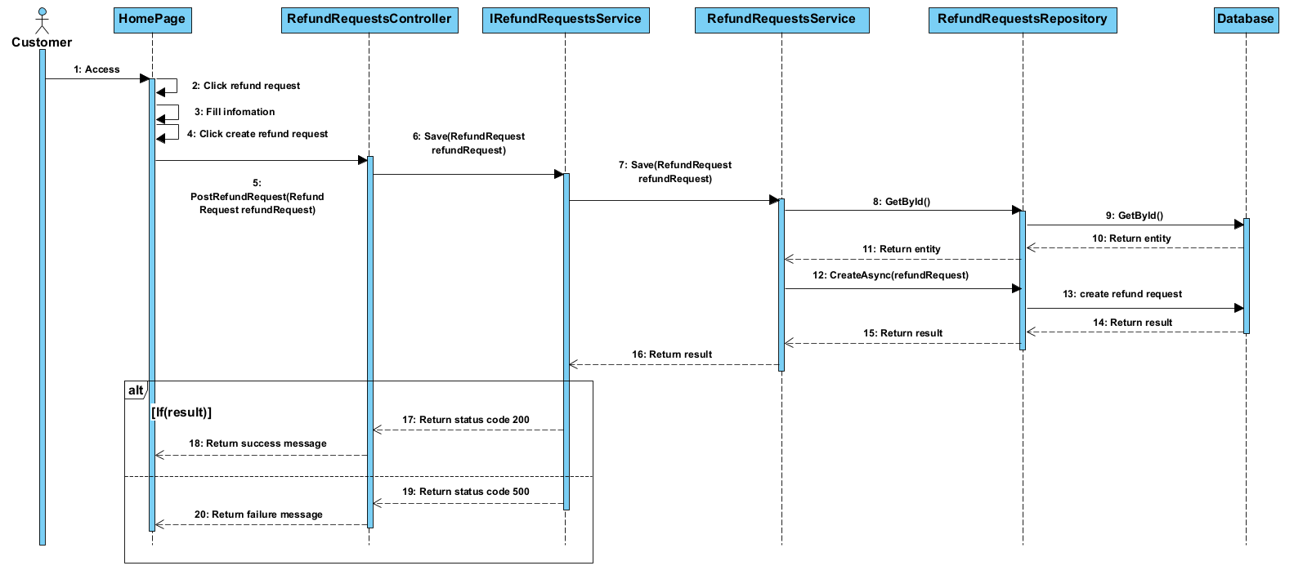

### 3.48<View Refund Request by id>

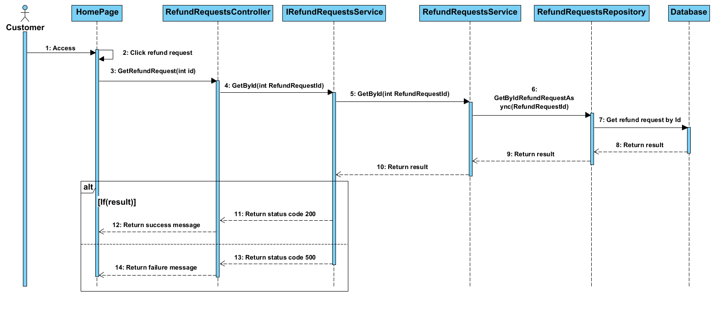

### 3.49<View All Refund Request >

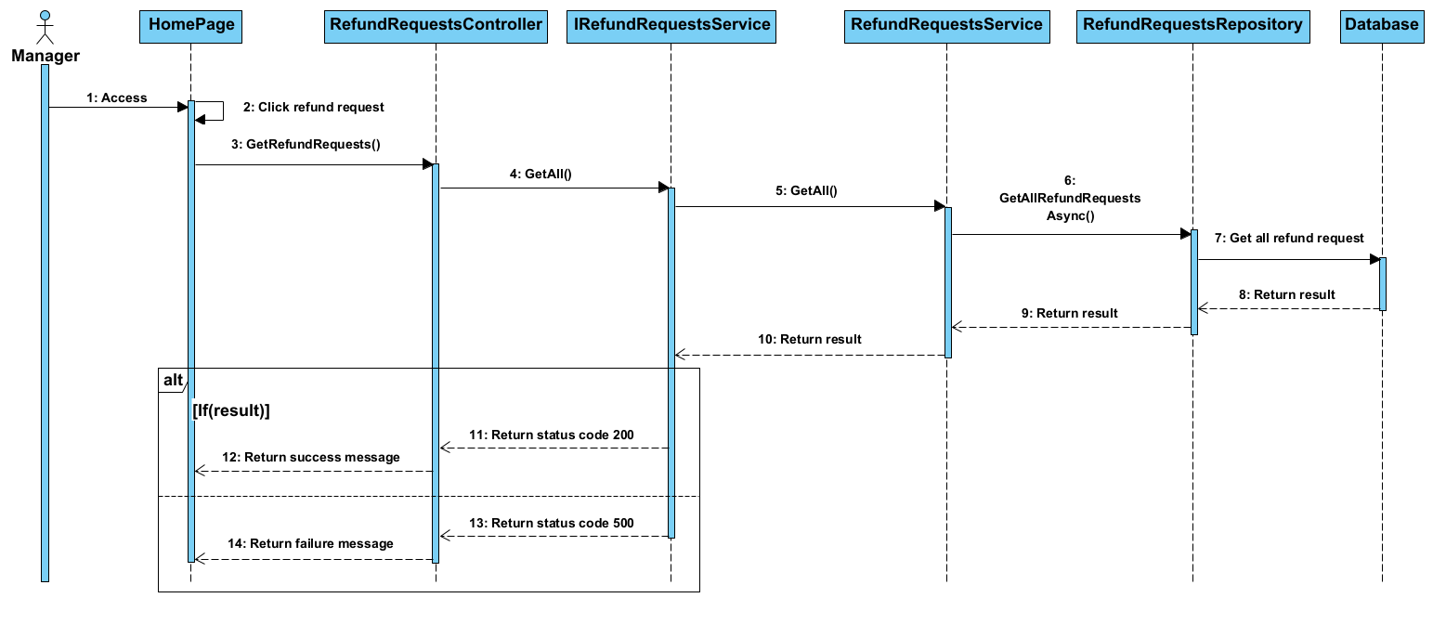

### 3.50<View Payment>

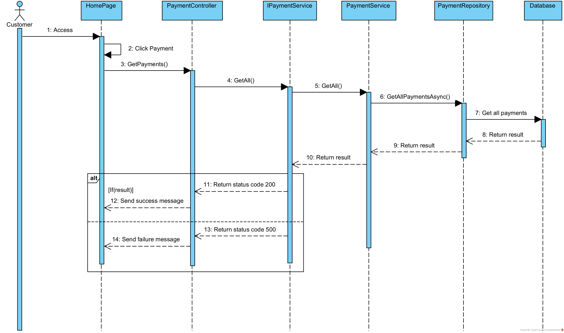

### 3.51.<Create Payment>

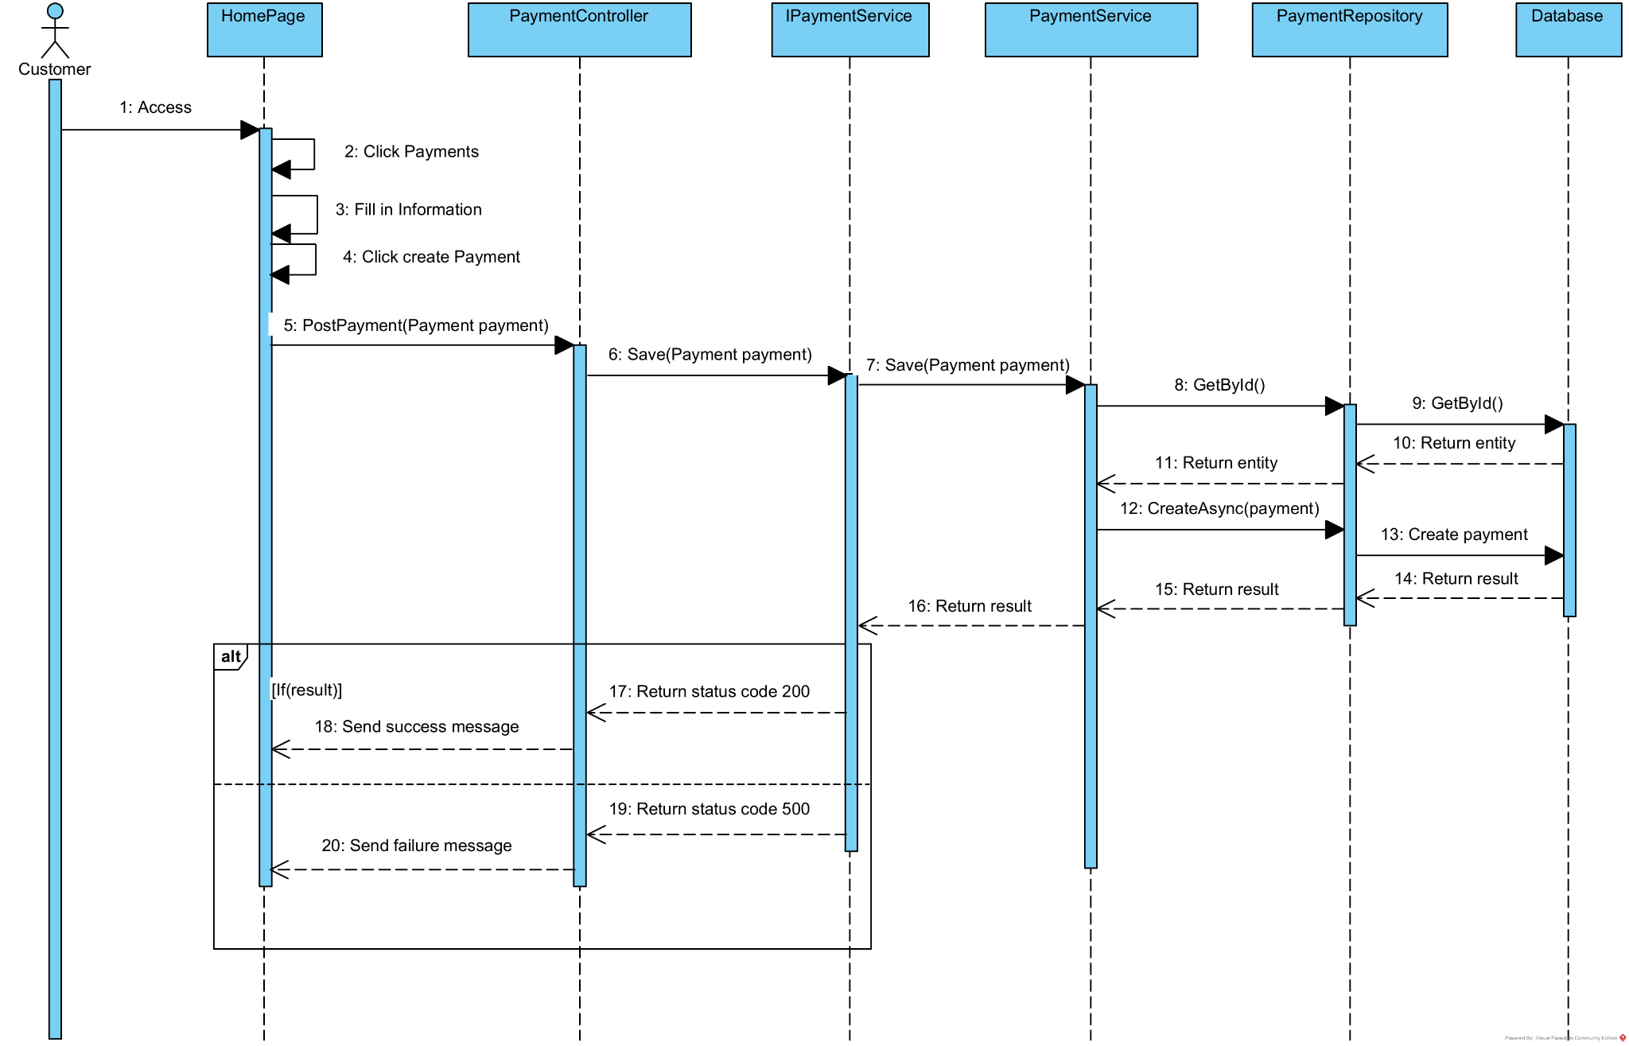

### 3.52. <Delete Payment>

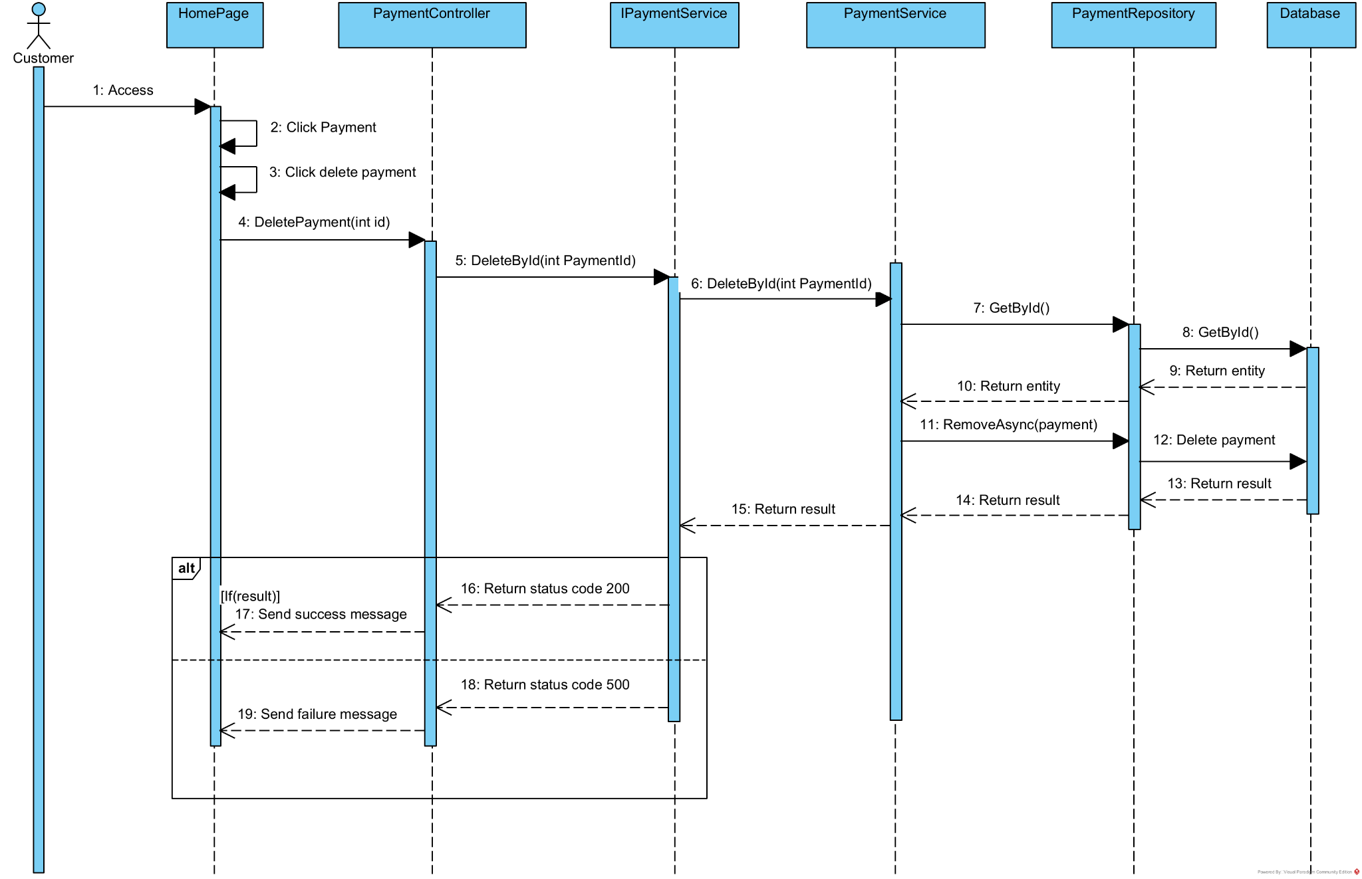

### 3.53. <Update Payment>

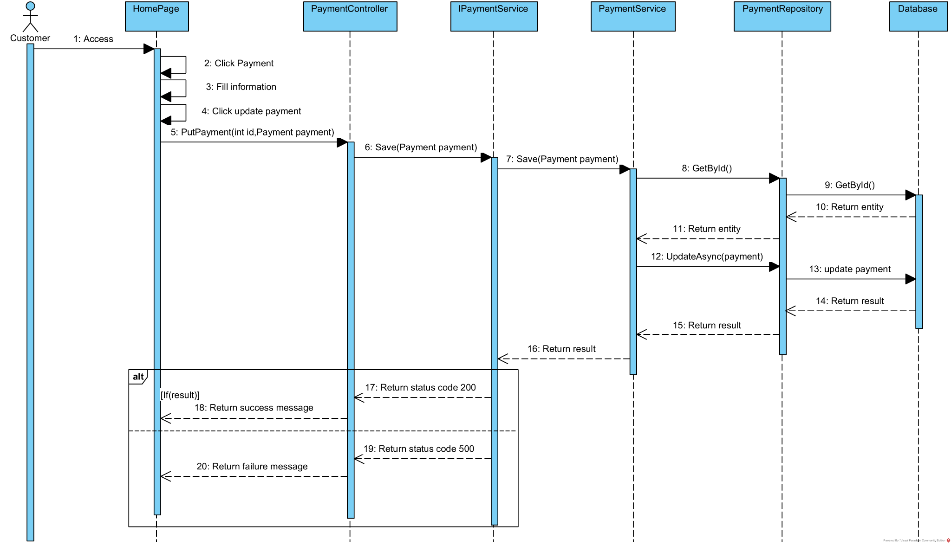

### 3.54. <Get Payment by Id>

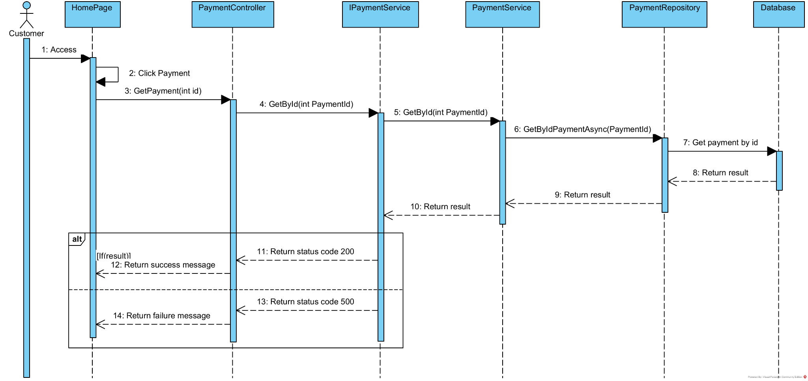

### 3.55. <View Schedule Farm>

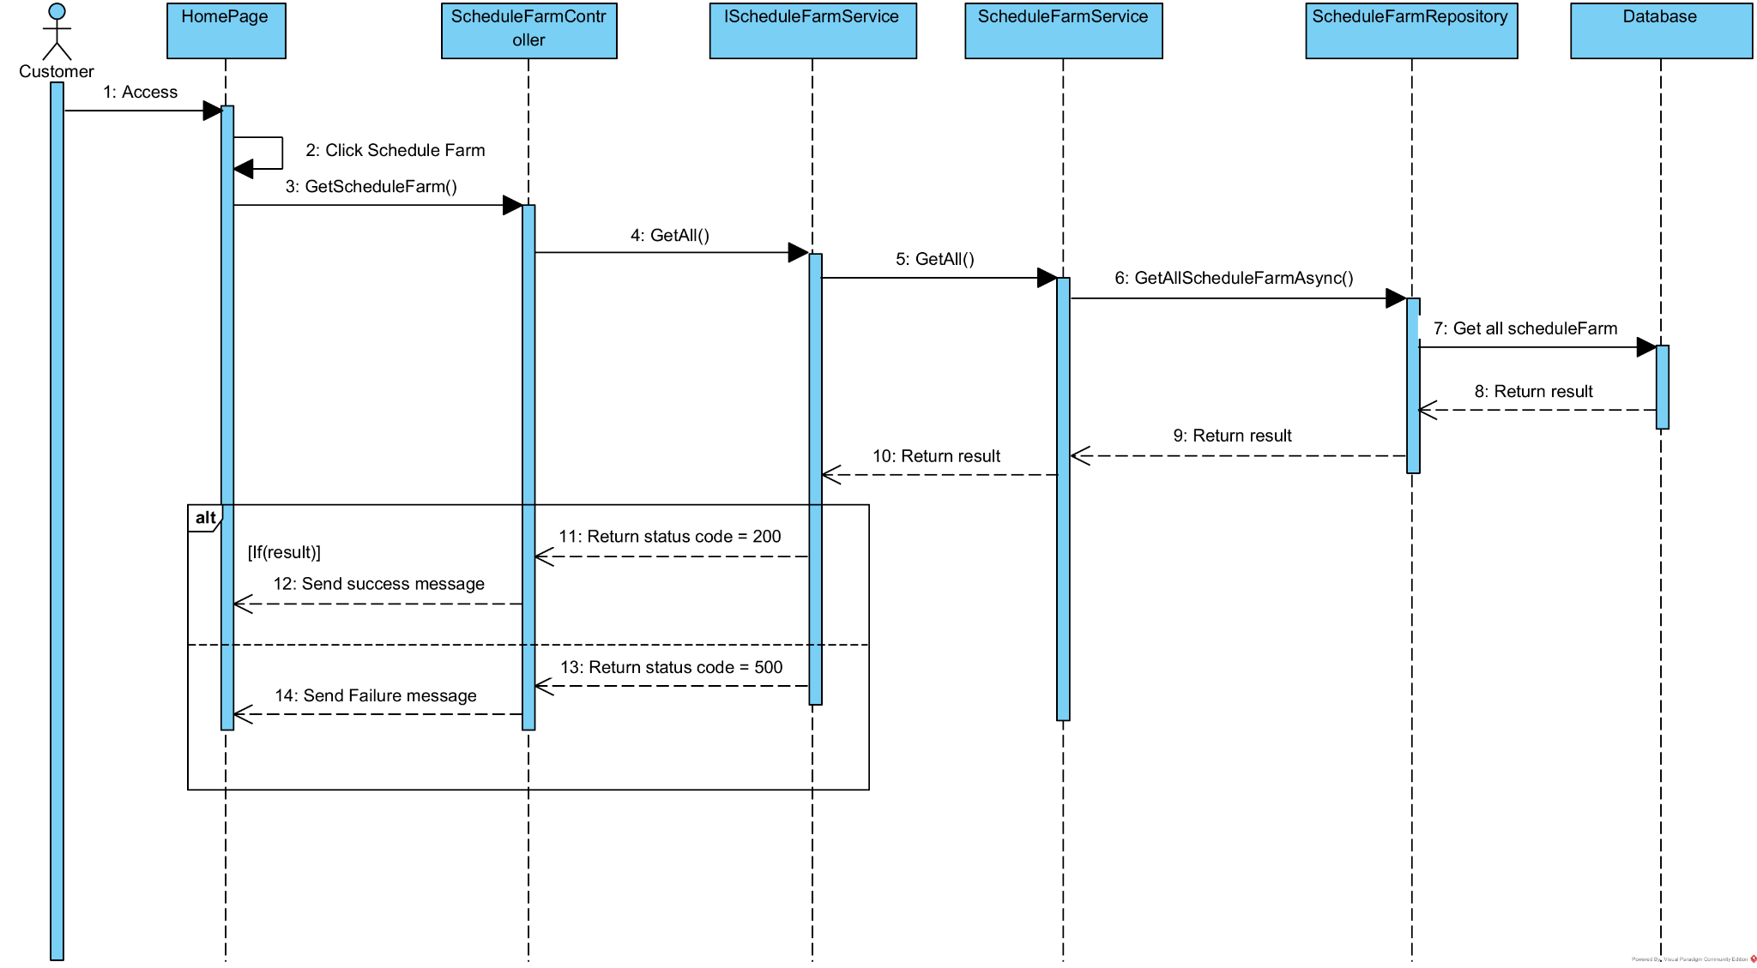

### 3.56. <Create Schedule Farm>

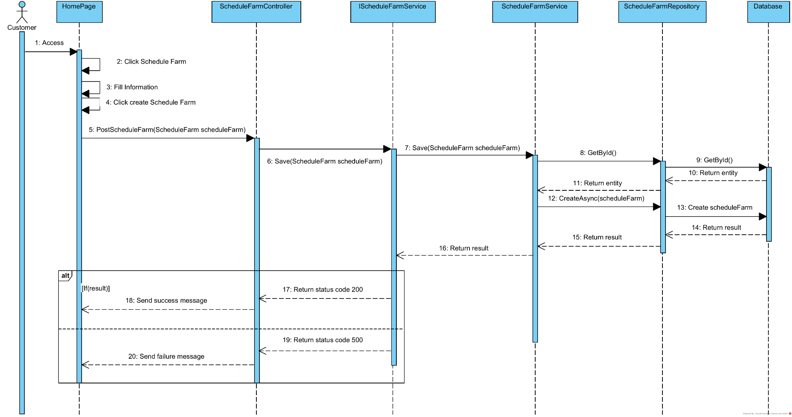

### 3.57. <Update Schedule Farm>

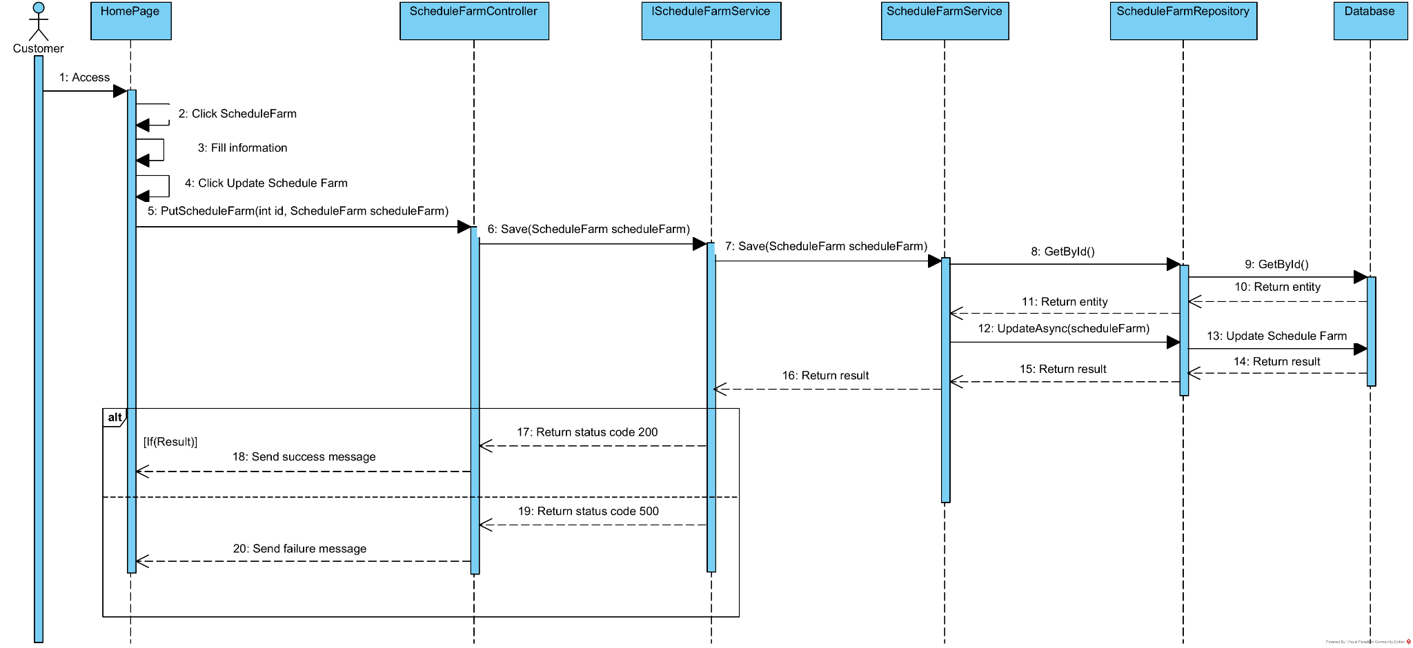

### 3.58. <Delete Schedule Farm>

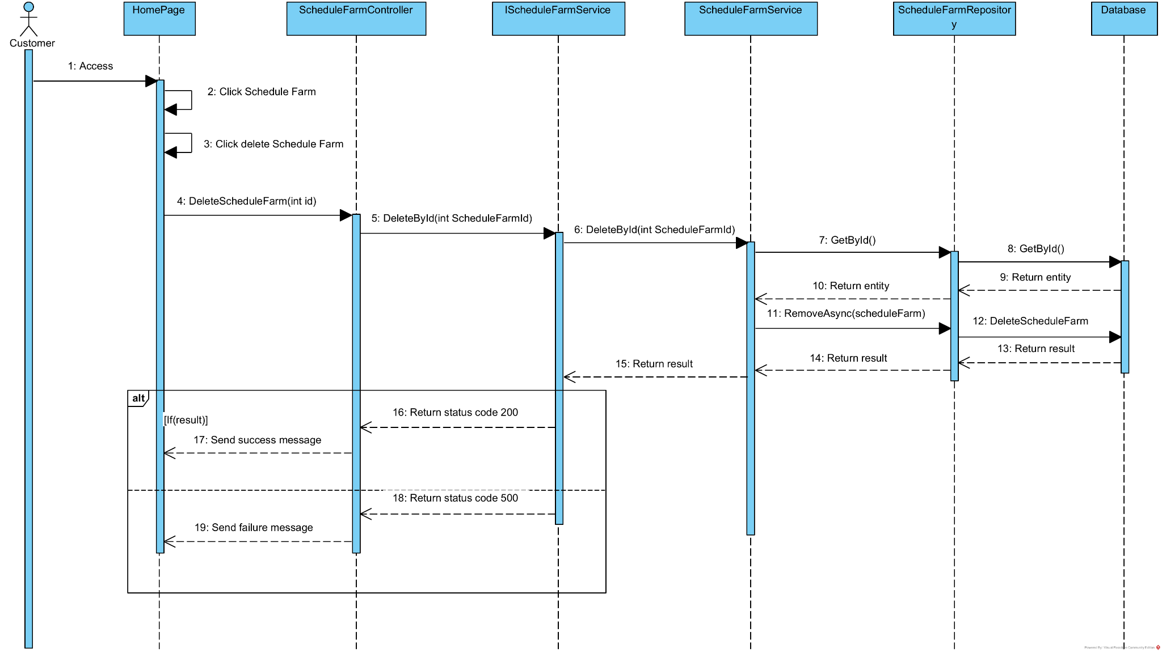

### 3.59. <GetScheduleFarmById>

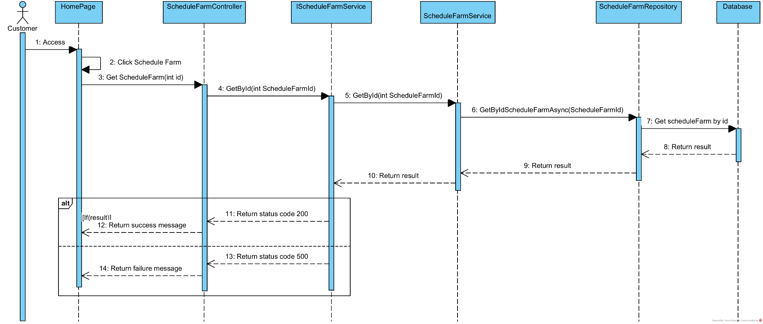

### 3.60. <View Trip Schedule>

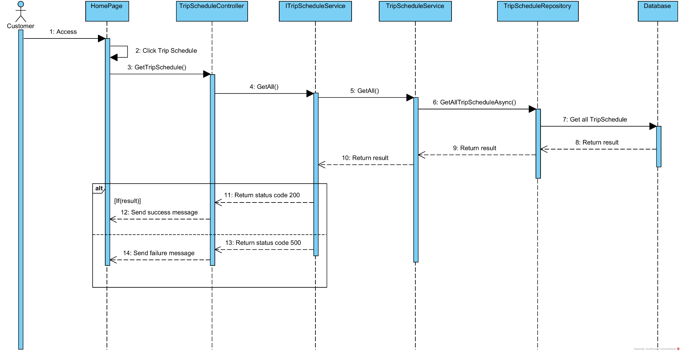

### 3.61. <Create Trip Schedule>

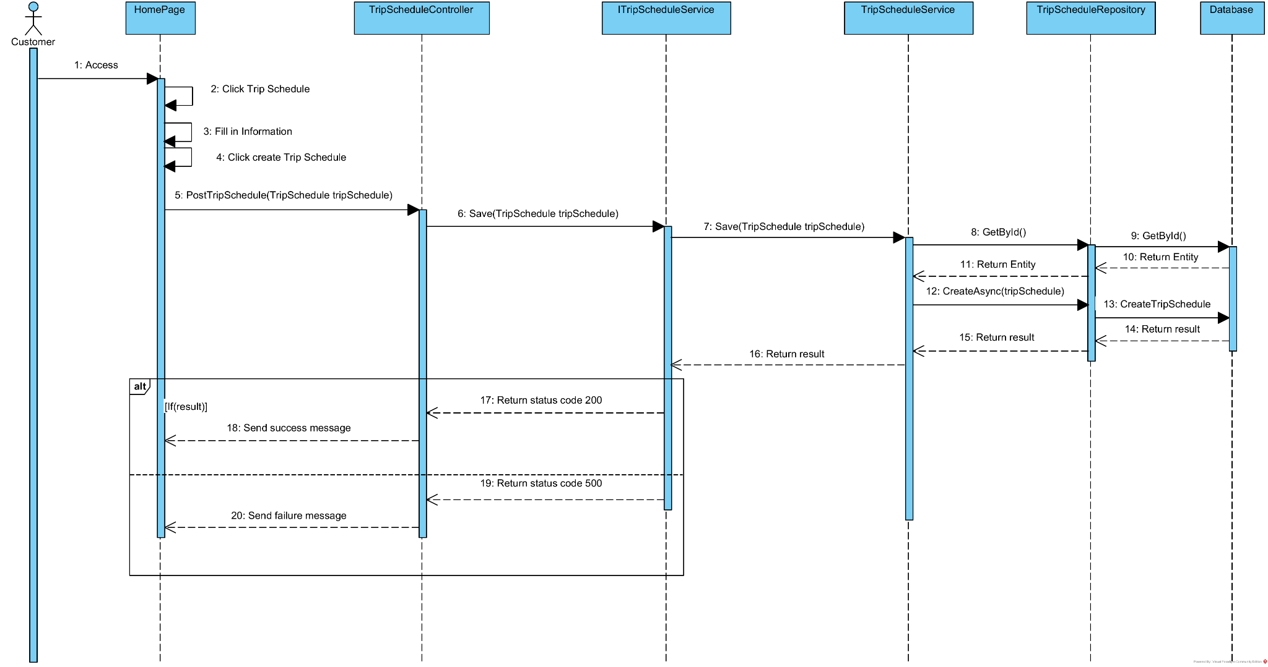

### 3.62. <Update Trip Schedule>

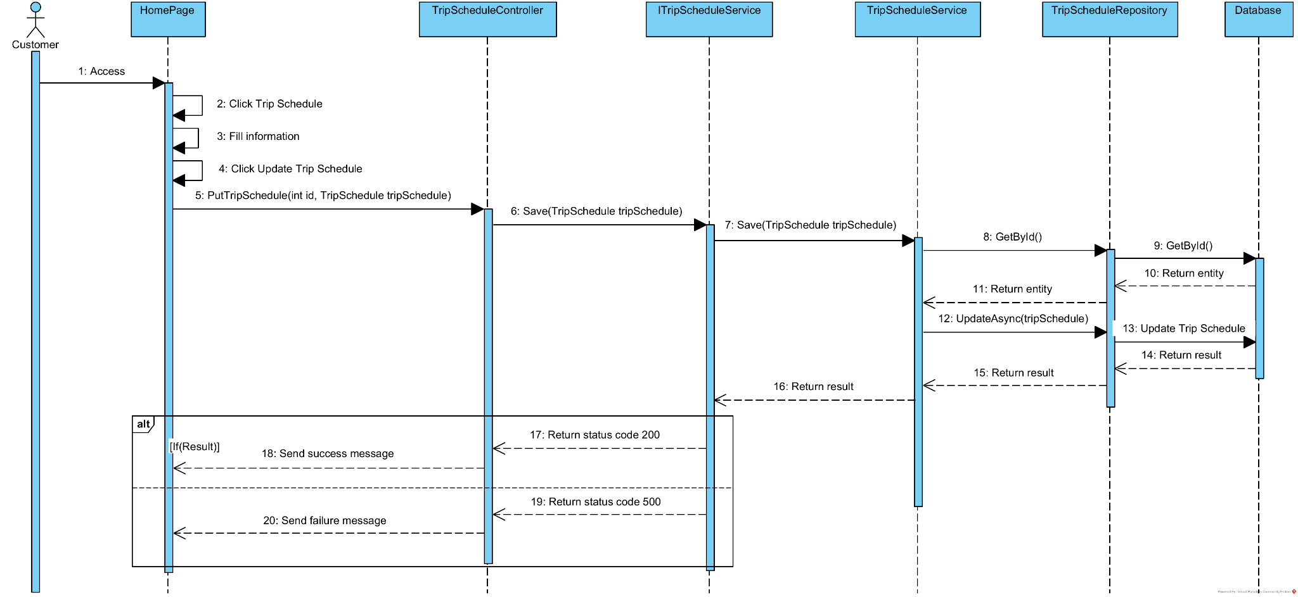

### 3.63. <Delete Trip Schedule>

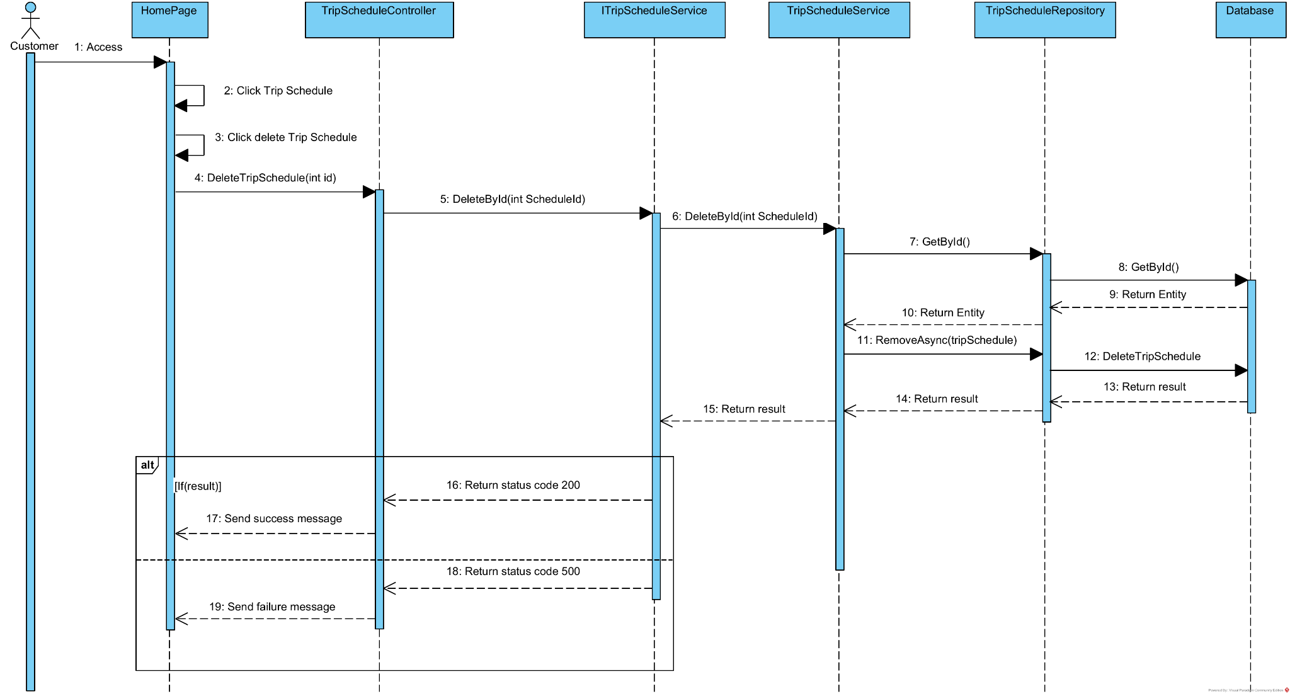

### 3.64. <Get Trip Schedule By Id>

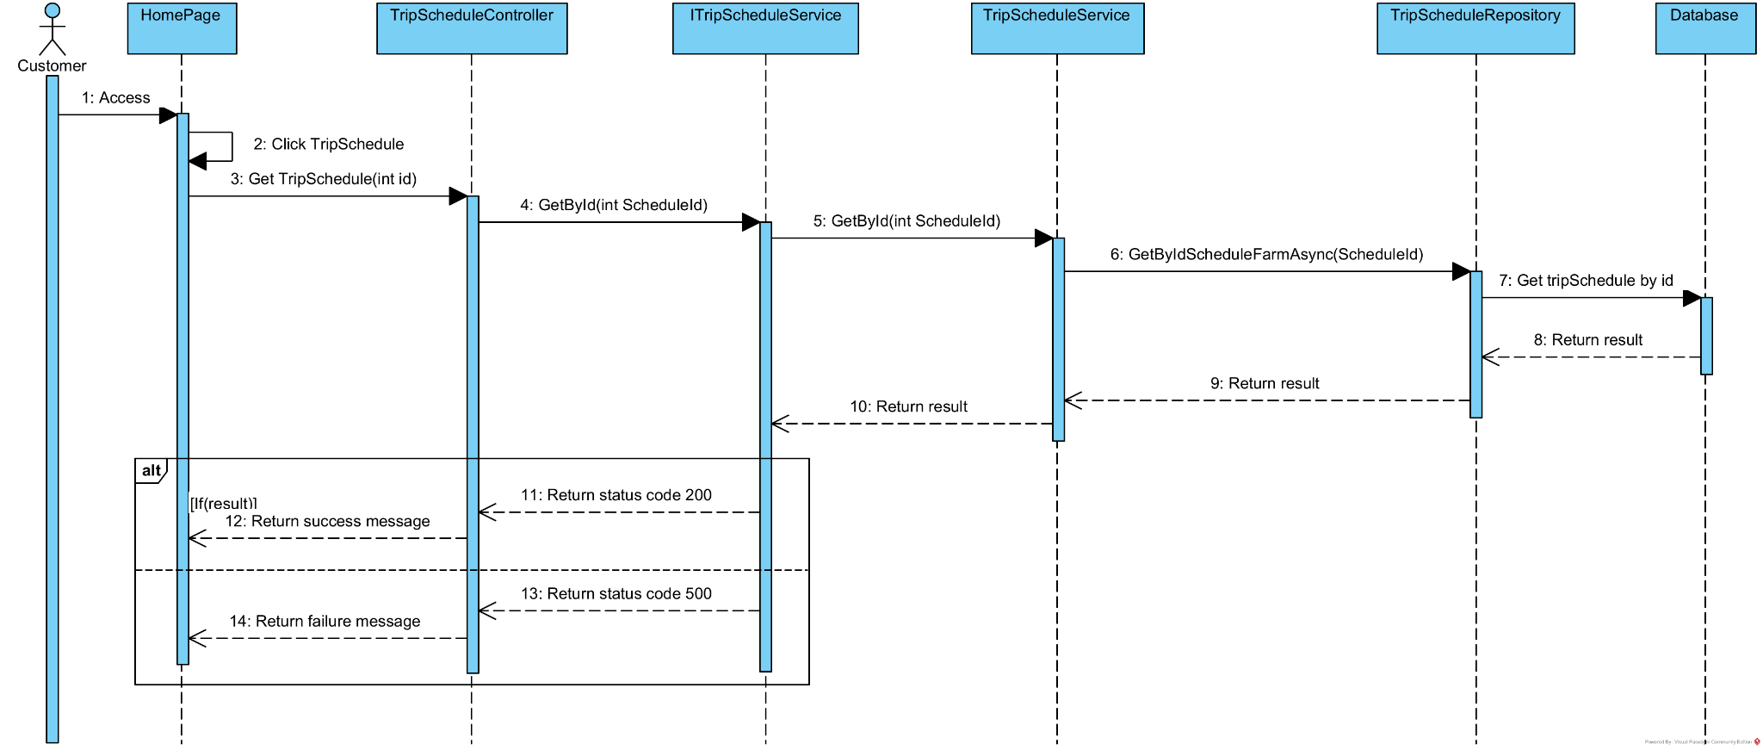

### 3.65. <Update trip>

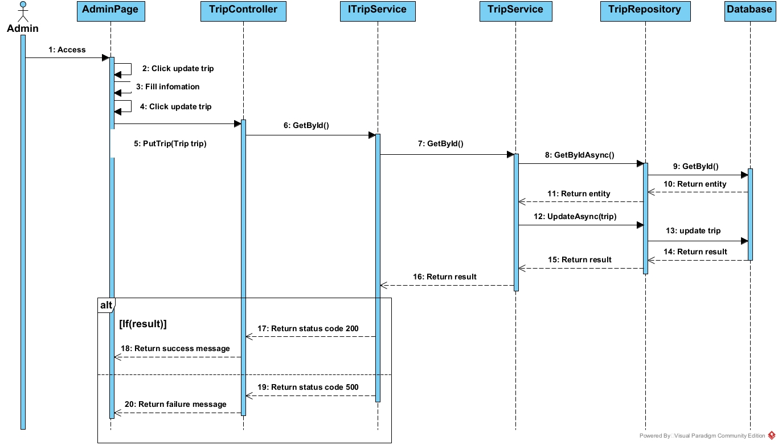

### 3.66. <Add trip>

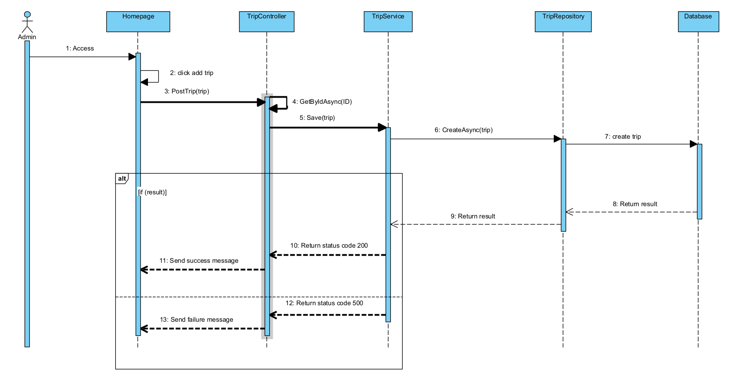

### 3.67. <Get By Id Order KoiFish Detail>

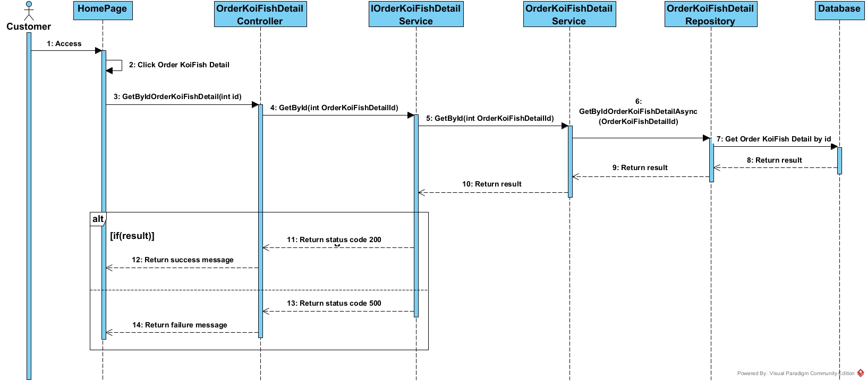

### 3.68. <Delete trip>

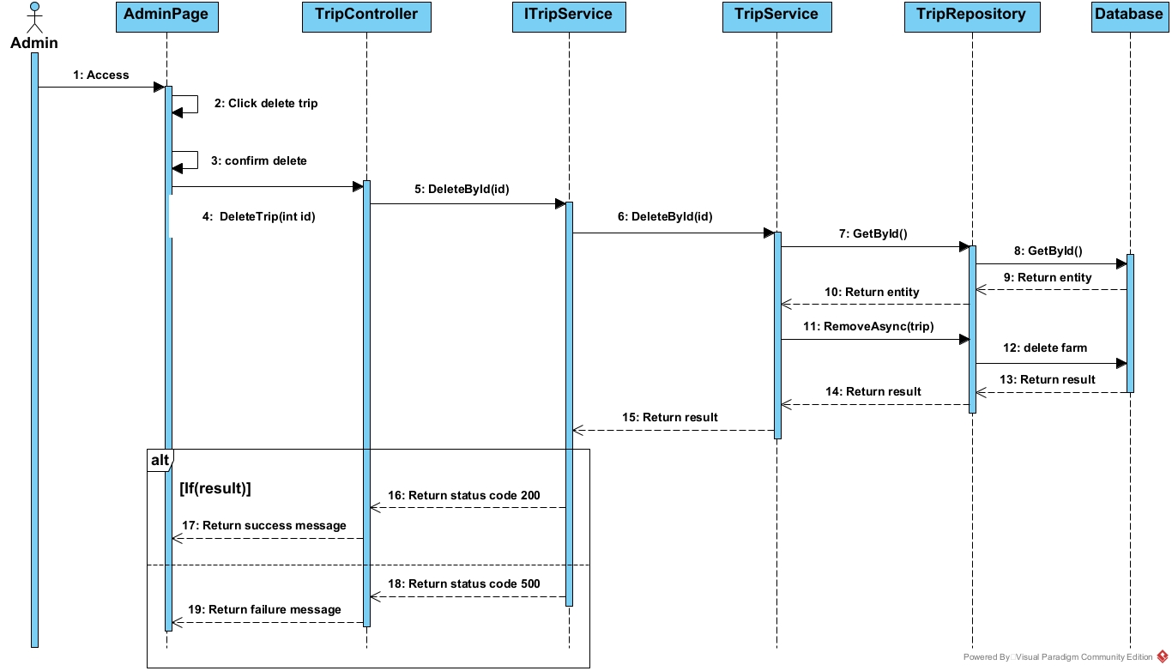

### 3.69. <Forgot password>

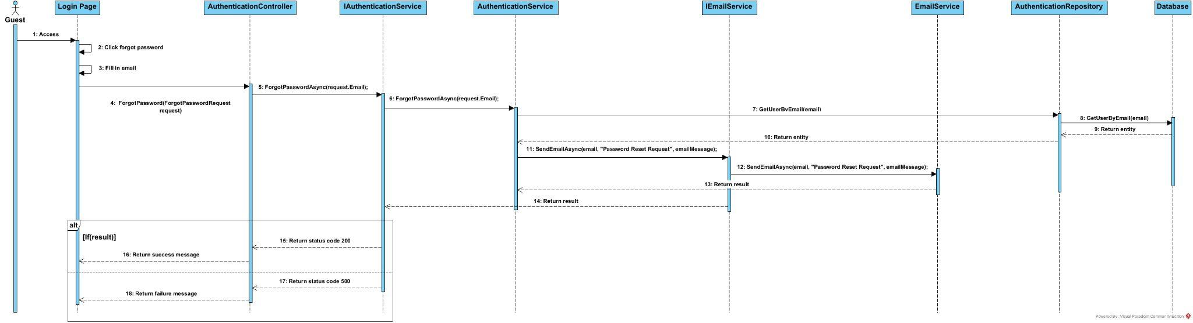

## 4. State diagram

### 4.1. <OrderTrip>

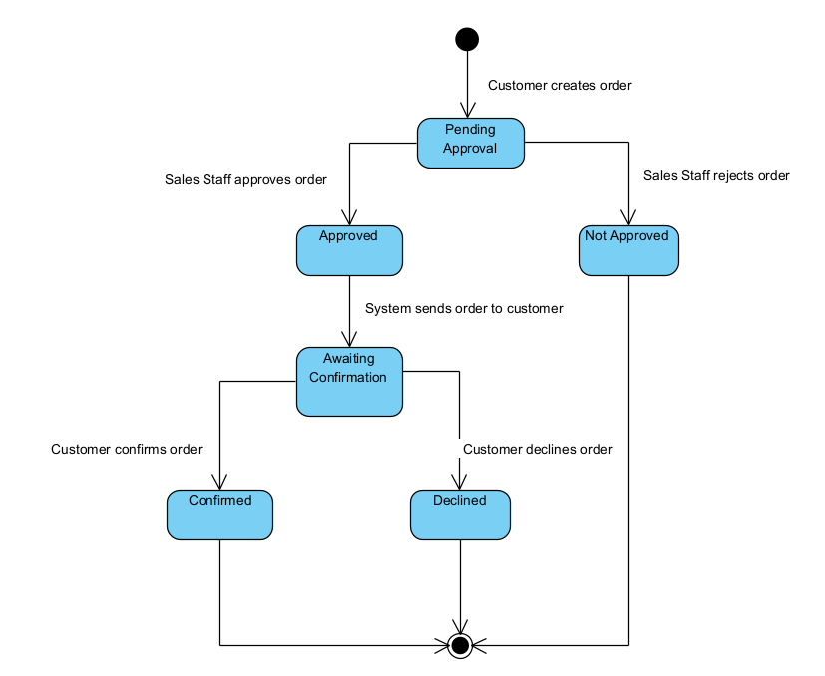

### 4.2. <OrderKoiFish>

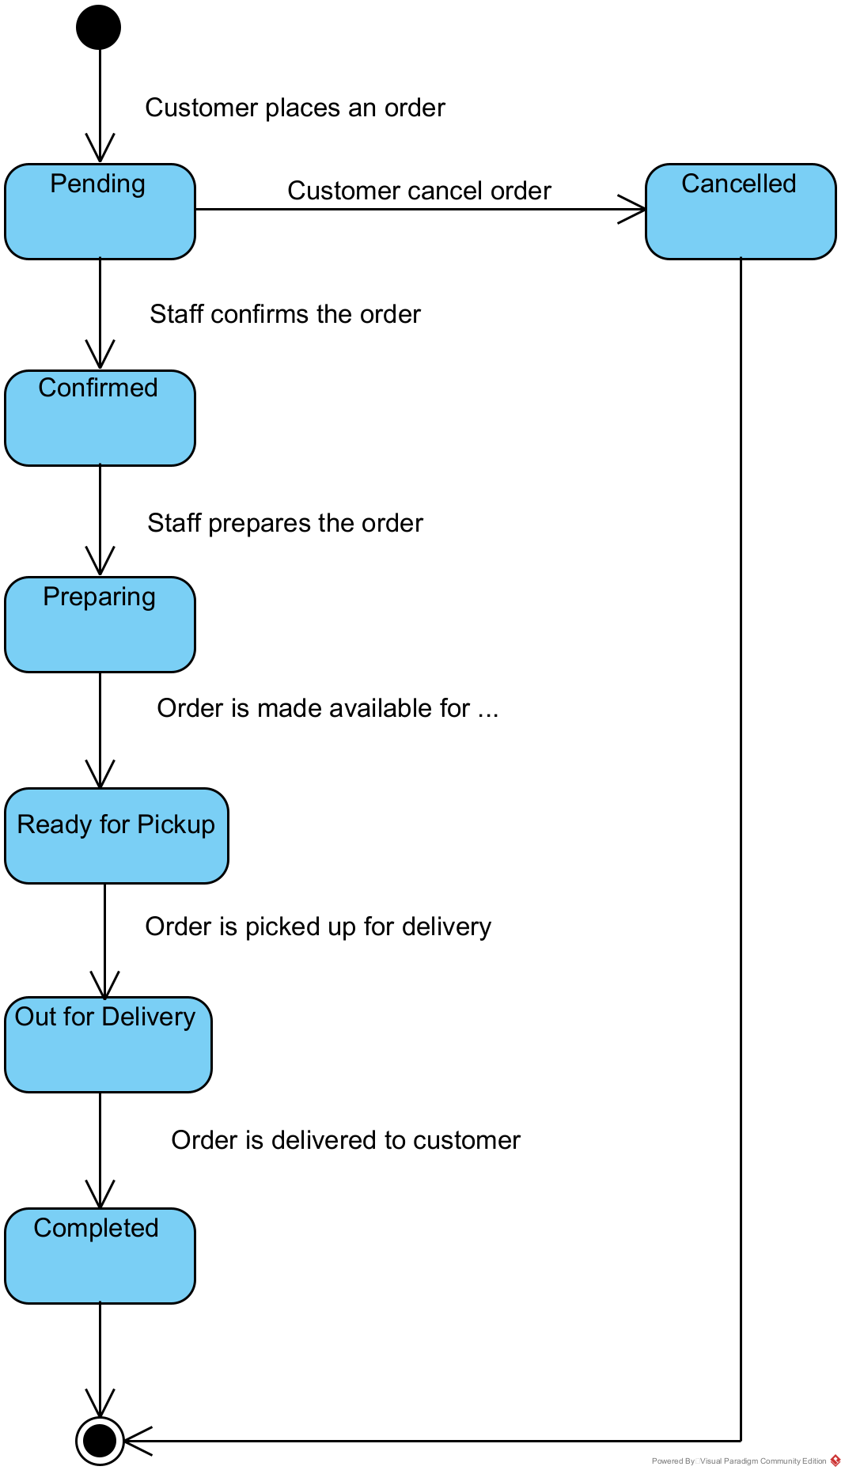

### 4.3. <Payment>

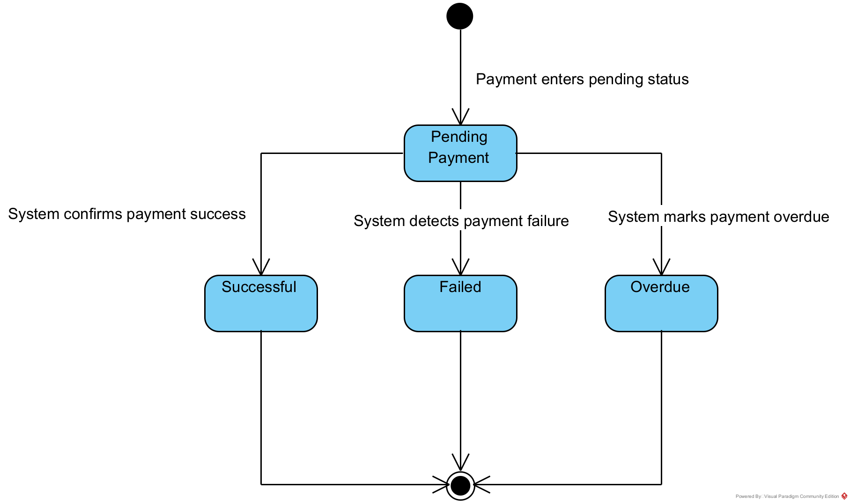

### 

### 4.4. <CheckIn>

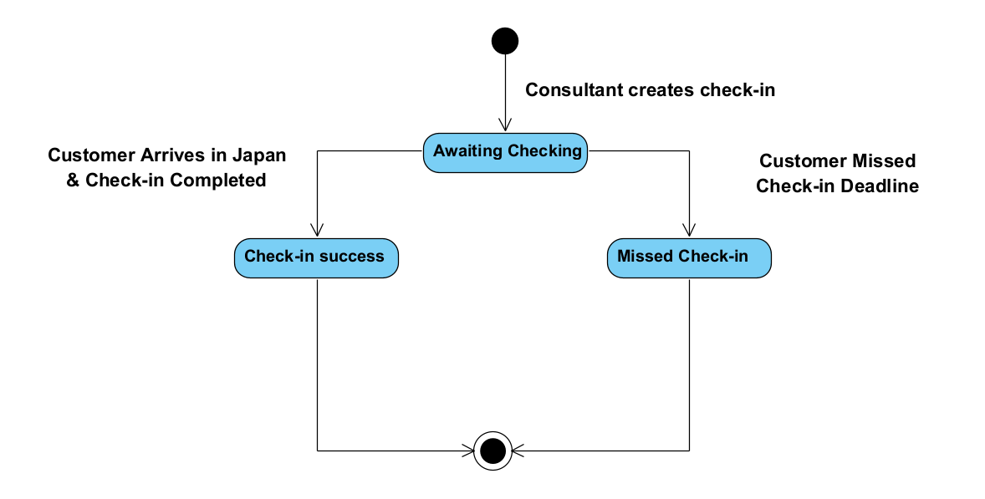

### 4.5. <Order History>

